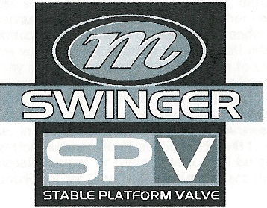

2005 SWINGER SERVICE MANUAL

PN 042133, REV NC.

05 SWINGER SERVICE MANUAL INDEX

Section | Description | Page
1 | INTRODUCTION | 3
2 | SETUP, TUNING, PERIODIC MAINTENANCE | 3
3 | GLOSSARY | 4
4 | AIR SPRING SYSTEM AND SPV AIR PRELOAD, SWINGER AIR | 6
5 | COMPLETE SHOCK LESS HARDWARE, COIL SPRING | 6
6 | HARDWARE REMOVAL AND INSTALLATION | 7
7 | DU BUSHING REMOVAL AND INSTALLATION | 8
8 | RIDE KITS | 9
9 | BOTTOMOUT BUMPER REPLACEMENT, SWINGER COIL | 10
10 | REBOUND ADJUSTER KNOB REMOVAL AND INSTALLATION, SWINGER COIL | 11
11 | DAMPING SYSTEM | 12
12 | DAMPING SYSTEM BLEEDING - SWINGER 3 WAY COIL SHOCKS | 12
13 | DAMPING SYSTEM BLEEDING - SWINGER 4 & 6 WAY COIL SHOCKS | 15
14 | DAMPING SYSTEM BLEEDING - SWINGER 3 WAY AIR SHOCKS | 22
15 | DAMPING SYSTEM BLEEDING - SWINGER 4 WAY AIR SHOCKS | 27
16 | TROUBLESHOOTING | 33
17 | TABLE 1: FASTENER TORQUE REQUIREMENTS | 35
18 | SWINGER REAR SHOCK SERVICE KITS | 36

Contact Information

Answer Products Customer Service Department
28209 Ave. Stanford
Valencia, CA 91355
Toll Free: (800) 423-0273
Direct : (661) 257-4411
FAX: (661) 775-1798
E-mail: warranty@answerproducts.com
tech@answerproducts.com
Web site: www.answerproducts.com



SECTION 1: INTRODUCTION

This manual is intended to guide the user through basic service of Manitou Swinger rear shocks. Service is supported by the identification of common parts and assemblies that have been assembled into Service Kits. The purpose of this manual will be to describe conditions that may drive the need for service and to provide installation instructions for the kits.

Due to the time-consuming nature rear shock service, at this time our primary focus is to offer service kits that minimize the amount of downtime and labor involved. As the program matures, and we are able to gather feed back from our customers, we may offer kits to a more detailed level.

Important information is highlighted in this manual by the following notations:

WARNING
Failure to follow WARNING instructions could result in severe injury or death to the person inspecting or repairing the shock absorber or the shock absorber operator

CAUTION
A CAUTION a caution indicates special precautions that must be taken to avoid damage to the shock absorber.

NOTE
A NOTE provides key information to make procedures easier or clearer

GENERAL WARNING: Rear shocks by design contain gases and fluids under extreme pressure and warnings contained in this manual must be observed to reduce the possibility of injury or possible death. Following these instructions can help you reduce the risk of being injured. Any questions in regards to the information in this manual should be directed to Answer Products Customer Service at (661) 257-4411.

WARNING: The Swinger Shock uses compressed air to provide fluid pressure in the damping system and spring resistance in Air models. BOTH systems must be relieved of pressure prior to servicing these systems. Failure to relieve air pressure could result in injury or possible death.

CAUTION: The Swinger Shock uses precision machined aluminum and other soft alloy components. Using correct tools for assembly is essential to prevent damage.

SECTION 2: SETUP, TUNING, PERIODIC MAINTENANCE

Instructions for shock setup, tuning, and periodic rider maintenance is not covered in detail in this manual. Please refer to the Manitou Swinger Rear Shock Owner's Manual (PN 042105) for that information. If you did not receive a manual, you can download one at www.answerproducts.com or contact Answer Products Customer Service at (661) 257-4411.

SECTION 3: GLOSSARY OF TERMS

Air Canister – Can that holds the air spring air in an air shock.

Air Preload Adjuster – Located on the reservoir of SPV shocks. It contains the red Schrader valve for setting the SPV pressure and a hex fitting for adjusting the air volume (air preload)

Bottom Out – Point at which a shock reaches full compression.

Control Eyelet (C-End) – Eyelet that is on the rebound adjuster end of a shock. The air canister is attached to this end on air shocks and the spring retention collar is attached to this end on coil shocks.

Damper Eyelet (D-End) - Eyelet that is on the damper body end of a shock. On SPV shocks, this is the end that contains the SPV valve and reservoir if applicable.

Damper Body – Section of shock that contains the damping system

Damper Piston – Piston in that controls the flow of oil during compression and rebound.

Damper Shaft – Shaft attached to the damper piston that connects the two moving sections (damping system and control eyelet) of the shock together.

Damping System - Controls compression and rebound rate (speed). The system also provides the peddling platform unique to shocks with the SPV technology.

DU Bushing – Teflon guide bushing pressed into the eyelets. Mounting hardware is inserted into the DU bushings and rotates within the bushing as need by the suspension design.

Eyelet – Found on each end of the shock, it is where the DU bushing and mounting hardware are and provides the connection between the shock and bicycle.

Internal Floating Piston (IFP) - A floating piston that separates damping oil from the SPV air chamber or reservoir.

Mounting Hardware – Spacers that allow shocks to be mounted into the wide variety of suspension designs.

Schrader, Air – Black in color, it is the valve for pressurizing the air canister in an air shock

Schrader SPV - Red in color, it is the valve for pressurizing the SPV system.

Seals: O-Rings - Black synthetic rubber with a round cross section. Primarily used for fluid
sealing.

Seals: Quad Seals - : Black synthetic rubber with an “X” cross section, primarily used for sealing air.

Seals: Wipers – Teflon ring, used for keeping debris out of quad seals, guiding the damper piston, and providing support.

Top Out – Point at which a shock returns to its full extension.

SECTION 4: AIR SPRING SYSTEM AND SPV AIR PRELOAD, SWINGER AIR

WARNING: The Swinger Air uses compressed air to provide resistance to compression in place of a coil spring. You must be certain that the air canister is relieved of all pressure prior to servicing the air system. Failure to relieve air pressure could result in injury or possible death.

Sealing of the shock is accomplished through a series of o-rings, quad seals, and wipers. When the air canister is removed, these seals can be replaced from Seal Kit C.

1. Failure of an air shock to maintain air pressure is usually the result of defective or worn seals. If there is suspicion of an air leak, pressurize the air canister to 150psi from the adjuster eyelet Schrader Valve and the SPV Air Preload Schrader to 100psi. Locate the leak by spraying the air canister and Schrader joints with a mild solution of dish soap and water or submerge in a bucket of water. Bubbles will form in from the area of leakage. | 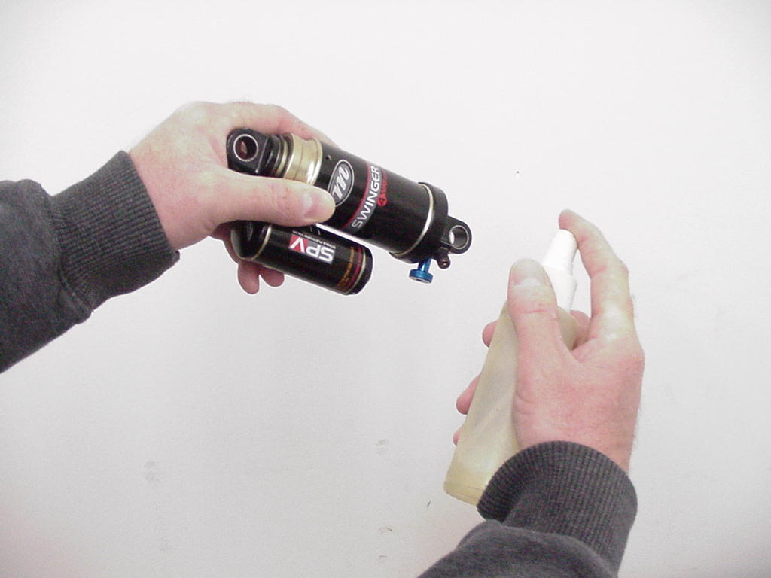
2. For leaks at the adjuster eyelet or damper end of the air canister, refer to the detailed disassembly instructions contained in the section on Damping System Bleeding - Swinger Air. This will guide you on how to replace the applicable o-rings and seals.  3. For leaks at the Schrader valves, release all air pressure and replace the Schrader valve core or assembly as needed. The core is removed using a standard core removal tool. The assembly is removed by removing the core and unscrewing the assembly by inserting a 3mm hex into the center of the valve.  4. For leaks in the air preload reservoir area (4W Swinger), release all pressure replace the preload adjuster o-ring, Schrader valve core, or Schrader assembly as needed. | 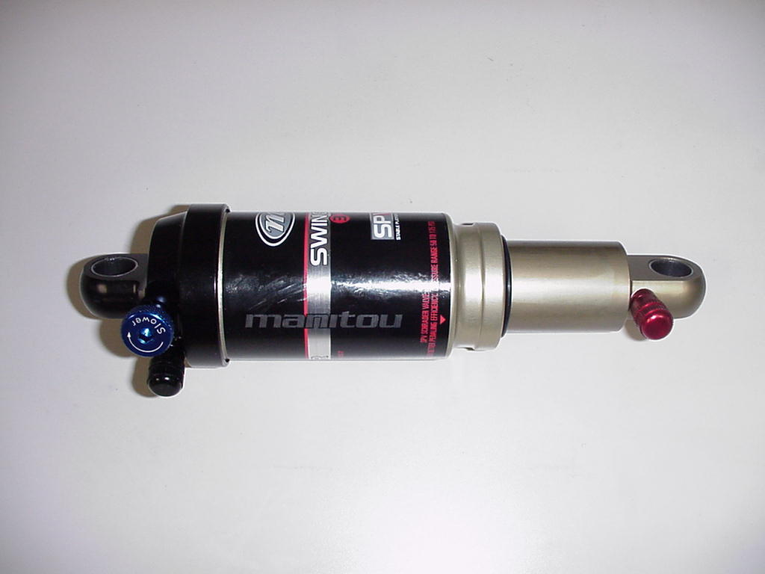  Adjuster Eyelet SPV Air Preload  (Air Spring)Schrader  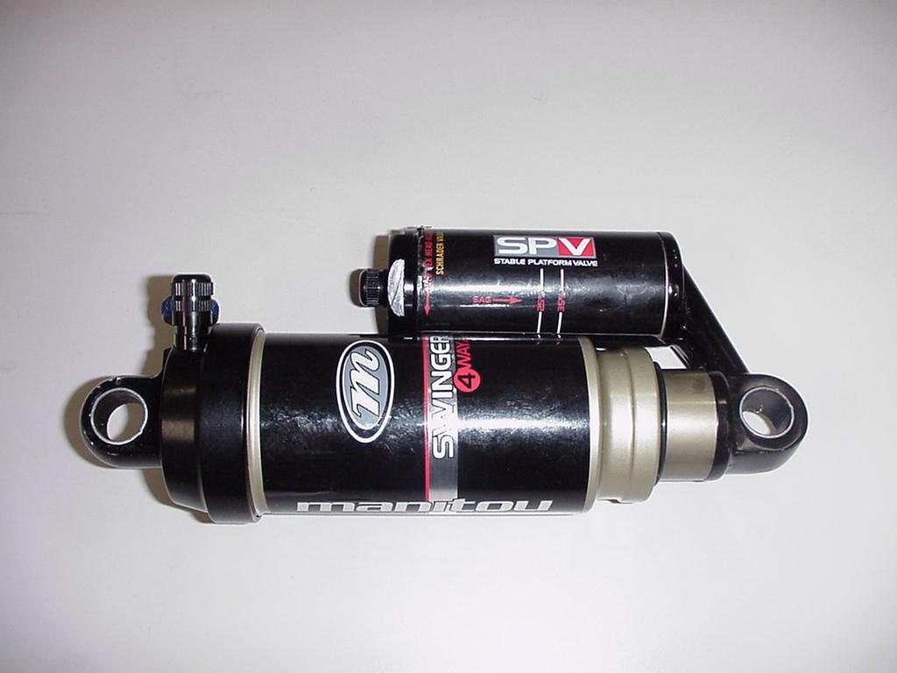

AIR SPRING SYSTEM AND SPV AIR PRELOAD, SWINGER AIR (CONT.)

5. If when you pressurize the air canister the shock collapses to its shortest travel position, the shock has an air piston leak into the negative chamber. Place the shock in the shock tester and extend it to its full travel. Depress the adjuster eyelet Schrader while the shock is extended under load. If it remains in the full travel position, refer to the section on Damping System Bleeding - Swinger Air for instructions on servicing the air canister and piston seals.

6. If the shock returns to the short travel position, it is not serviceable and the entire shock must be replaced.

WARNING: Attempting to service a shock with this condition could result in injury or possible death.

SECTION 5: COMPLETE SHOCK LESS MOUNTING HARDWARE AND COIL SPRING

The highest-level kit offered will be a complete shock, without mounting hardware or coil springs for coil forks. This kit is offered as a fast replacement where all that is need is to change out the hardware and spring and then reinstall the shock.

Swinger Air – Less Mounting Hardware  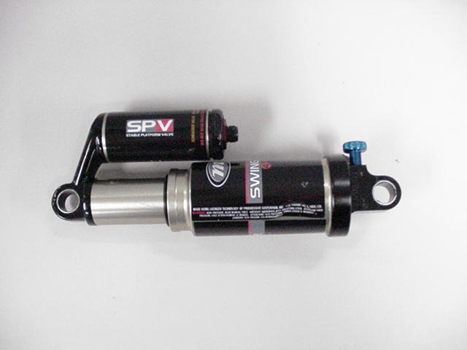 | Swinger Coil – Less Mounting Hardware and Coil  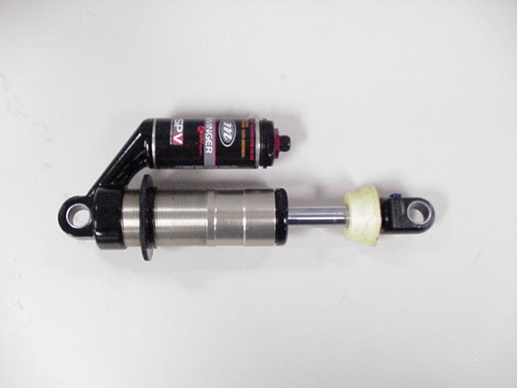

SECTION 6: MOUNTING HARDWARE REMOVAL AND INSTALLATION

Mounting hardware is used to mount shocks to the various frame configurations. Over time, the hardware may wear between the mounting bolts or DU Bushing which will result in play in the connection.

Remove hardware using pliers as shown in Figure 1 DU Bushing Eyelet

.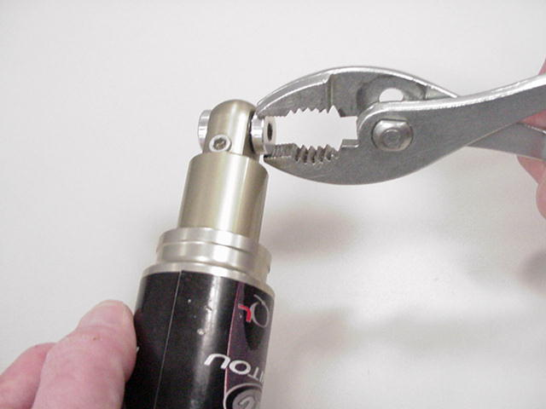 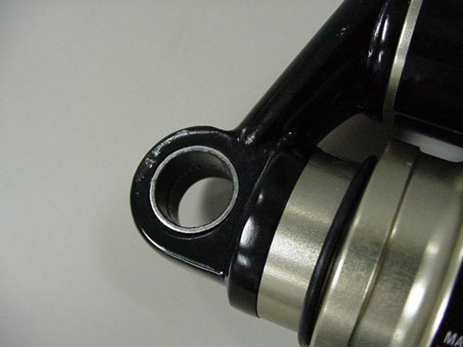
Figure 1 Figure 2

MOUNTING HARDWARE REPLACEMENT

Hardware should have a slight press fit into the DU bushing and can be tapped in place with a rubber mallet or soft jaws in a vise. Apply a small amount of thick grease such as Motorex Bike Grease 2000 (PN 85-0033) to the hardware before installation.

There are virtually an infinite number of hardware combinations in use on bikes today. When ordering hardware from Answer Products, It will be necessary to identify the eyelet width, overall width and mounting hole diameter.

MOUNTING HARDWARE REPLACEMENT (CONT.)

- Measure the hardware width.  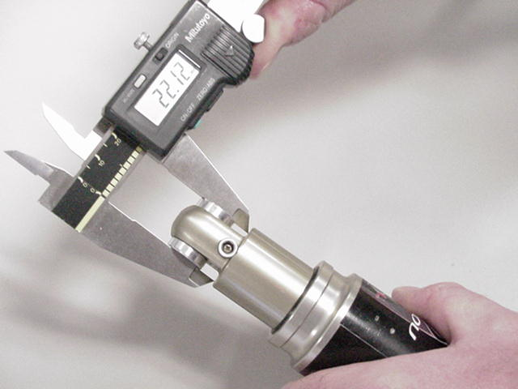 | - Measure mounting hole size. Current hardware is typically designed to accept a 6mm or 8mm fastener.  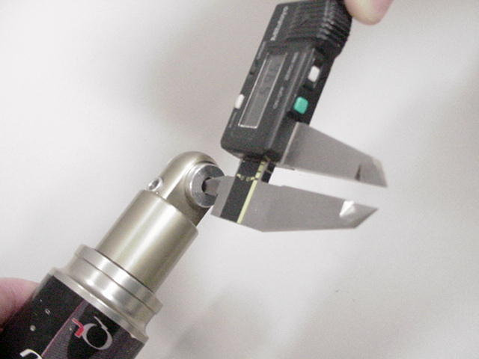

SECTION 7: DU BUSHING REMOVAL AND INSTALLATION

DU bushings are press fit into the shock eyelets at each end of the shock. The hardware fits into the bushings and will rotate slightly within the bushing during suspension compression. DU Bushings, like hardware, may wear over time. Removal and installation is accomplished using tool PN 85-6075.

REMOVAL  - Remove hardware from the shock.  - Insert unthreaded end of punch into the removal tool first and screw in about half a turn.  Punch | 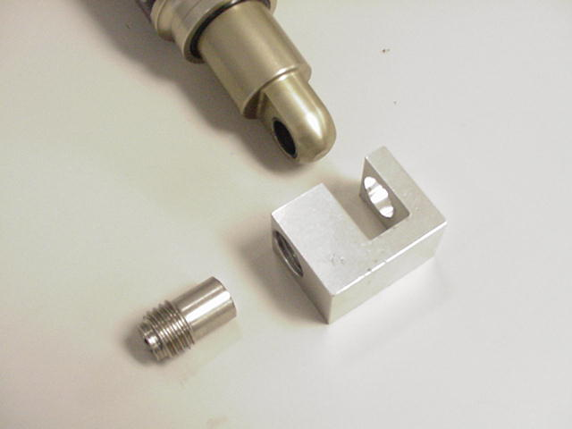
- Clamp removal tool in vise.  - Insert eyelet into tool.  - Use 6mm hex wrench to screw in punch, making sure that it is centered on the bushing. This will press out the bushing. | 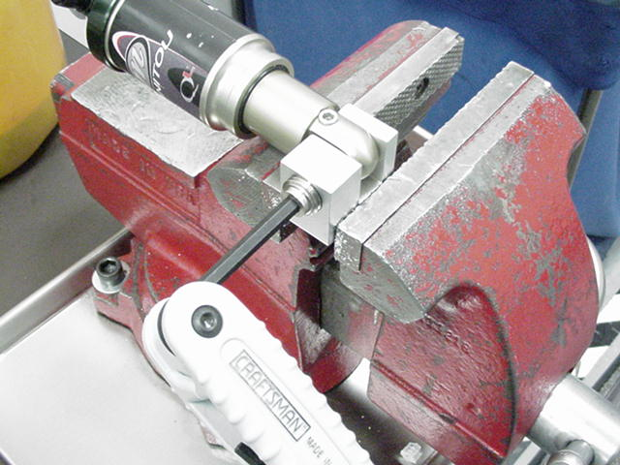
INSTALLATION  - Place a bushing onto the threaded end of the punch and into the removal tool; screw in about half a turn.  Bushing | 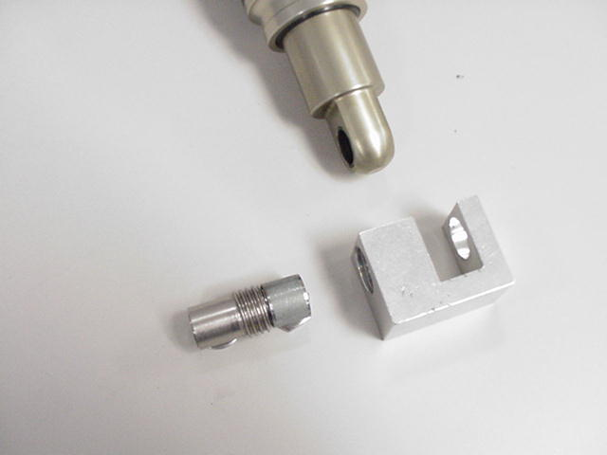
- Clamp removal tool in vise.  - Insert eyelet into tool.  - Use 6mm hex wrench to screw in punch, making sure that it is centered on the bushing and that the bushing is centered to the eyelet. This will press in the bushing. | 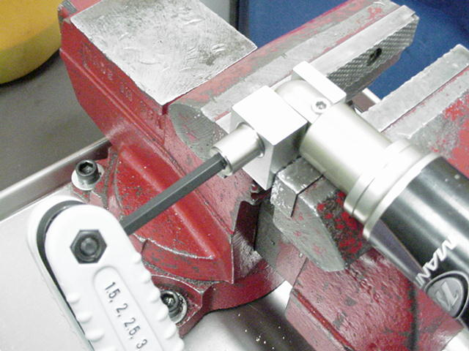

SECTION 8: RIDE KITS

Ride kits (Coil Swinger only) consist of a replacement spring of a specific spring rate that is firmer or softer depending on the rider's preference. Most manufacturers using Swinger Coil shocks vary the stock spring rate that is the standard offering based on frame size. Larger frame sized have higher spring rates to accommodate bigger riders. Due to the wide variety of frame geometry in use, it is left to the rider to determine if they are satisfied with their stock spring rate.

Spring rates and travel/stroke are marked on the outside of each spring.

Example: "300 X 2.75" Is a 300lb spring for a 2.75" Travel Shock

To change out the coil spring:  - Turn the spring preload adjustment ring to release any preload and back it away from the spring as far as possible.  - Remove the retaining collar.  - Slide spring over eyelet. You may need to turn the rebound control knob in clockwise to its fully closed position. NOTE: Model year 2003 Swingers use a rebound knob that can be removed by taking out a hex screw. Do not attempt to remove the 2004-2005 rebound knobs by unscrewing the 3mm hex in the knob, it will break.  - Slide the new spring over the eyelet.  - Reinstall the spring collar so that it butts against the eyelet, and the spring nests in the appropriate groove.  - Turn the spring preload adjustment ring until it contacts the spring and then apply 2mm of preload. | 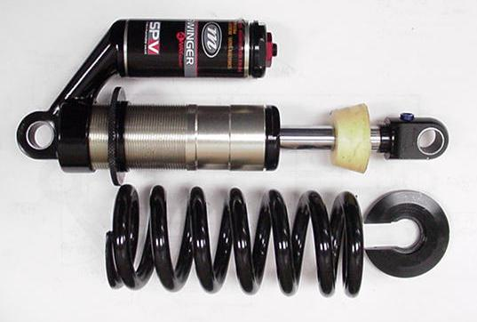  Retaining Collar  Spring Preload Adjustment Ring

SECTION 9: BOTTOMOUT BUMPER REPLACEMENT, SWINGER COIL

WARNING: The Swinger Shock uses compressed air to provide fluid pressure in the damping system. The damping system must be relieved of pressure prior to servicing. Failure to relieve air pressure could result in injury or possible death.

1. Remove hardware as shown under HARDWARE REMOVAL and remove Spring as shown under RIDE KIT Section.  2. Release reservoir pressure from the air preload. | 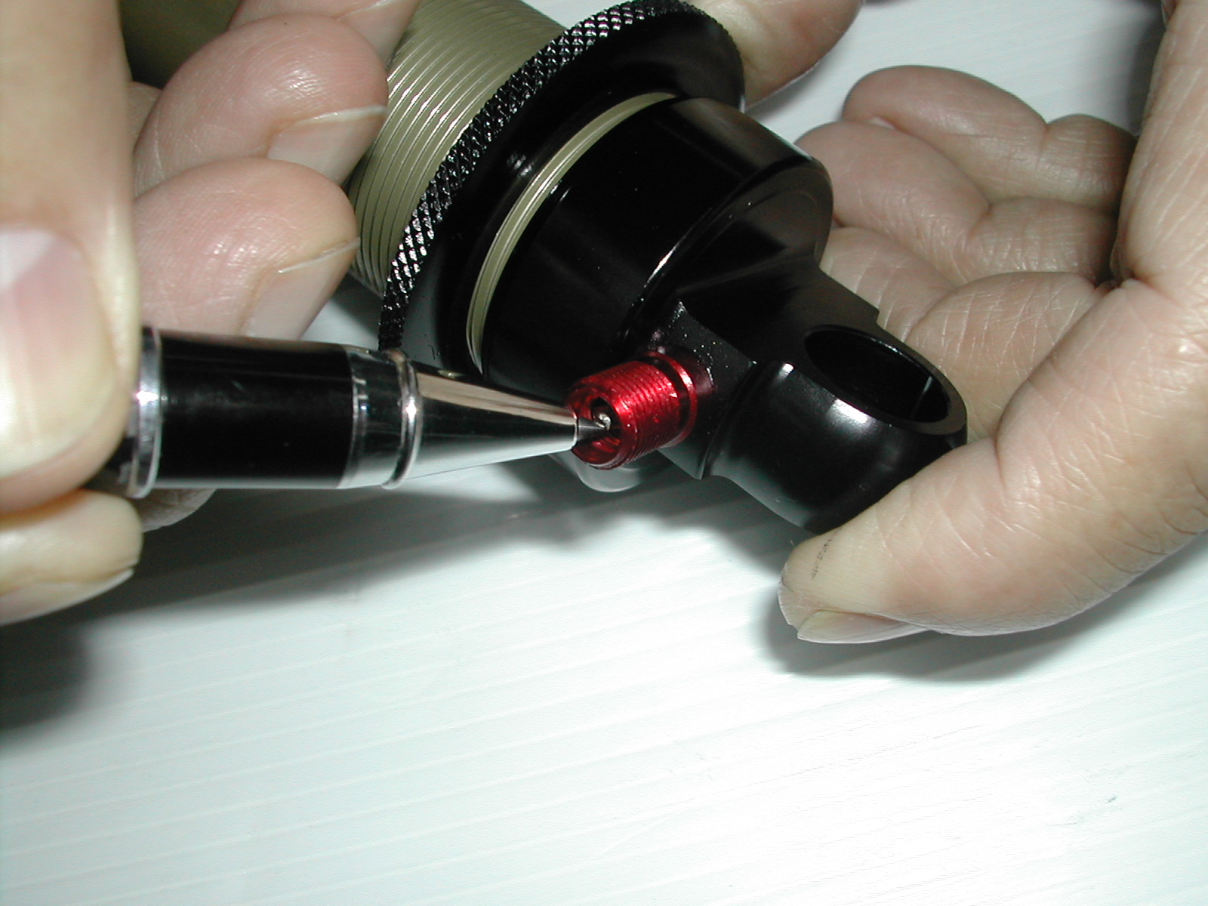  SPV Air Reservoir 3W Swinger Coil  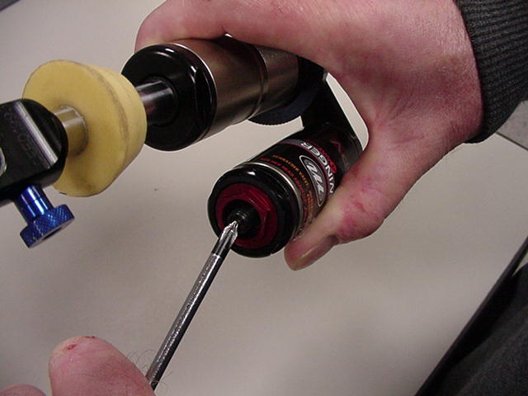  SPV Air Reservoir 4 & 6W Swinger Coil
3. Extend and clamp damper shaft in a vise using 12.7mm (.500) soft jaws, Answer PN 85-5148  4. Remove eyelet using adjustable open-end wrench. | 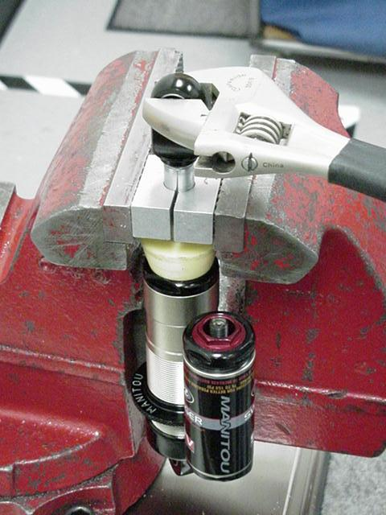
- Slip off old bumper.  - Install new bumper, Larger diameter face of the bumper should face the eyelet  - Clean damper shaft threads with alcohol and apply Blue Loctite.  - Install damper shaft in vise using soft jaws as shown above and torque per Table 1.  9. Add air to re-pressurize the air preload reservoir per instructions in the Owner’s Manual. | 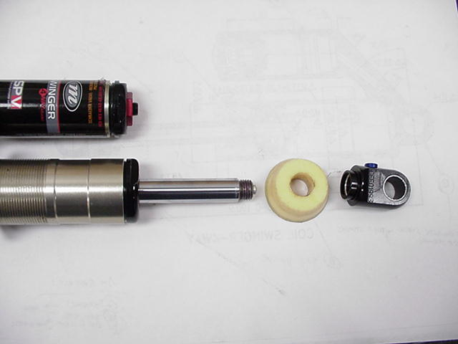

SECTION 10: REBOUND ADJUSTER KNOB REMOVAL AND INSTALLATION, SWINGER COIL

Instructions in the 2004 Swinger Shock Owners Manual were incorrect when it stated that the rebound knob had to be removed to replace shock springs. Turning the knob to its full clockwise setting is sufficient to provide clearance for removal.

Removal  1. Remove control eyelet as shown under Bottom out Bumper Replacement, Swinger Coil.  2. Remove 1.5mm hex set screw located under the control eyelet with the set screw pointed up. Underneath the set screw is a spring and detent ball bearing. Turn the eyelet over on a cloth rag and tap the eyelet to dislodge the spring and ball.  3. Unscrew the rebound knob from the eyelet. | Rebound Knob  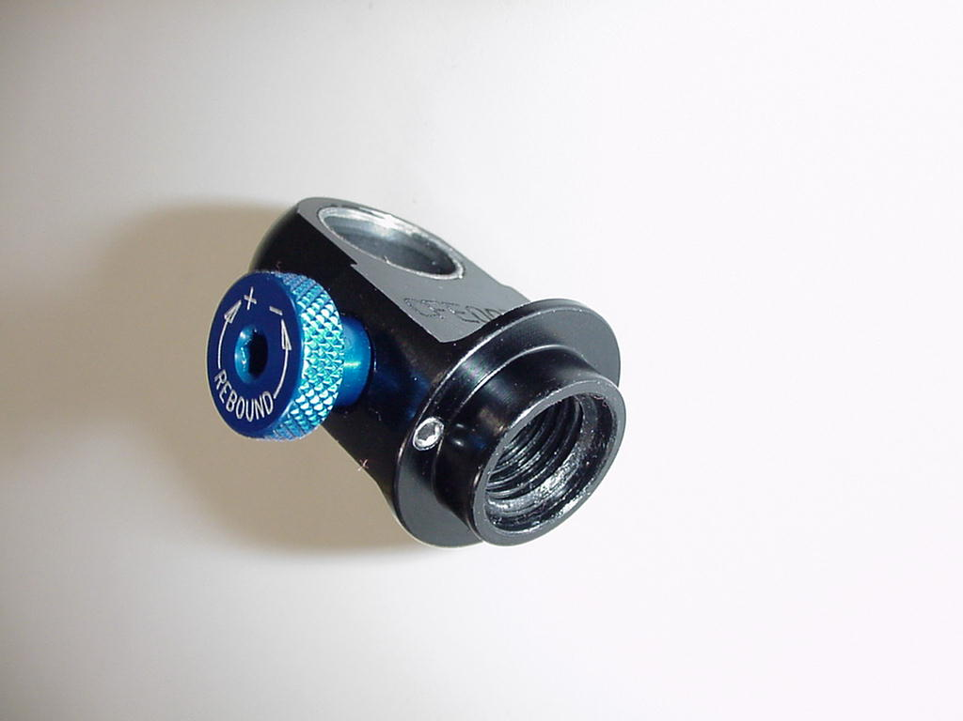  Set Screw
Installation  1. Installation is in reverse order. Place a small amount of grease on the ball and rebound knob detents. Screw in the knob and place the ball and spring in the set screw hole.  2. Apply a small amount of blue Loctite to the set screw threads. Screw in the set screw until it is flush with the eyelet. | Set Screw Spring Detent Ball  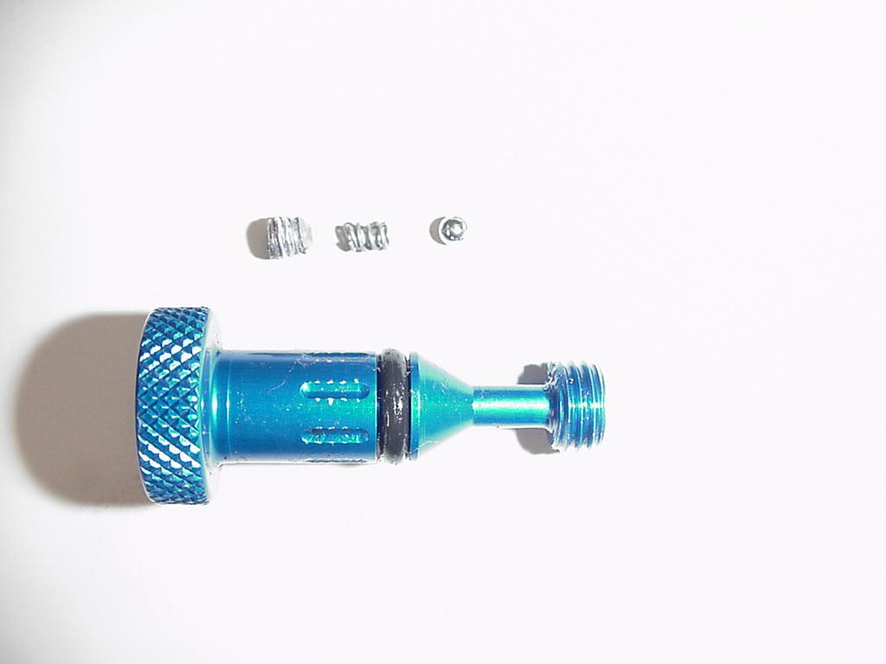  Knob Detents

SECTION 11: DAMPING SYSTEM

The damping system controls compression and rebound rate (speed). The system also provides the peddling platform unique to shocks with the SPV technology. The main conditions requiring service you may encounter in regards to the damping system are leaks, a suspect SPV, broken rebound adjuster knob, or lose damper or reservoir body.

SPV VALVE INSPECTION

If you are unable to achieve the pedaling platform after adjusting the shock per the Owner's Manual, you will need to inspect the SPV. Follow the instructions under the damping bleeding section for the shock in question in order to inspect the SPV.

LEAKS

If oil is found to be leaking from the shock, the seals and/or o-rings that seal that suspect joint must be serviced. Once the system has lost oil, the faulty seals must be replaced and the shock bled to restore the shock to full performance.

LOOSE DAMPER OR RESEVOIR BODY

All Swinger service can be performed without removing the damper or reservoir bodies where they are threaded into a machined casting. This joint is bonded in place during final assembly at the factory. If either becomes loose during service, remove the body, and thoroughly clean the threads on each part. Apply green Loctite the threads and use the Answer reservoir clamp PN 85-6037 to tighten the bodies.

SECTION 12: DAMPING SYSTEM BLEEDING - SWINGER 3 WAY COIL SHOCKS

WARNING: The Swinger Shock uses compressed air to provide fluid pressure in the damping system. The damping system must be relieved of pressure prior to servicing. Failure to relieve air pressure could result in injury or possible death.

1. Remove hardware as shown under HARDWARE REMOVAL and remove Spring as shown under RIDE KIT Section  2. Release SPV pressure from the air preload. | SPV Air Preload

DAMPING SYSTEM BLEEDING - SWINGER 3 WAY COIL SHOCKS (CONT)

3. Unscrew control eyelet and damper shaft assembly using an adjustable open-end wrench. Pour out damping oil and discard. | Control Eyelet Damper Shaft Assembly  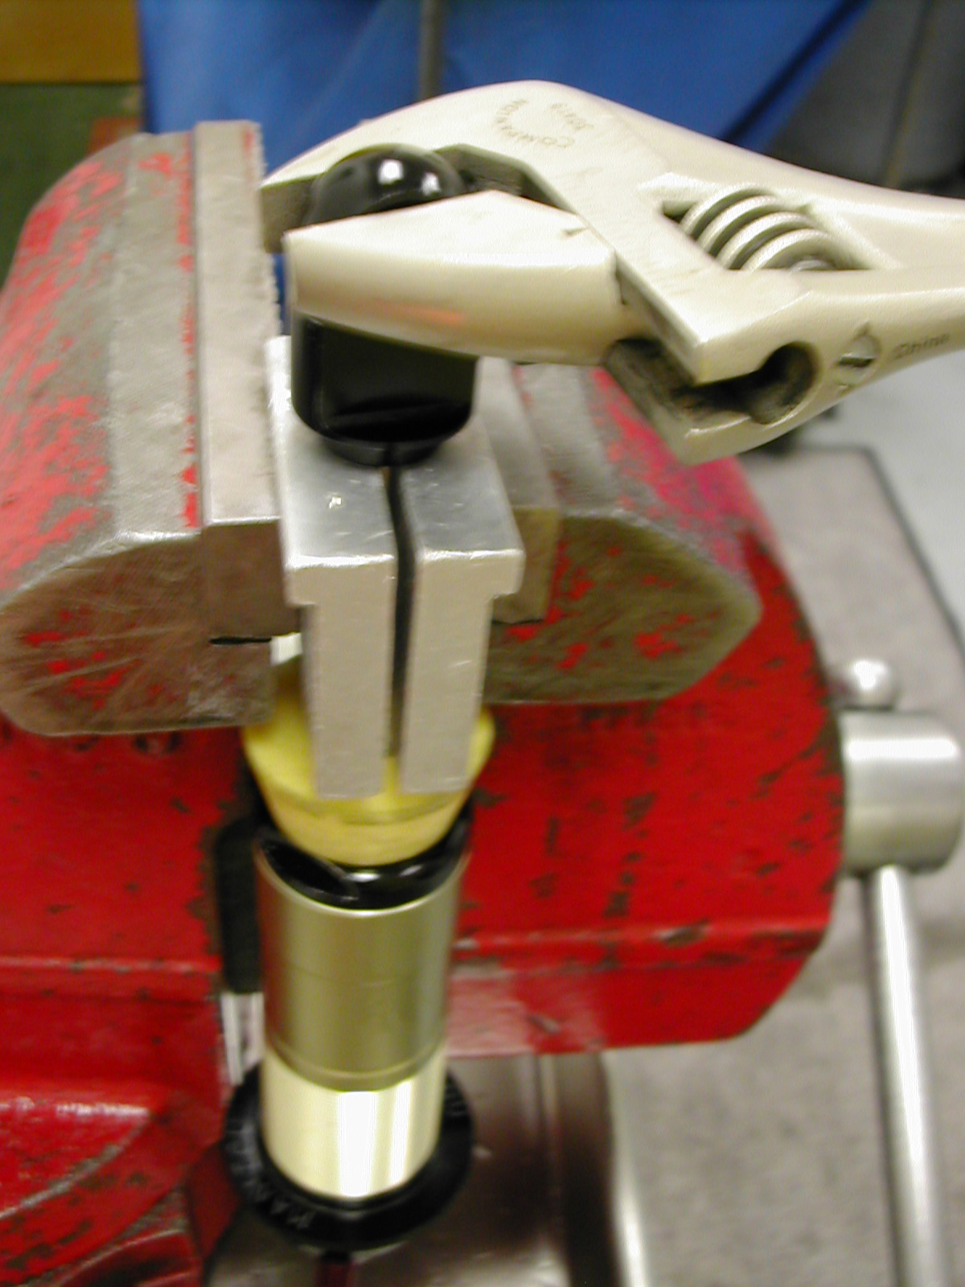
4. Using pliers, remove the rebound adjuster needle from end of the damper shaft. | 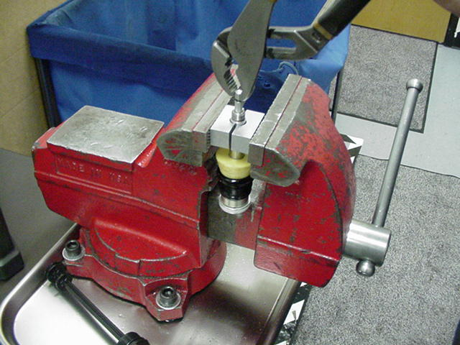
5. Inspect SPV valve, there should be a .025 (.6mm) gap as shown in the photograph adjacent to the damper piston. If the gap is on the opposite side, the valve is defective and will need to be serviced. See service instructions in the section on DAMPING SYSTEM BLEEDING - Swinger Coil Shocks with Reservoirs | 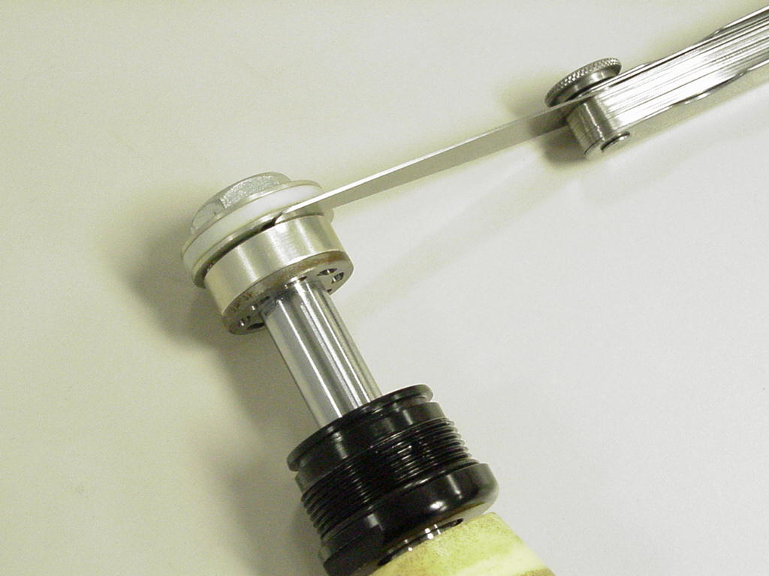
6. Remove IFP (Internal Floating Piston) using a shock pump to pressurize the damper body. Point the damper body away from you as you pressurize the body and expel the IFP  WARNING: This action creates backpressure behind the IFP to eject it. The reservoir body should not be pointed at anyone during this step. | 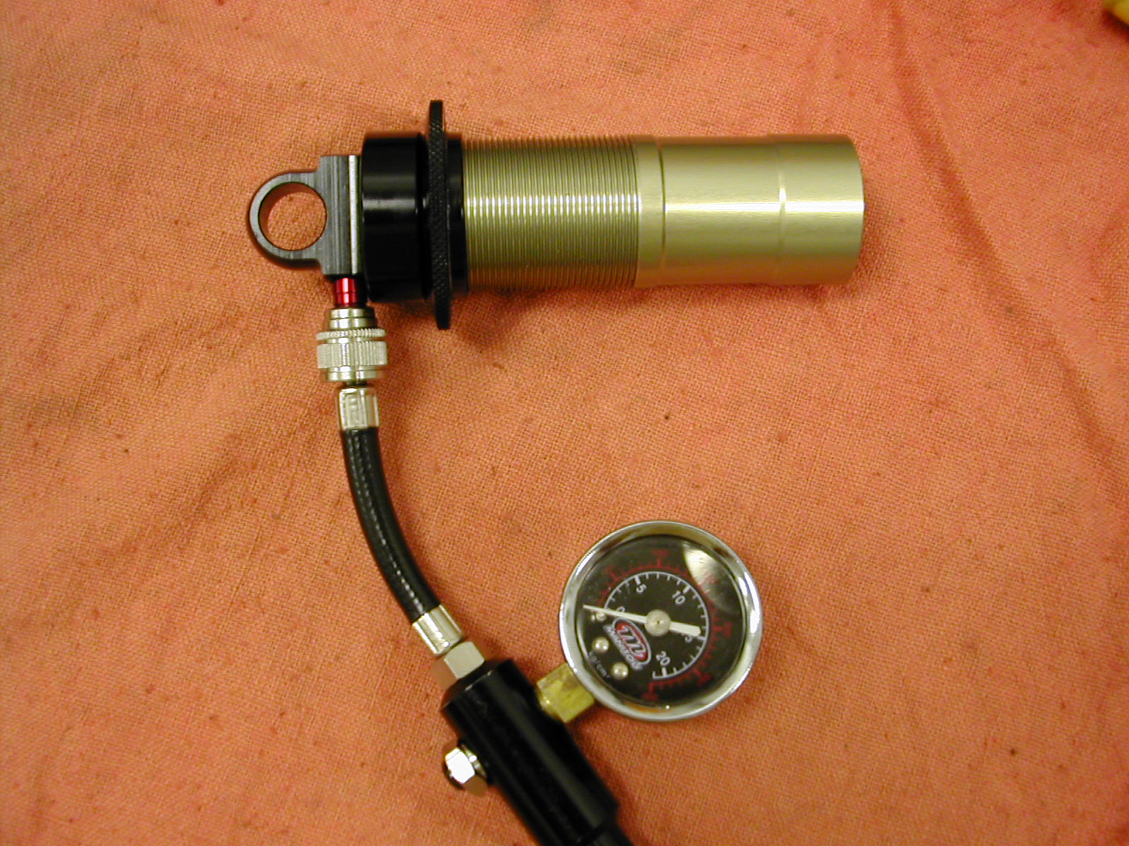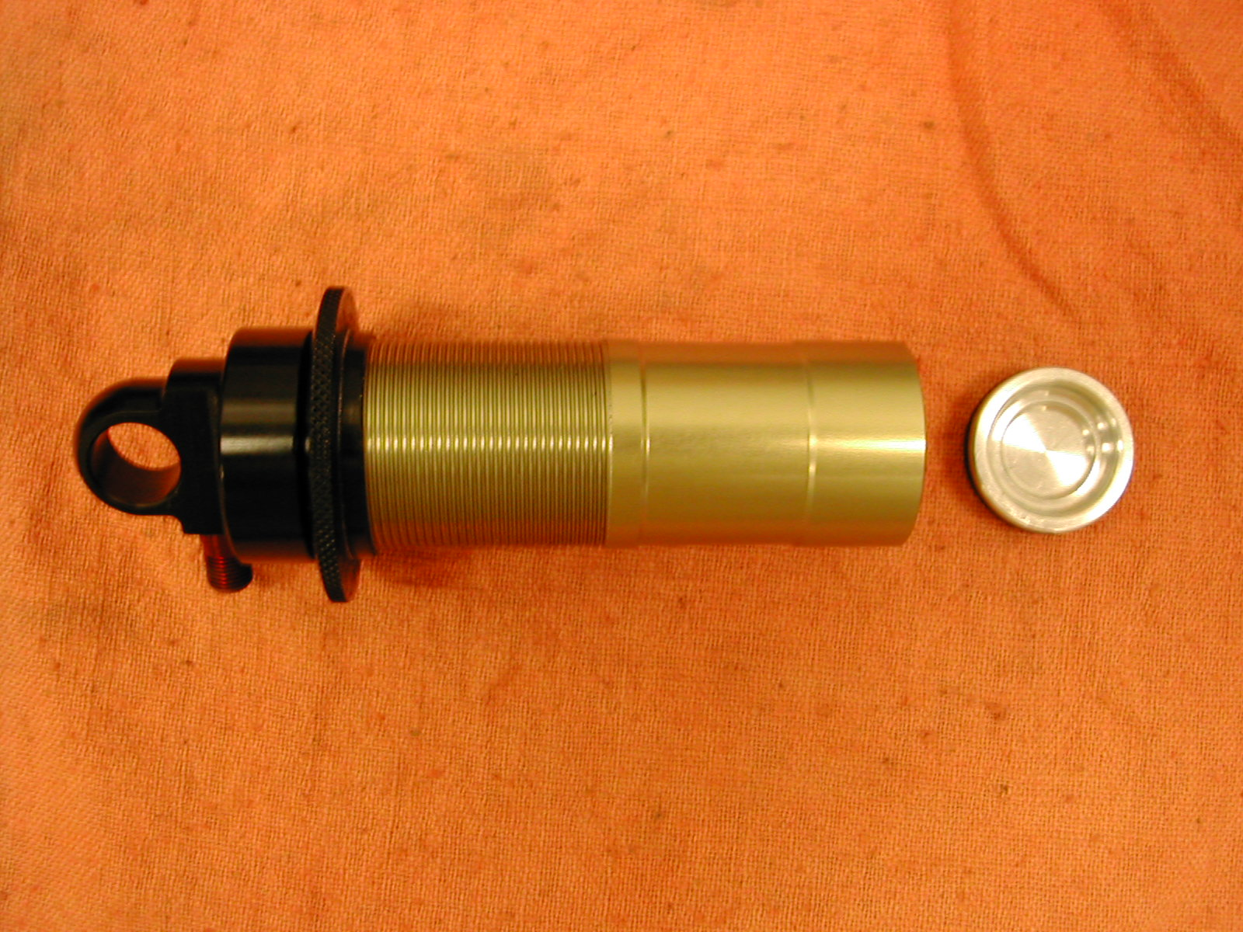

DAMPING SYSTEM BLEEDING - SWINGER 3 WAY COIL SHOCKS (CONT)

7. Replace external o-rings on damper cap and IFP. Grease with a thick grease such as Motorex Bike Grease 2000. | Damper Cap (2)  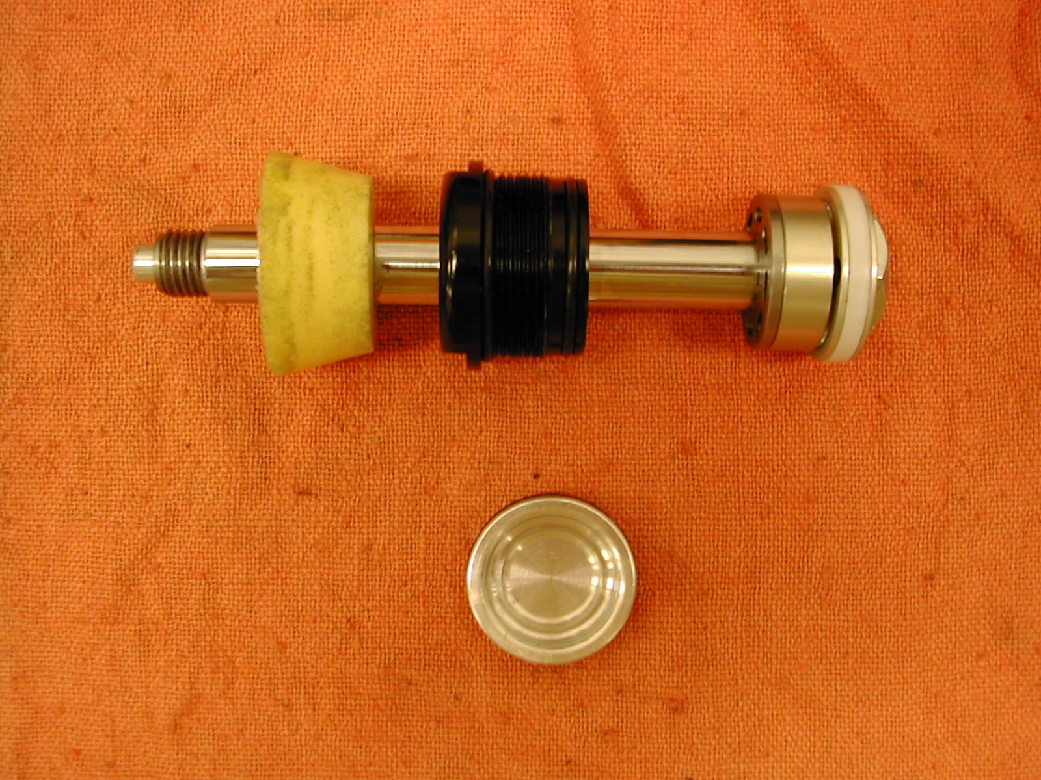  IFP
8. Remove valve core from the Schrader valve in the damper body. Reinstall IFP into the damper body. Push IFP to the bottom of the body. Replace the valve core in the Schrader valve. | 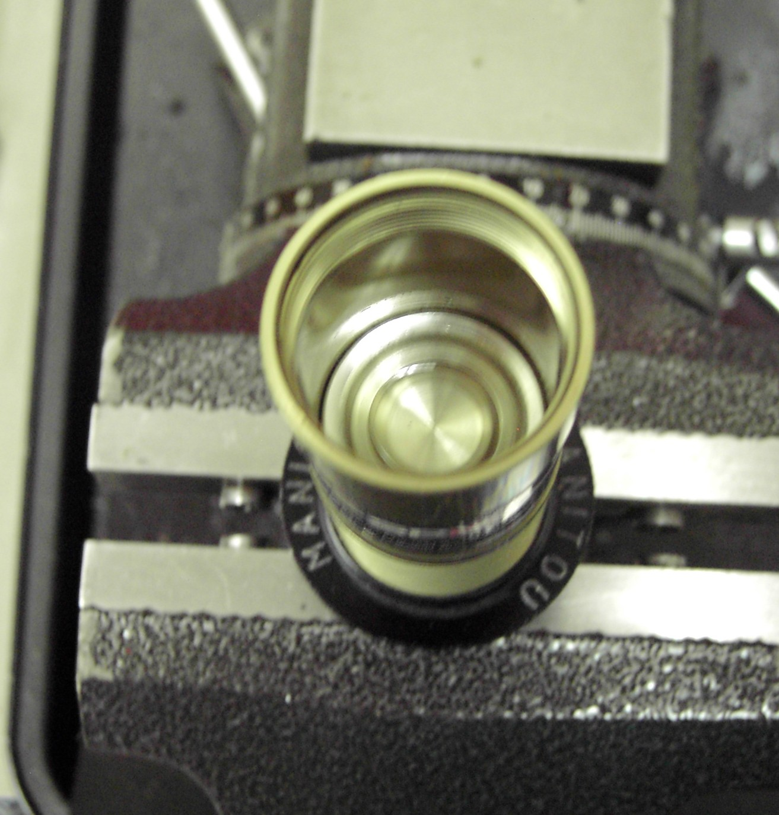
Note: The following bleed procedures will work on all year models of Swinger shocks.  - Slide damper cap on damper shaft assembly so that it is at the edge of the oil return port. Secure the damper body up right in a vise. Fill the damper body with 5wt. Motorex fork oil.  - Slowly insert damper shaft assembly into the damper body. Make sure there are no air bubbles stuck to the piston as it is submerged in the oil. A paper clip can help to dislodge any stubborn bubbles. Once the cap contacts the damper body screw it in and tighten it per to 61-78 in/lbs or 70-90Kg/cm.  - Compress the damper shaft until it protrudes from the damper cap 8.5mm when measured from the top of the cap to the top of the shaft. See Picture. | Damper Cap Oil Return Port  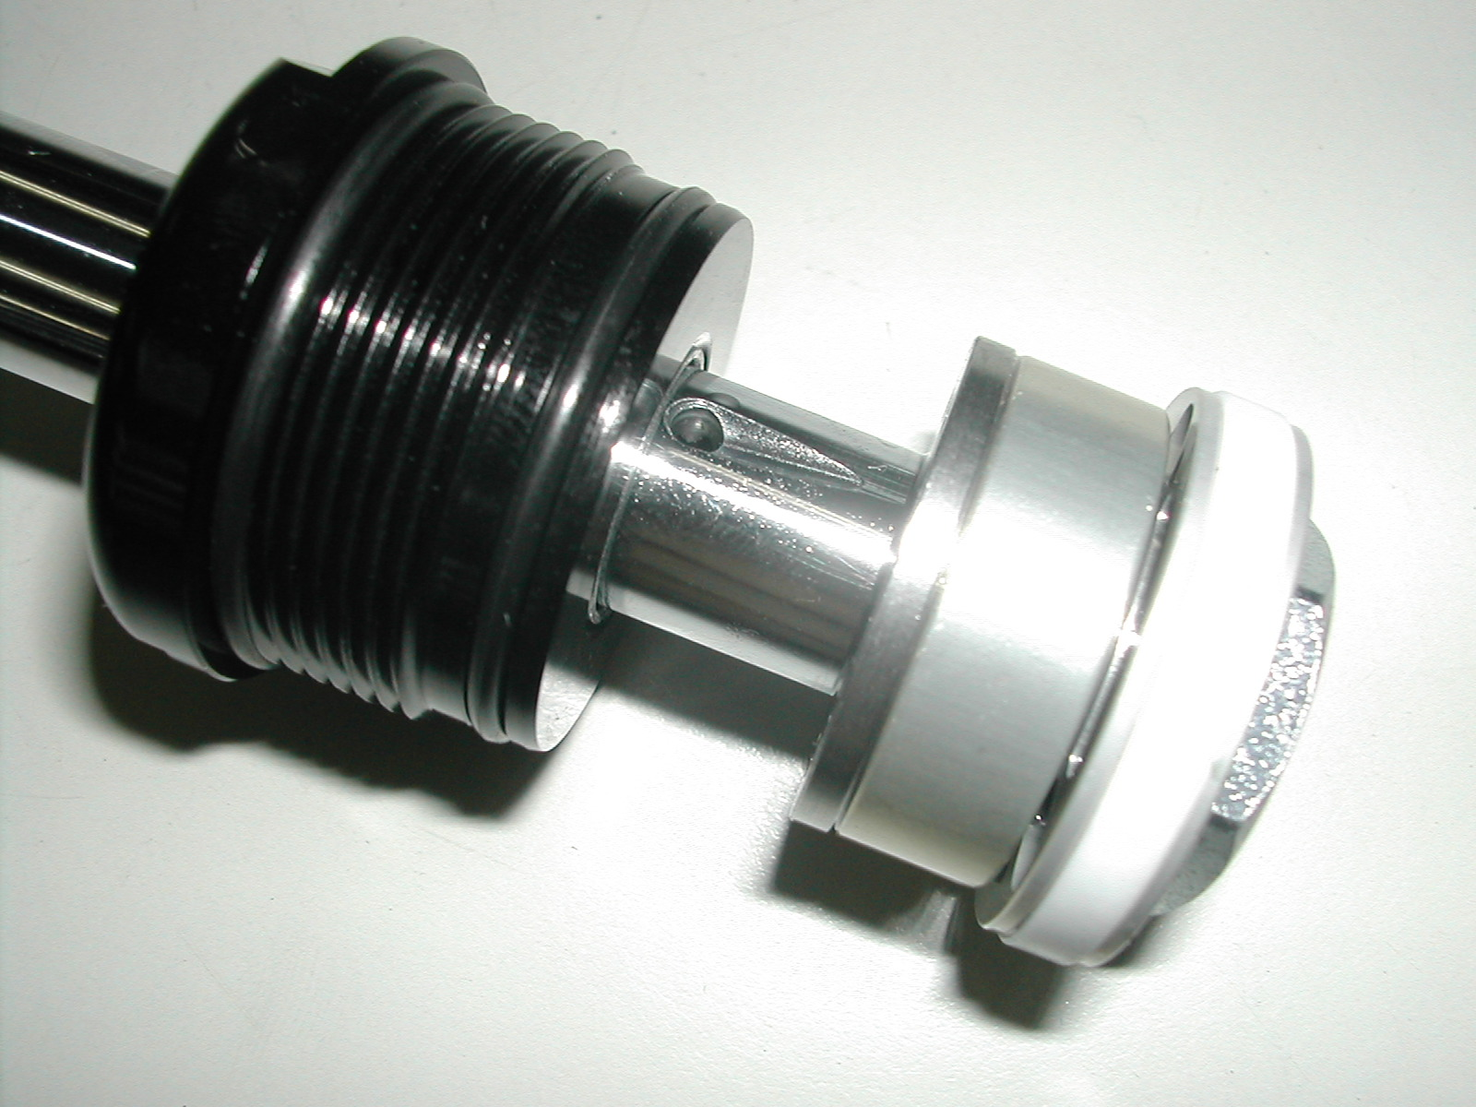  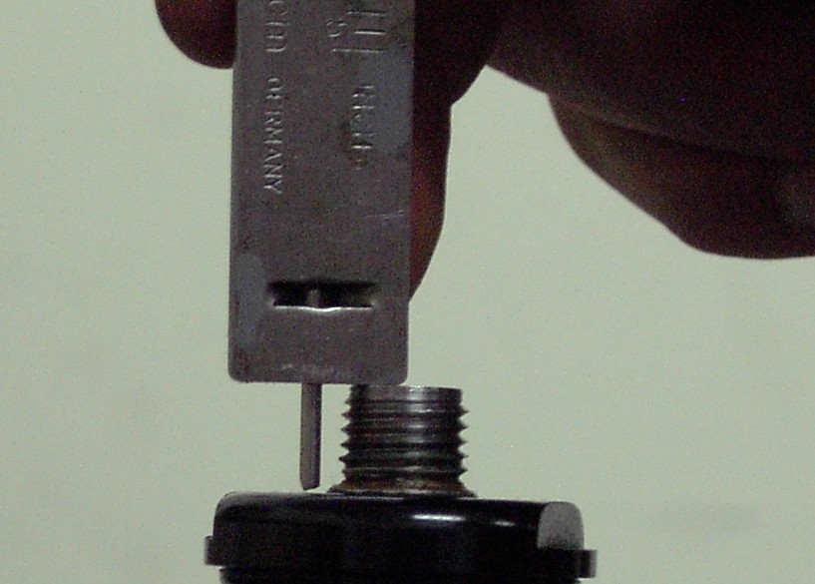

DAMPING SYSTEM BLEEDING - SWINGER 3 WAY COIL SHOCKS (CONT)
11. Remove the valve core from the damper body, and then insert the needle valve until the o-ring and the needle are fully seated. Holding the needle in position fully extend the damper shaft. Then reinstall the valve core in the damper body. | 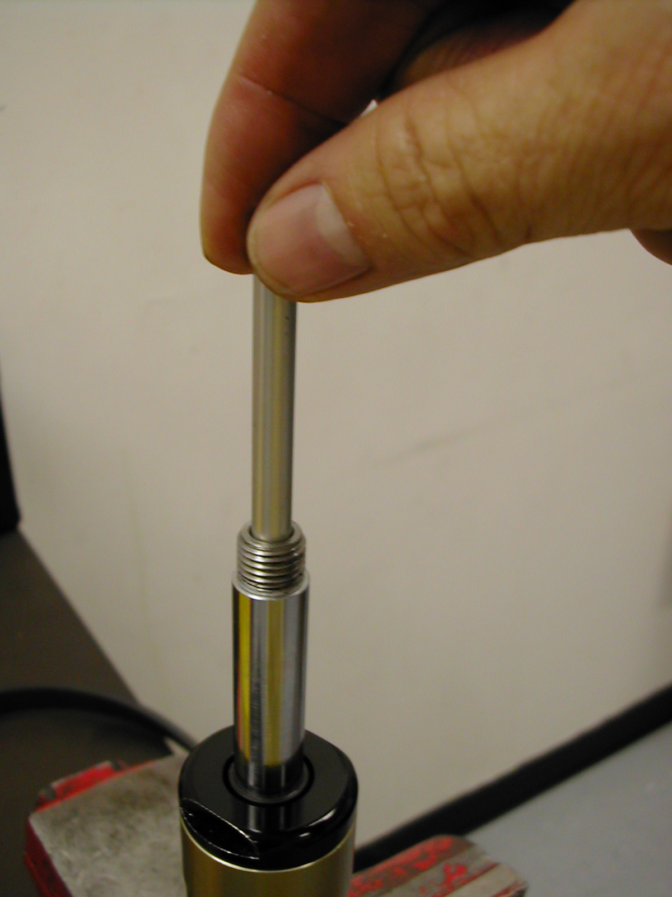
- The IFP is now set to the proper level. Install bottom out bumper and control eyelet as shown under the bottom out bumper Replacement section.  - Install spring as shown under Ride Kits.  - Pressurize the SPV chamber per the Owners Manual Guidelines. | 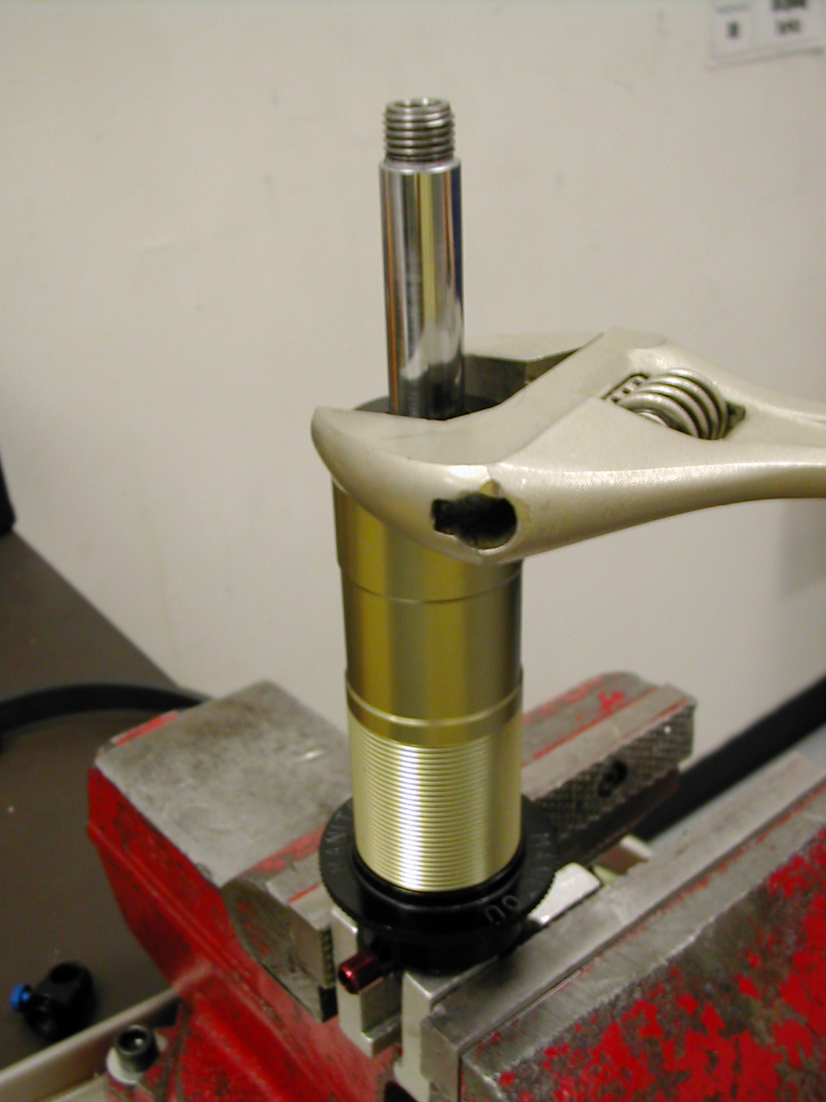

SECTION 13: DAMPING SYSTEM BLEEDING - SWINGER 4 & 6 WAY COIL SHOCKS

WARNING: The Swinger Shock uses compressed air to provide fluid pressure in the damping system. The damping system must be relieved of pressure prior to servicing. Failure to relieve air pressure could result in injury or possible death.

NOTE: Leaks from Low/High Speed Adjusters on Swinger 6 Way Shocks. The 6 Way adjuster knobs are adjusted using a 3mm (Early 2004 Models) or 2mm (Late 2004 Models) hex. If too much force is applied then the knob is adjusted counterclockwise, the adjuster needles may strip out and result in an oil leak. If this occurs during adjustment and the shock has not been compressed, the adjusters can be replaced without a complete teardown and bleeding of the shock. Follow the instructions in Step 10.
1. Remove hardware as shown under HARDWARE REMOVAL and remove Spring as shown under RIDE KIT Section
2. Release reservoir pressure from the air preload.
3. Unscrew air preload assembly and damper shaft assembly using an adjustable open-end wrench.  Damper Cap | Air Preload Assembly  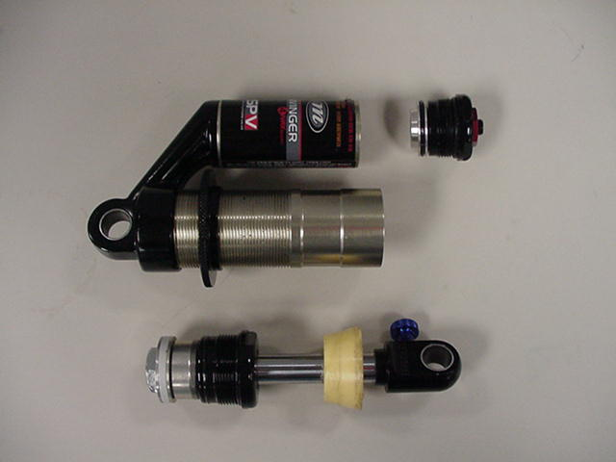  Damper Shaft Assembly
4. Inspect SPV valve, there should be a .025 (.6mm) gap as shown in the photograph adjacent to the damper piston. If the gap is on the opposite side, the valve is defective and will need to be serviced.

5. If it is necessary to remove the valve, clamp the damper shaft using soft jaws and loosen the damper piston bolt. Grasp the damper bolt, piston, SPV, and SPV backing plate and remove as a set from the damper shaft. | 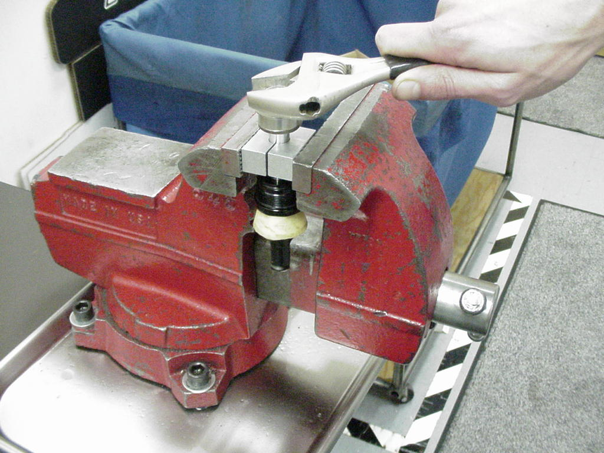
6. Remove the SPV backing plate and SPV. It is best to replace a defective valve.  If a replacement SPV is not immediately available you can attempt to service the defective one. However, since the valve has already failed once, there is no guarantee how long a repaired valve will remain functional. | Backing Plate  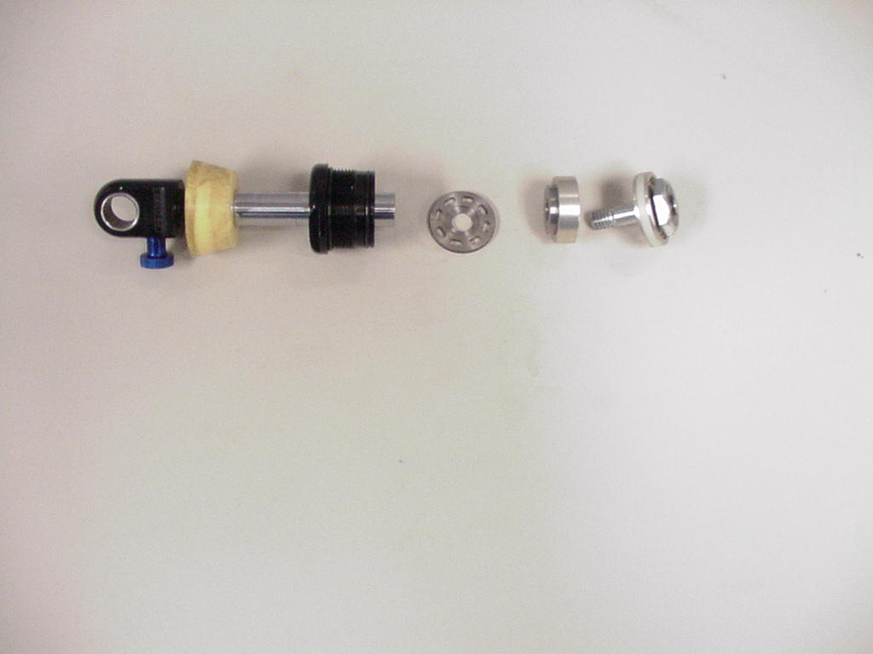  SPV
Separate the two halves as shown. Inspect the two seals for signs of damage. Grease seal surfaces and reassemble.  When reassembled, the valve will trap air inside and keep the two haves from nesting completely. A good valve when fully compressed to a flat condition will smoothly return to its original state .025 (.6mm) offset when released.  7. Remove the damper cap and replace the internal o-ring. Reinstall cap onto shaft and reassemble the SPV and damping piston stack in reverse order. Apply Loctite to damper piston bolt and torque per Table 1. | Inspect two seals for damage  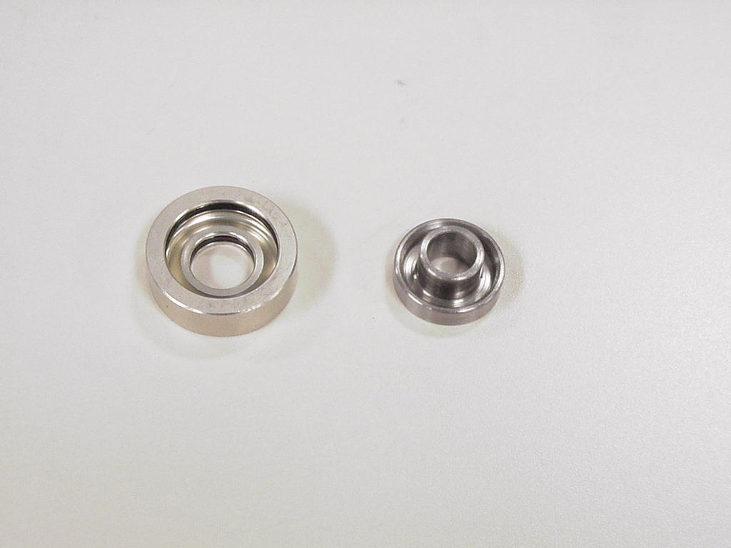
8. Remove IFP (Internal Floating Piston) using IFP removal tool. Insert the removal tool into the top of the damper body. Cover hole in tool with your thumb. Point the reservoir body away from you and push the tool to the bottom of the damper body.  WARNING: This action creates backpressure behind the IFP to eject it. The reservoir body should not be pointed at anyone during this step. | 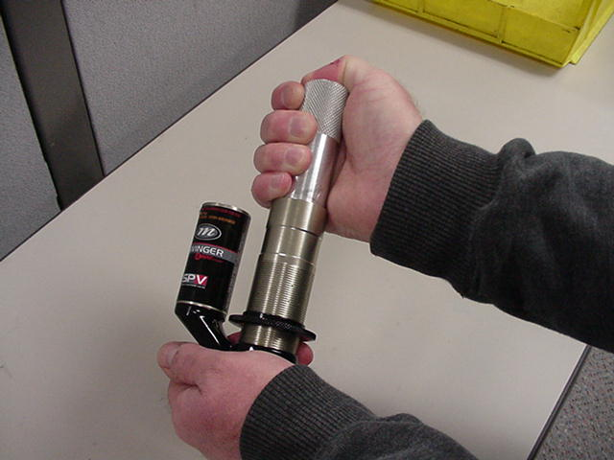
9. Replace external o-rings on damper cap, IFP, and air preload assembly as shown. Grease with a thick grease such as Motorex Bike Grease 2000. | IFP Air Preload (2)  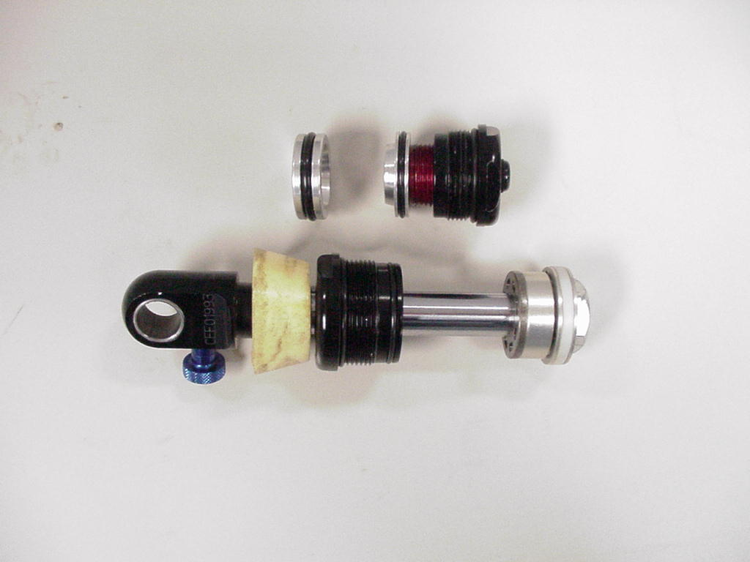  Damper Cap (2)
- If oil was leaking from one of the high or low speed compression adjusters on a 6 Way Swinger, the adjusters should be replaced, Do Not remove unless a leak was detected. Remove the two 1.5mm set screws found on the backside of the reservoir forging. Remove the adjuster needles using a 3mm hex (Early Model Year 2004) or 2mm hex (Late Model Year 2004), Pour a small amount of damping oil in each hole prior to replacing the needles. | 1.5mm Set Screws  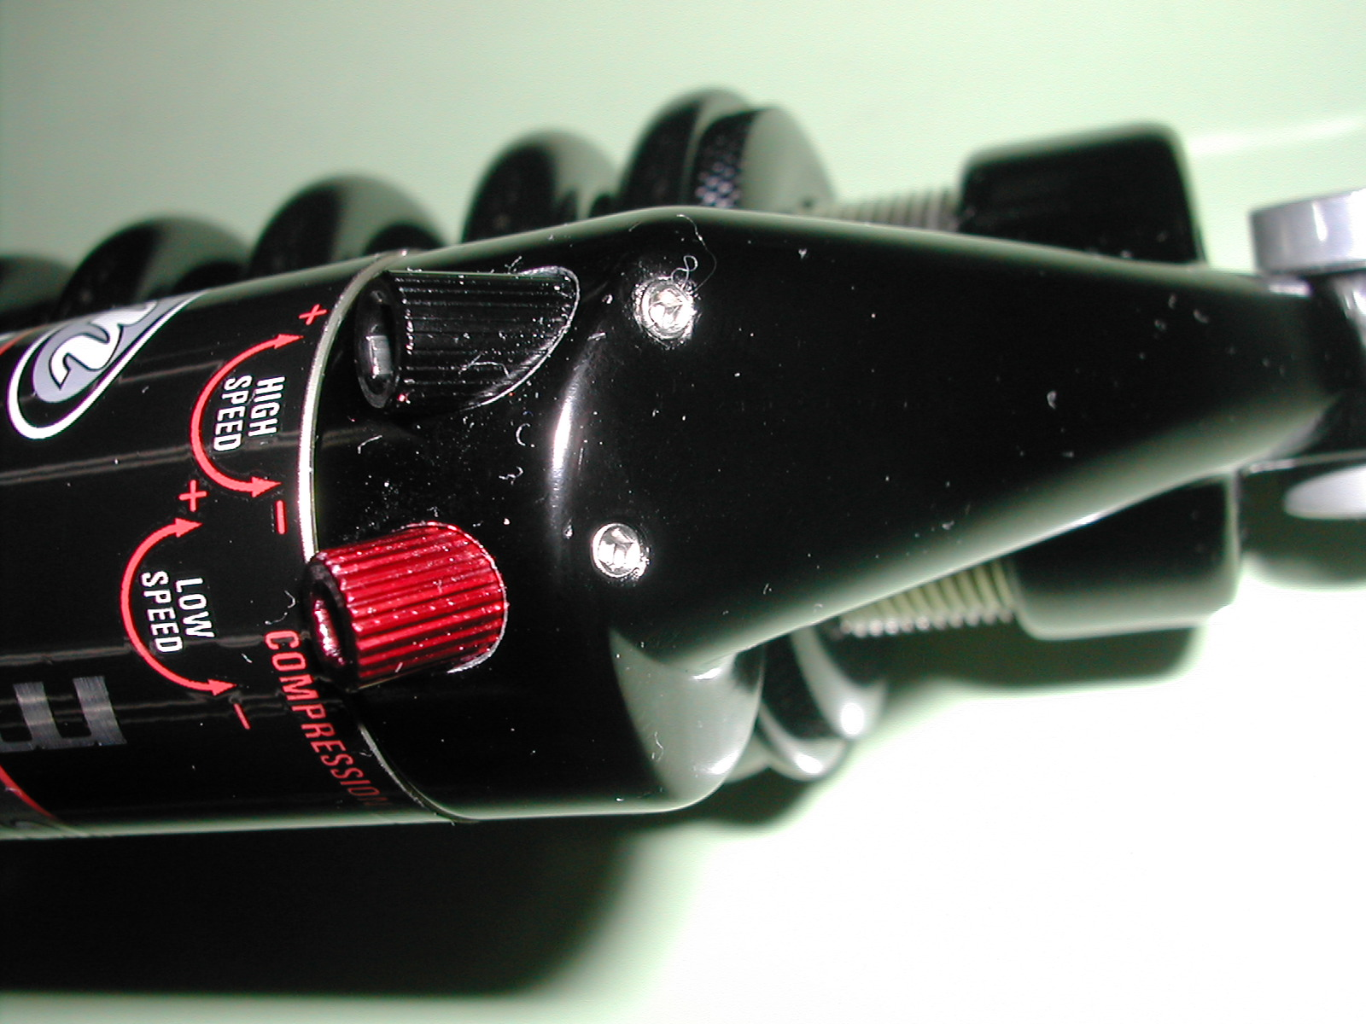  Low Speed Needle (Red)  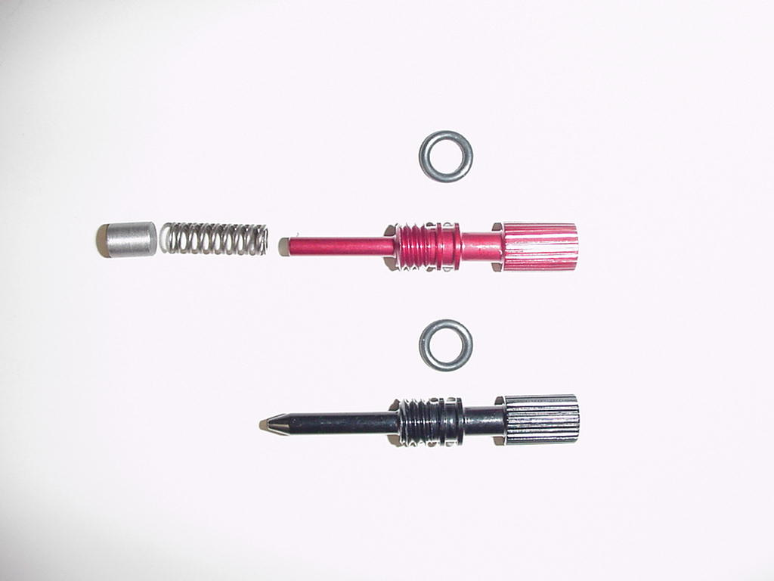  High Speed Needle (Black)
Replace in reverse order. As you screw in the needles use a 2mm hex to guide the needle o-rings past the set screw openings to prevent damage. Apply blue loctite #242 to the set screws prior to installation. Tighten the set screw until it makes contact with the needle and then back off 1/4 turn.  NOTE: Each adjuster needle is unique; replace one at a time to avoid confusion. | 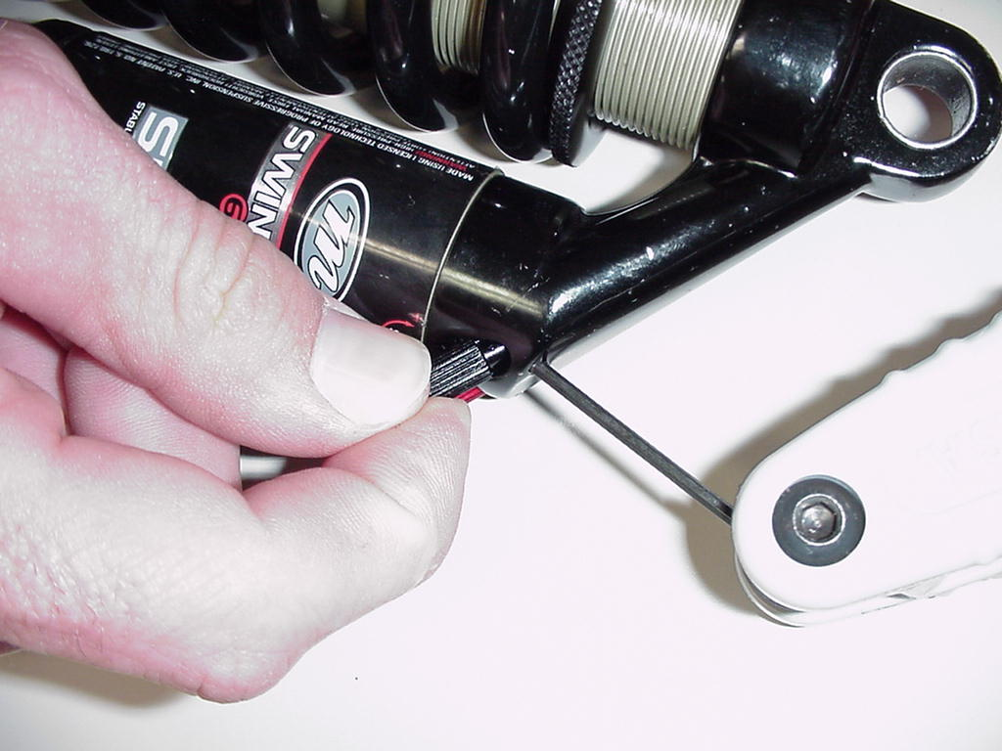
11. Remove Eyelet as shown under the section on BOTTOMOUT BUMPER REPLACEMENT | 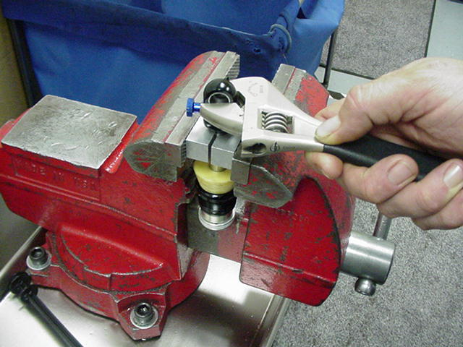
12. Using pliers, remove the rebound adjuster needle from end of the damper shaft. | Damper Needle
Note: The following instructions will work on all year model 4 and 6-way Swinger shocks.  13. Slide damper cap on damper shaft assembly so that it is at the edge of the oil return port | Damper Cap Oil Return Port

DAMPING SYSTEM BLEEDING - SWINGER 4 & 6 WAY COIL SHOCKS (CONT)

14. Fill body and reservoir with oil. On the 6-way shocks open the H/L circuits all the way. Using the IFP Removal tool cycle the oil thru the damping circuits between the main body and the reservoir. Top off the oil levels in the shock and the reservoir. Push the damper shaft back into the main body; tap the assembly to remove any air that maybe trapped in the ports of the piston. Once the end cap touches the shock body, screw it in and tighten it to 61-78in/lbs or 70-90 Kg/cm. Fully extend the damper shaft.

15. Top up the oil level in the reservoir. In a small container of oil tap the IFP to get the air out from under the o-ring insert the IFP into the reservoir starting at about a 45 degree so that you burp the air out of the piston cavity. Push the IFP past the threads in the reservoir. | 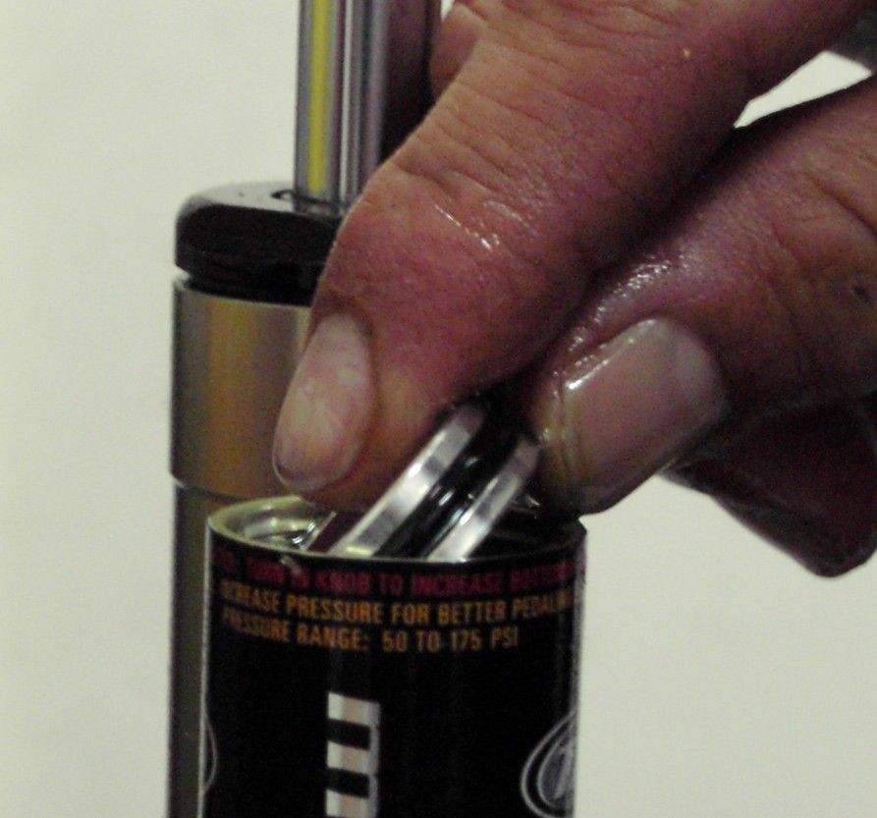
16. Back the IFP tool out fully as pictured, Using the IFP tool push the IFP piston fully into the reservoir. Screw the tool in hand tight until the flange is flush with the air reservoir body. Using a 6mm hex wrench, adjust the IFP Locating Tool so that the indicated travel matches the shock travel. Make sure that the travel indication line is flush to the top of the tool. | Travel Indicator lines  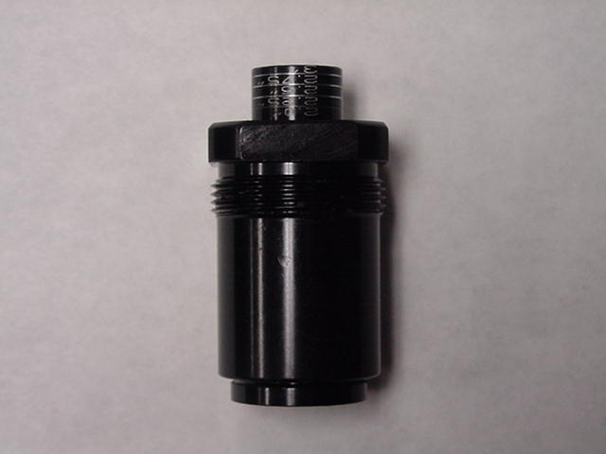
17. Install rebound adjuster needle, pointed end first. Push until the needle and o-ring seat firmly in the damper shaft. | 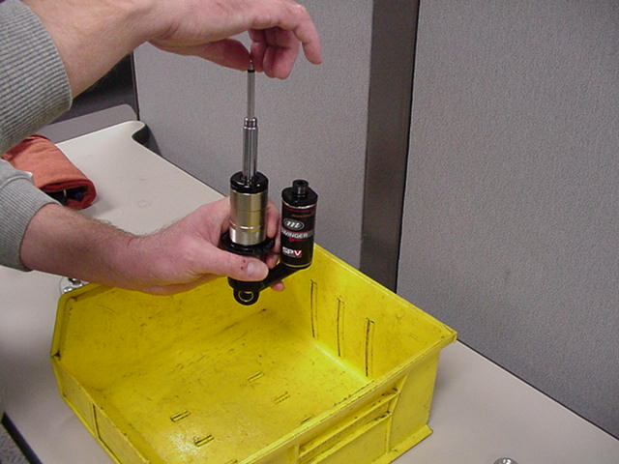

DAMPING SYSTEM BLEEDING - SWINGER 4 & 6 WAY COIL SHOCKS (CONT)

21. Install eyelet as shown under the section on BOTTOMOUT BUMPER REPLACEMENT. | 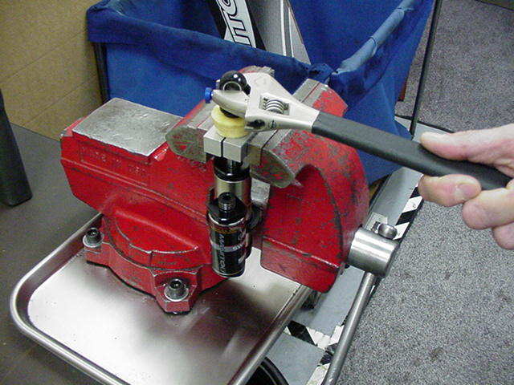
22. Remove the IFP location tool. Once the tool is removed DO NOT move the damper shaft | 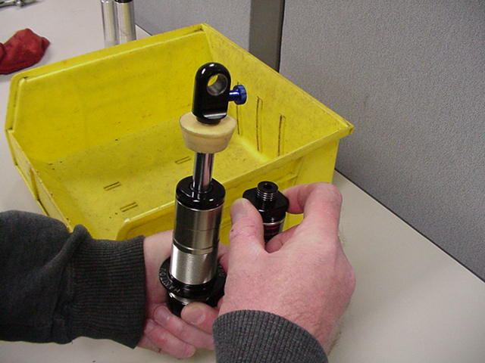
23. Apply blue Loctite to SPV air volume adjuster threads. Install the air preload adjuster and tighten to 43KgCm (50 in/lbs)  24. Add air to re-pressurize the air preload reservoir per instructions in the Owner’s Manual.  25. Reinstall spring using the instructions under RIDE KITS. | 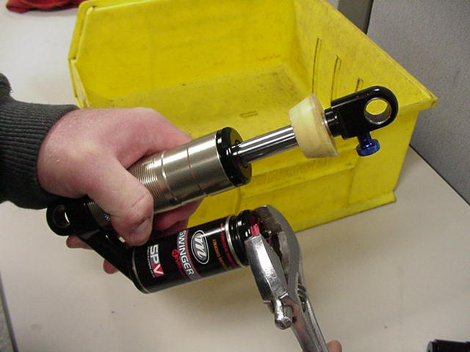

SECTION 14: DAMPING SYSTEM BLEEDING - SWINGER 3 WAY AIR SHOCKS

1. Release All air pressure from air canister (air spring) and SPV chamber.  2. Remove the SPV valve by removing valve core on the red SPV Schrader valve. Insert a 3mm hex wrench inside the valve and unscrew to remove.  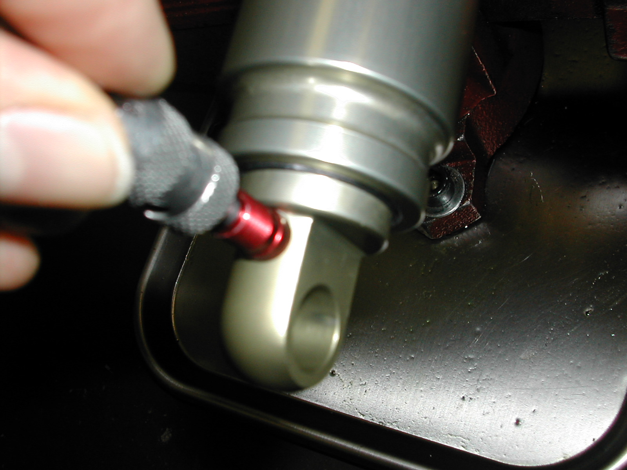  Valve Core Removal  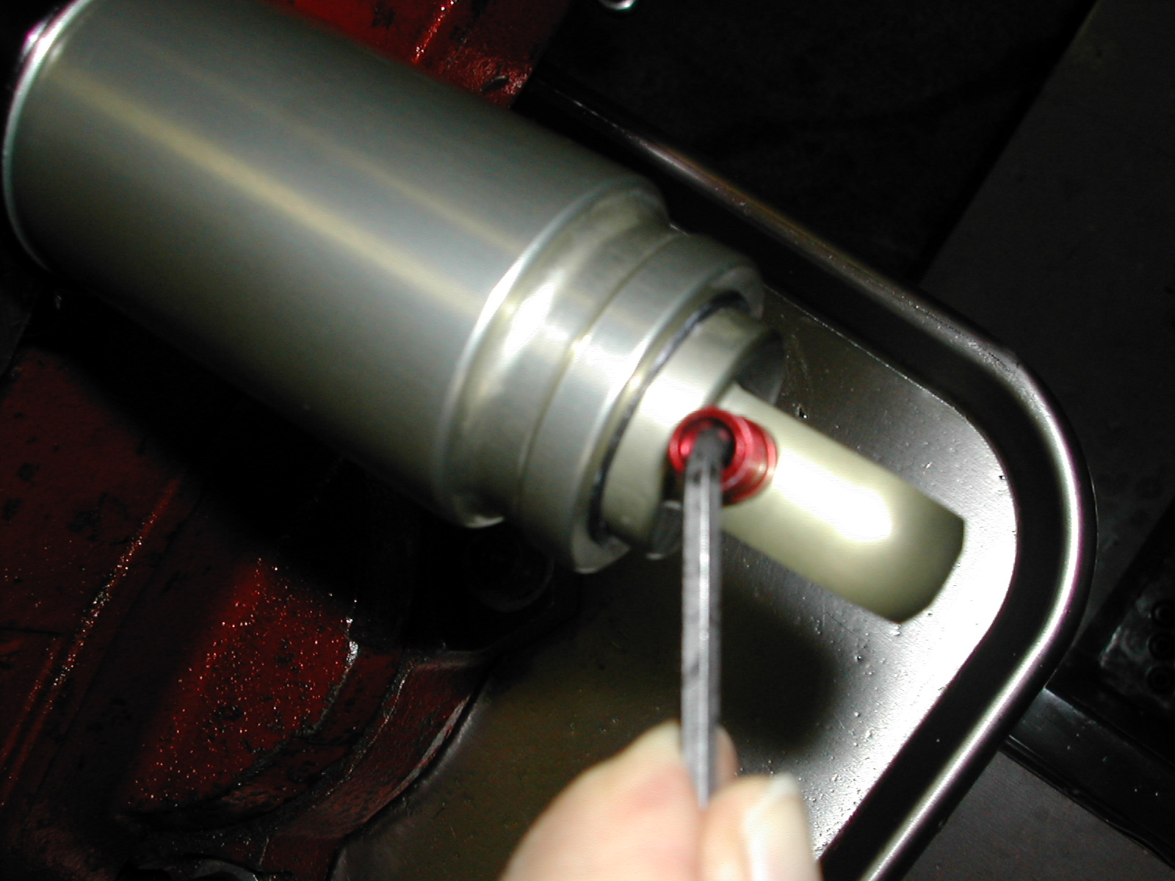  Schrader Removal Using 3mm Hex Wrench | Air Canister Schrader valve  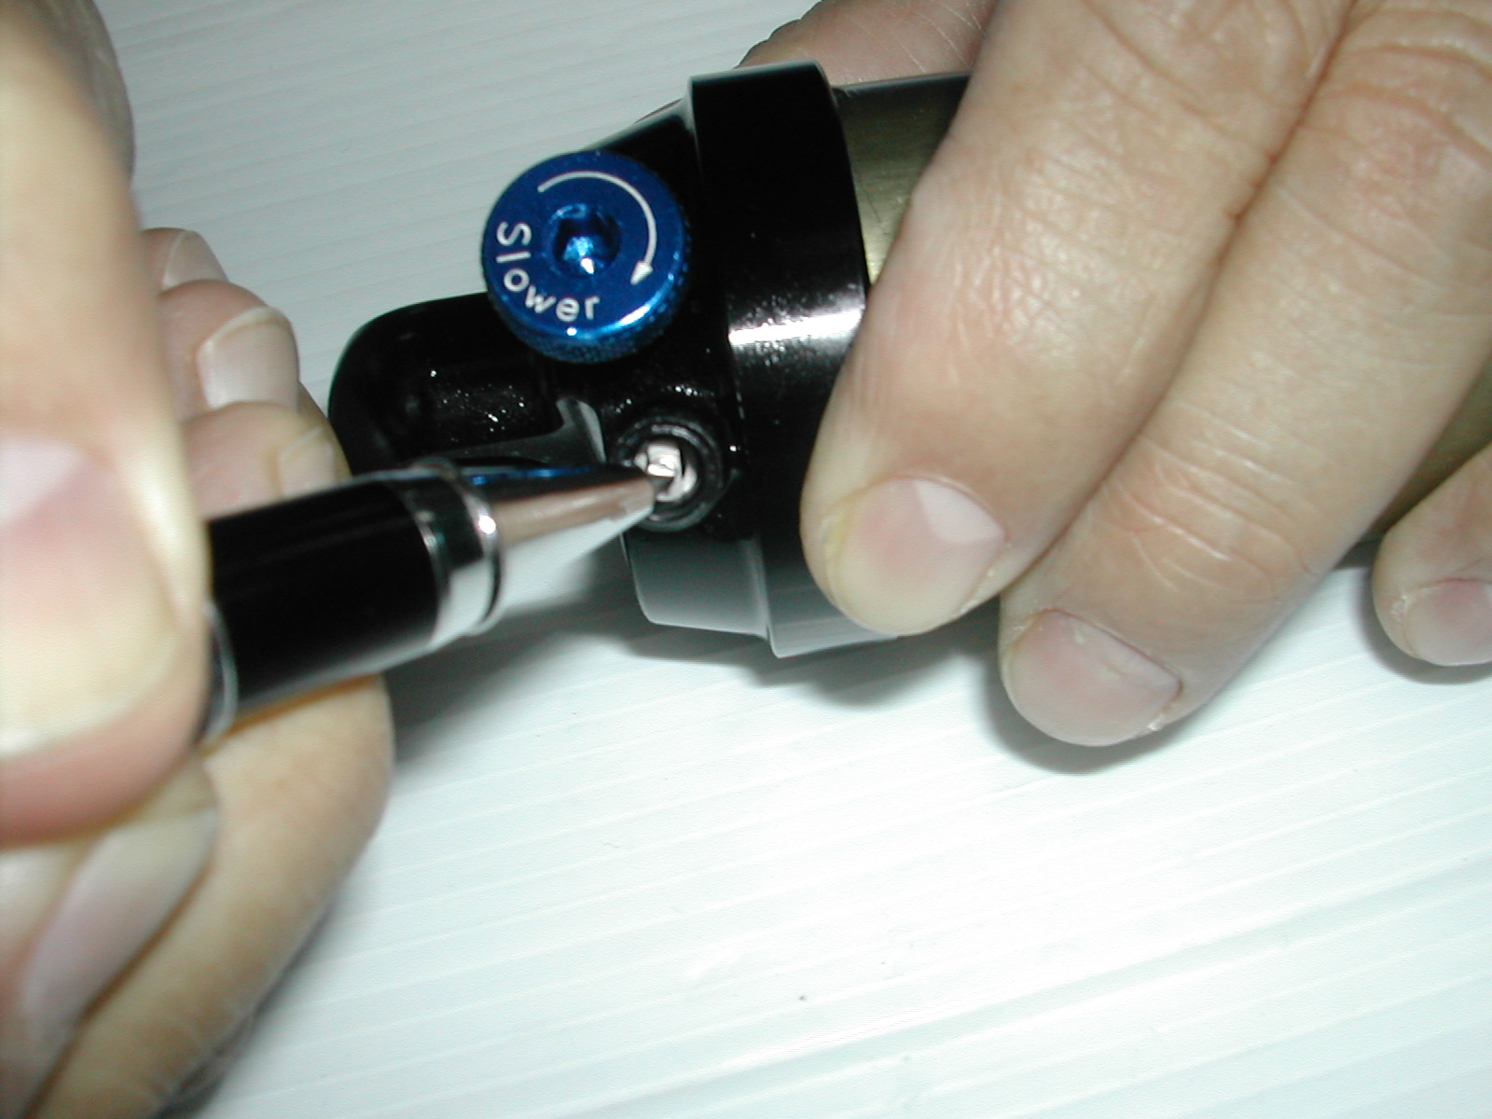  SPV Schrader Valve  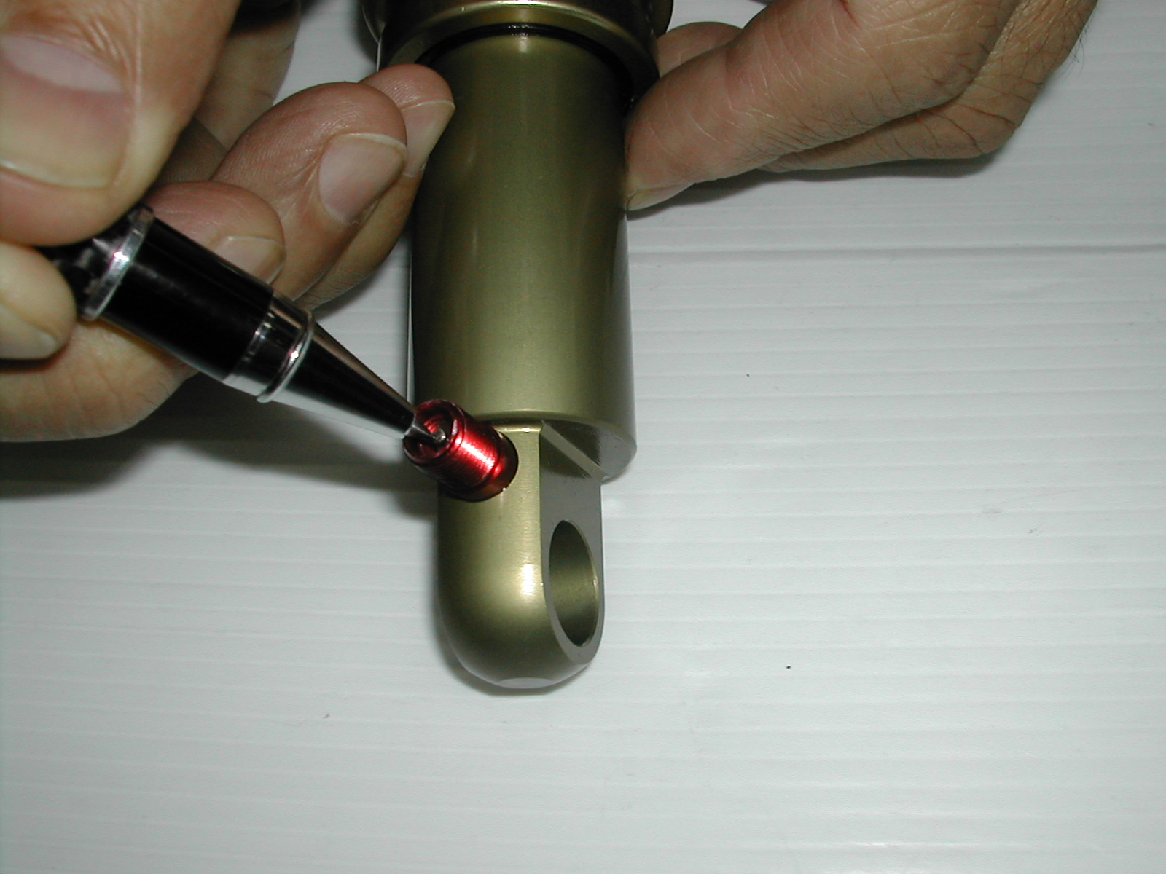
3. Remove hardware as shown under HARDWARE REMOVAL. Place adjuster eyelet in a vise using soft jaws. Using a rubber strap wrench to prevent damage, loosen the air canister completely. Pull back the air canister and slide it off the damper body to expose the 10mm damper shaft.  Note: If the only service necessary is to repair a leak from the adjuster end of the air canister, replace the air canister o-ring that is found inside the “C” eyelet. Reassemble the shock as described at the end of this section | 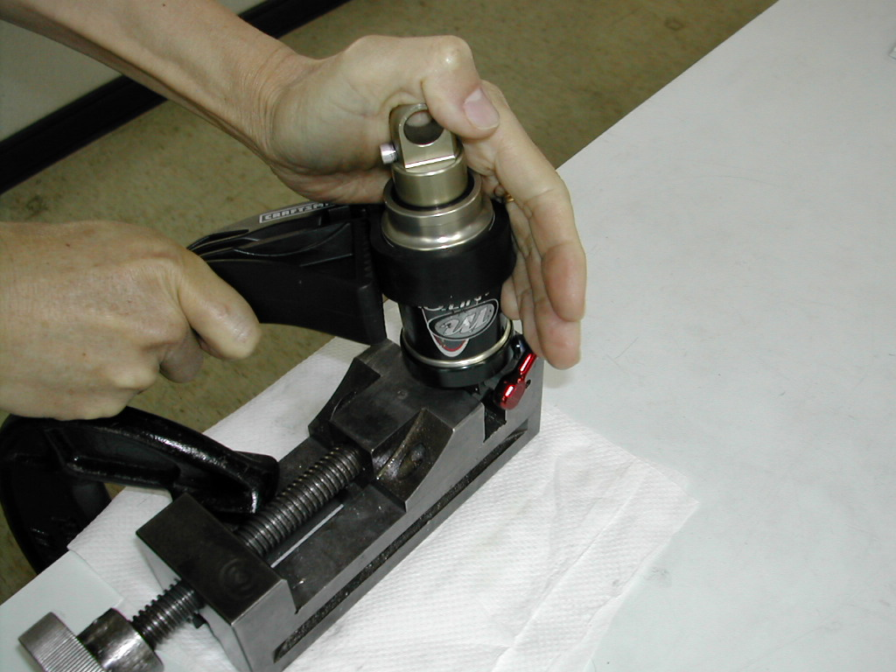

DAMPING SYSTEM BLEEDING - SWINGER 3 WAY AIR SHOCKS (CONT.)

4. Using 10mm soft jaws, clamp the damper shaft and remove the eyelet as shown. | 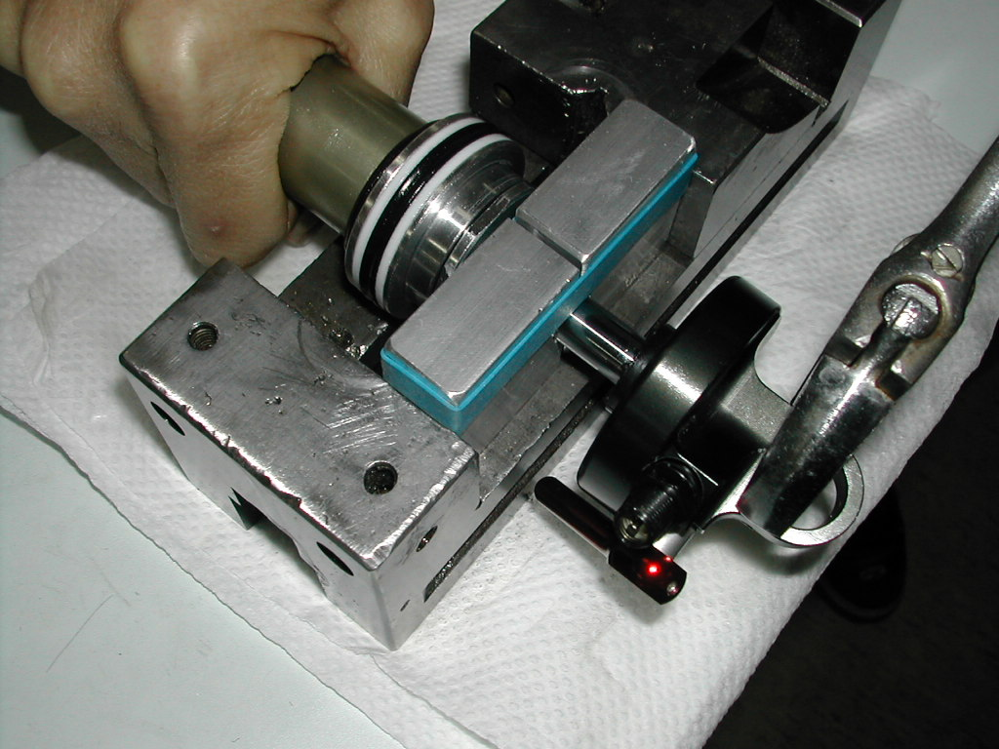
5. Clamp the damper body eyelet in a vise using soft jaws and remove the damper assembly by removing the air piston as shown. Remove from vise and drain damper oil into a container and discard. | 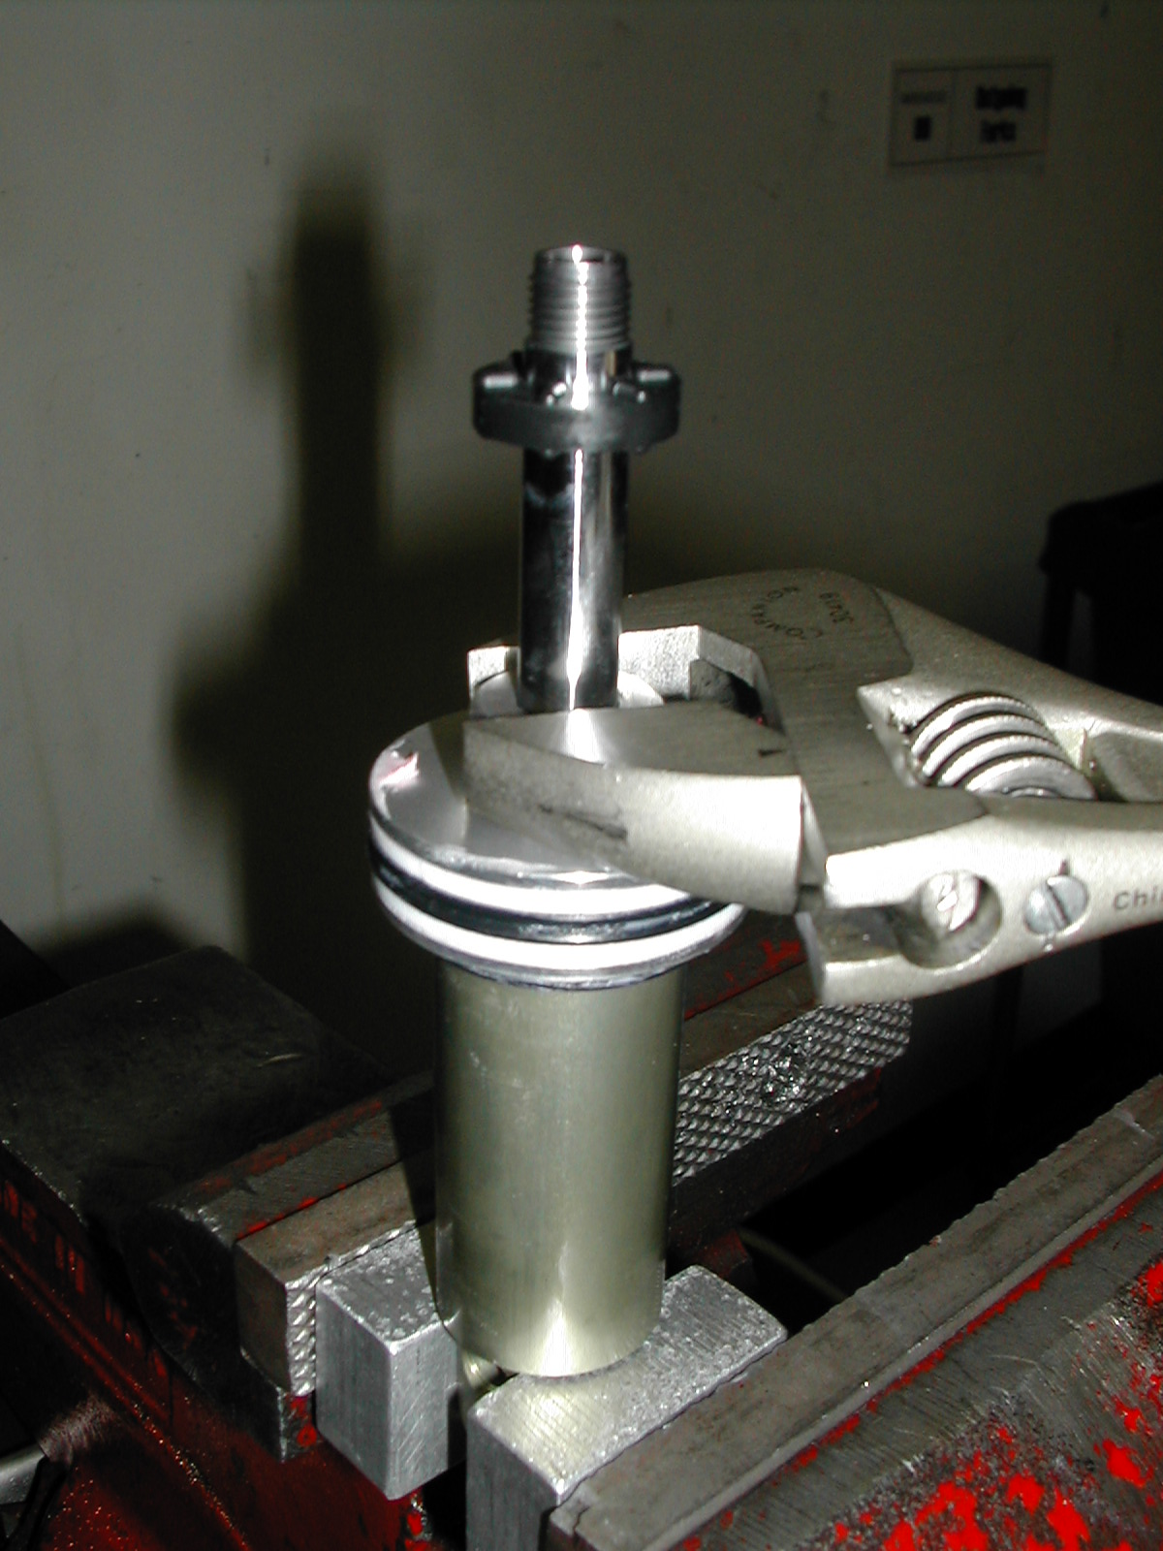  Air Piston
6. Remove IFP (Internal Floating Piston) using Shock pump. Temporarily reinstall the SPV Schrader valve. It is not necessary to reinstall the valve core. Point the damper body away from you while the SPV Schrader vale is pressurized.  WARNING: This action creates backpressure behind the IFP to eject it. The reservoir body should not be pointed at anyone during this step | 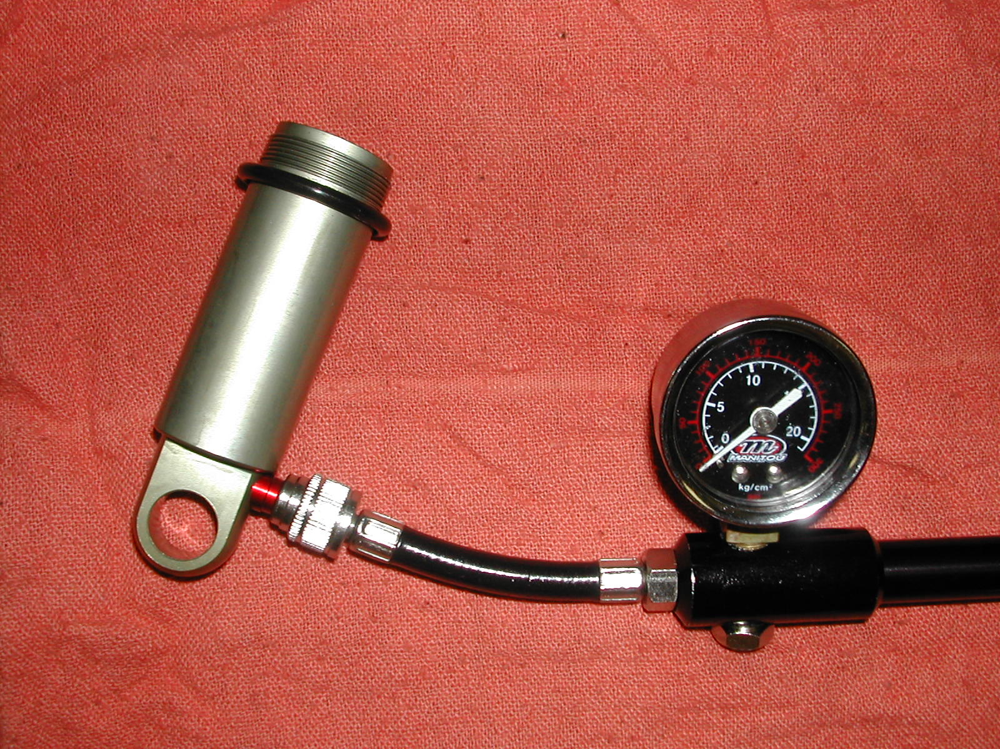  IFP (Damper piston side)  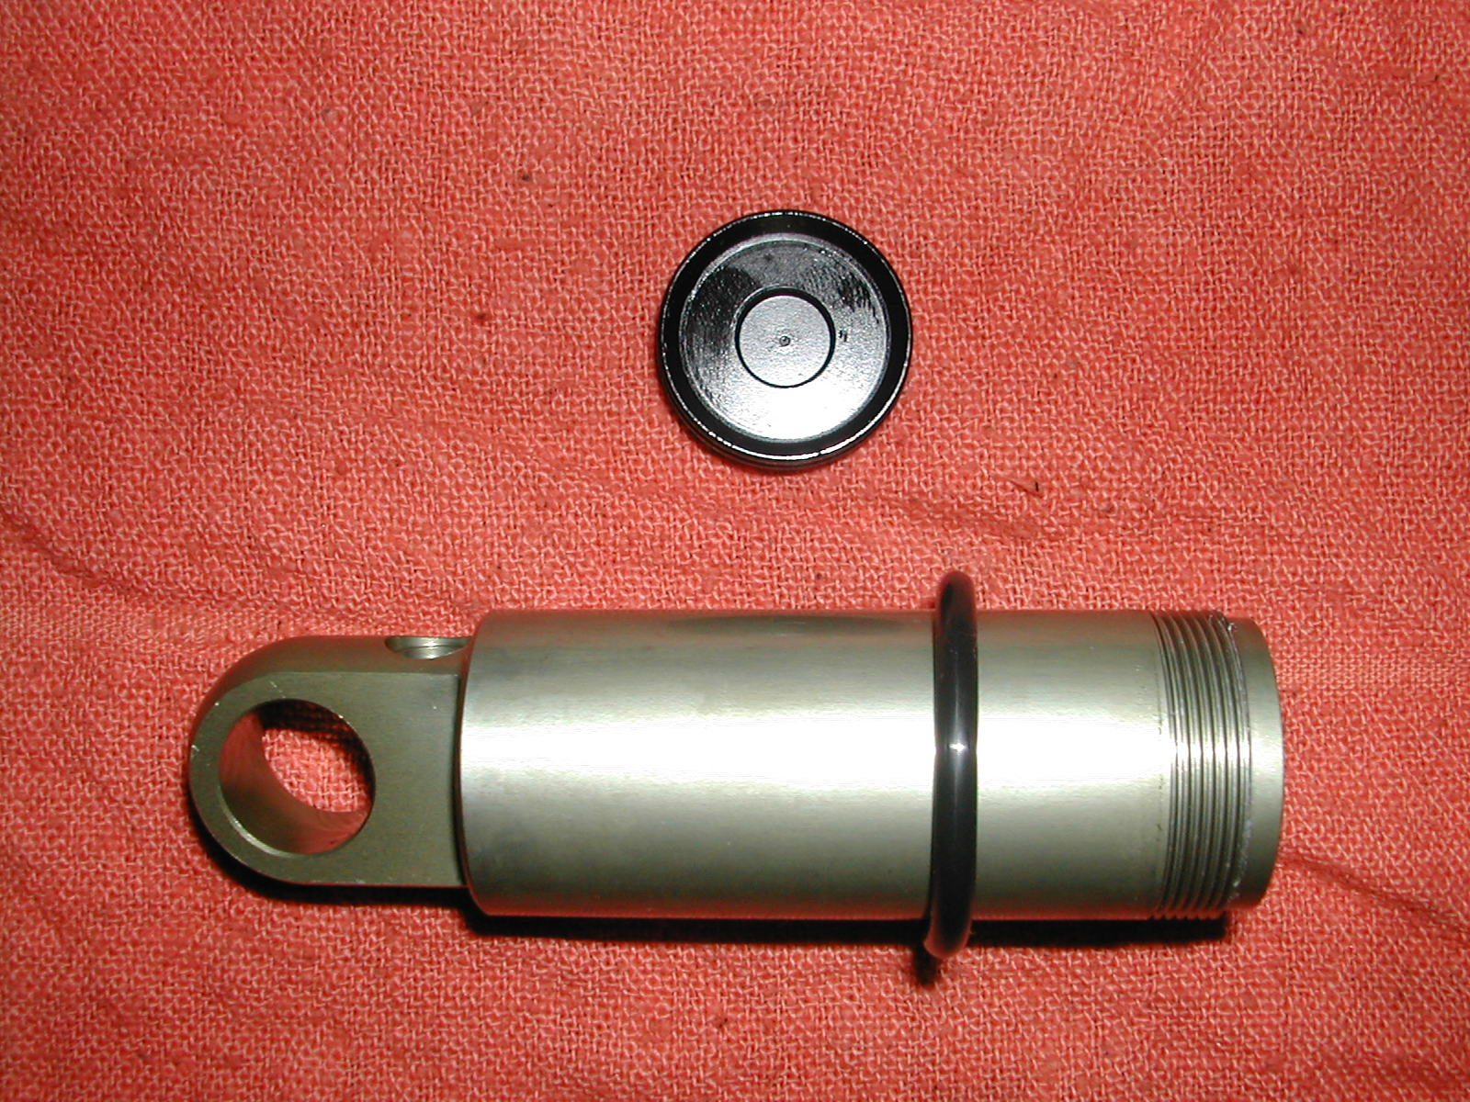

DAMPING SYSTEM BLEEDING - SWINGER 3 WAY AIR SHOCKS (CONT.)

7. Change out o-rings and seals where indicated (#of o-rings/seals in each assembly noted in photo) and grease with a thick grease such as Motorex Bike Grease 2000 | (3) (1)  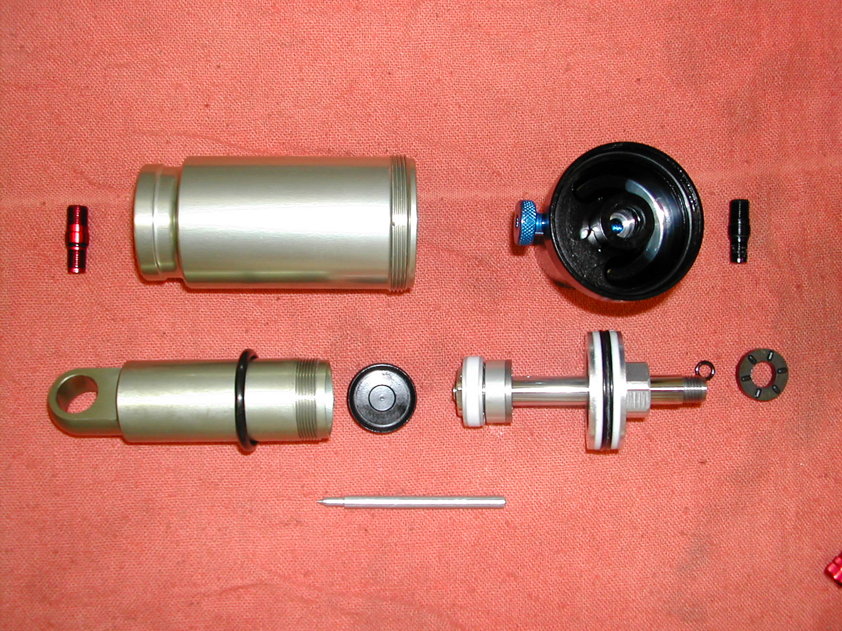  (1) (1 inside and 1outside)
NOTE: The Following bleed procedures will work on all model years of the Swinger Air Shocks.

8. Insert IFP into damper body; make sure the flat side of the piston face is facing the bottom of the damper body. Push the IFP to bottom of damper body. Install the SPV Schrader valve. Secure the damper body upright in a vise and fill it with 5wt. Motorex shock oil.

9. Slide the Air Piston so that it is at the edge of the oil return port. Slowly insert the damper shaft assembly into the damper body. Make sure there are no air bubbles stuck to the piston as it is submerged in the oil. A paper can help to dislodge any stubborn bubbles. Once the air piston contacts the damper body screw it down and tighten to 61-78 in/lbs or 70-90 Kg/cm. | Oil Return Port  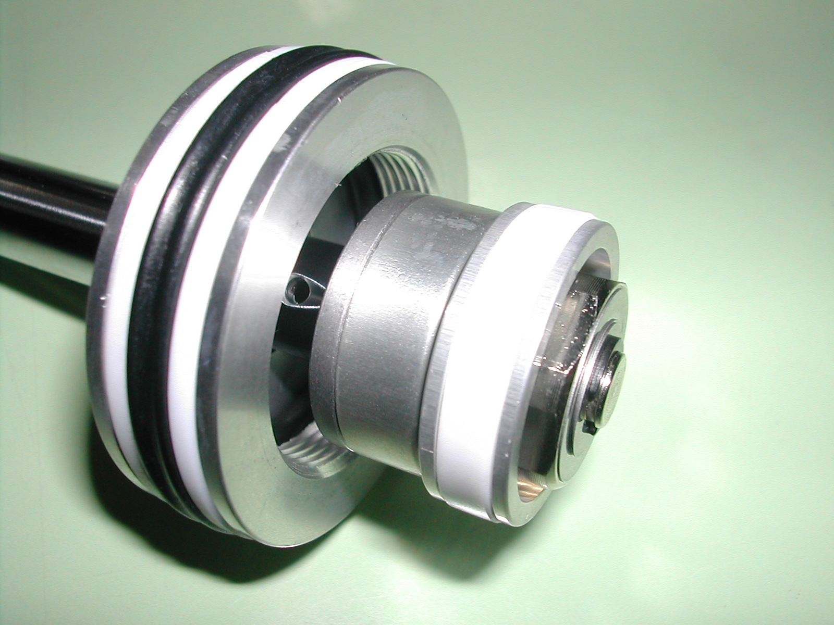

DAMPING SYSTEM BLEEDING - SWINGER 3 WAY AIR SHOCKS (CONT.)

11. Depress the damper shaft until it protrudes 12.5mm from the top of the air piston to the top of the damper shaft. | 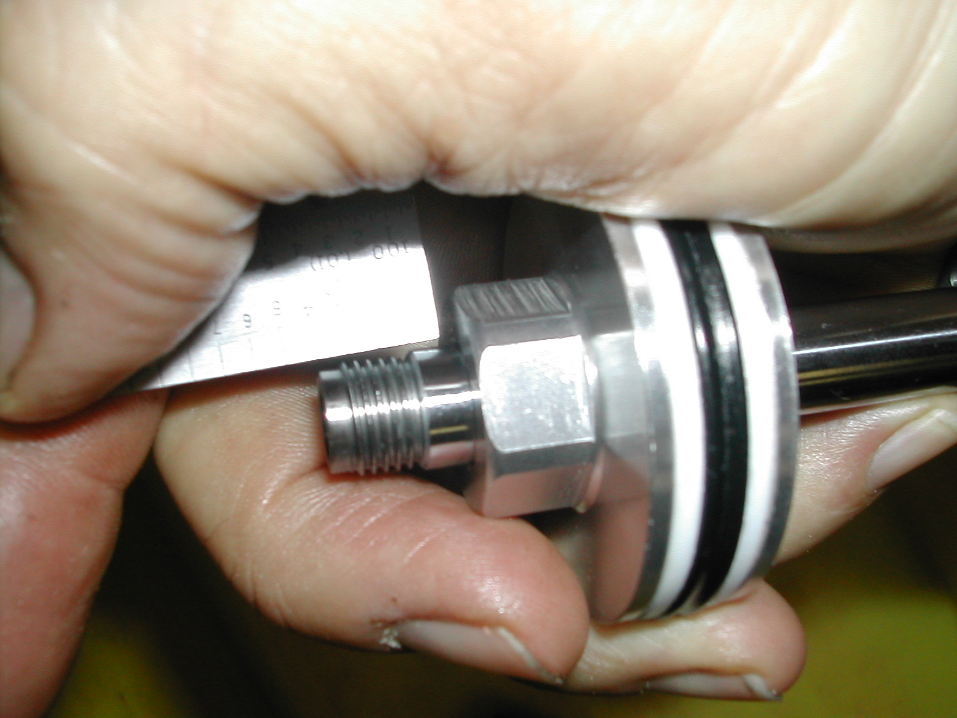
12. Insert the needle and o-ring into the damper shaft until they are firmly seated. Put on the bottom out bumper and then hand tighten the rebound damper eyelet. | 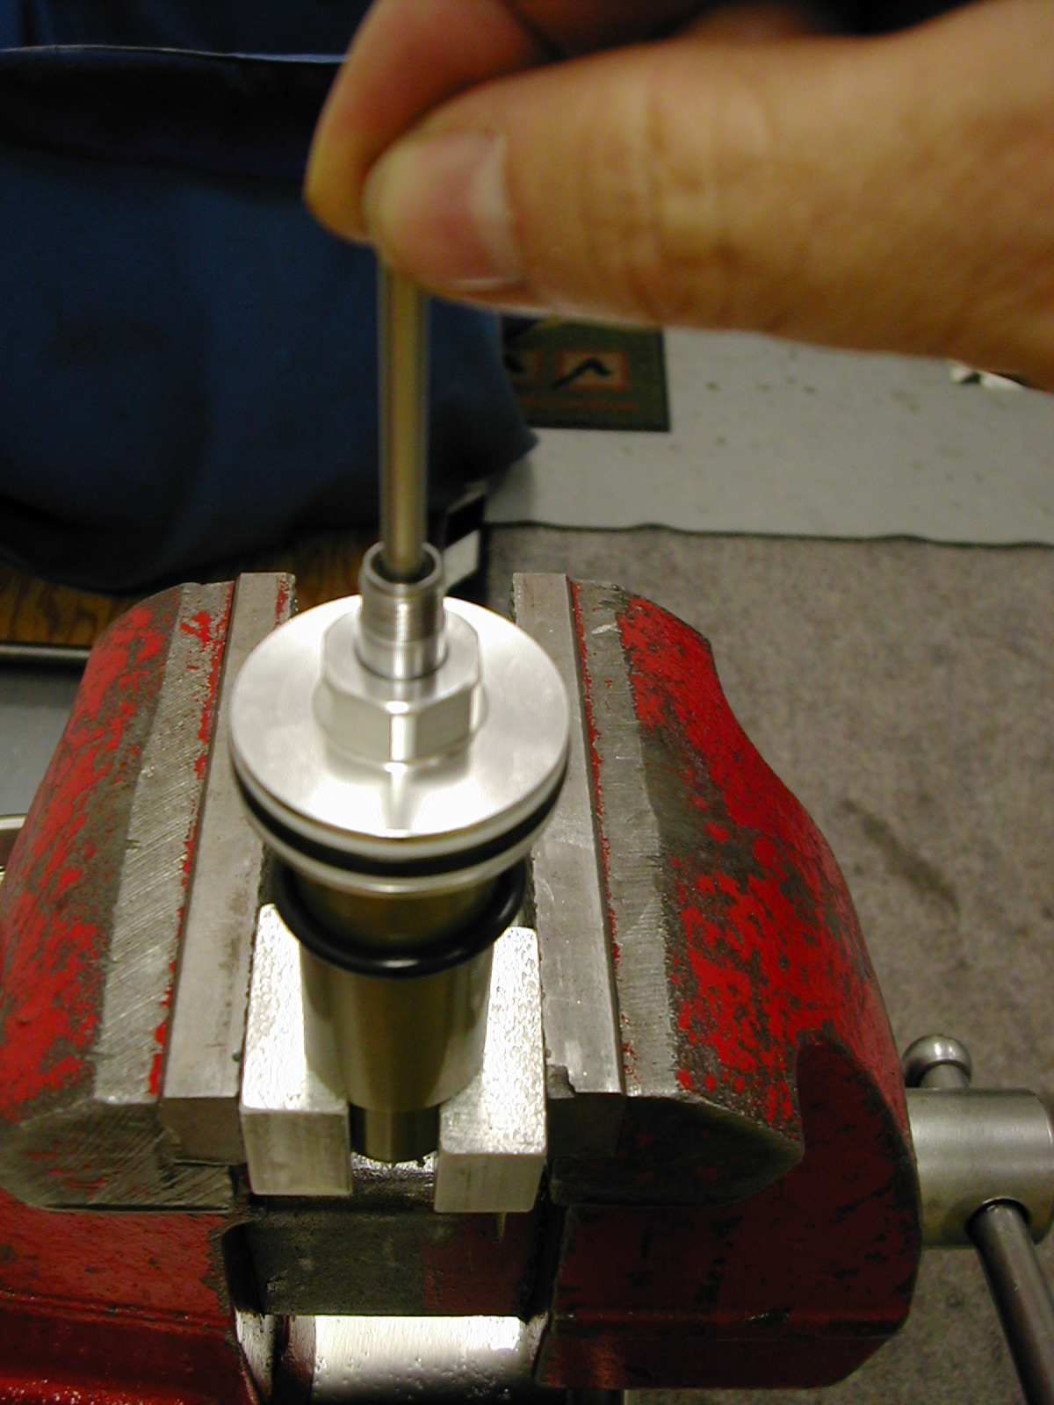
13. Remove the valve core from the Schrader valve and fully extend the damper shaft from the damper body. This will set the level of the IFP. Replace the valve core. | 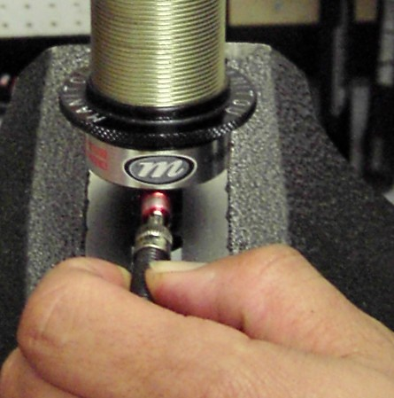

DAMPING SYSTEM BLEEDING - SWINGER 3 WAY AIR SHOCKS (CONT.)
14. Clamp the damper shaft in the soft jaw vise and tighten the damper control cap to 61-78 in/lbs or 70-90 Kg/cm. Pressurize the SPV chamber to check for leaks.

15. Release air pressure from the SPV chamber and remove the entire Schrader valve assembly. DO NOT compress the Damper Shaft. Slide the air canister over damper shaft. Once the canister clears the eyelet replace the Schrader valve and pressurize the SPV chamber to 30 PSI. | 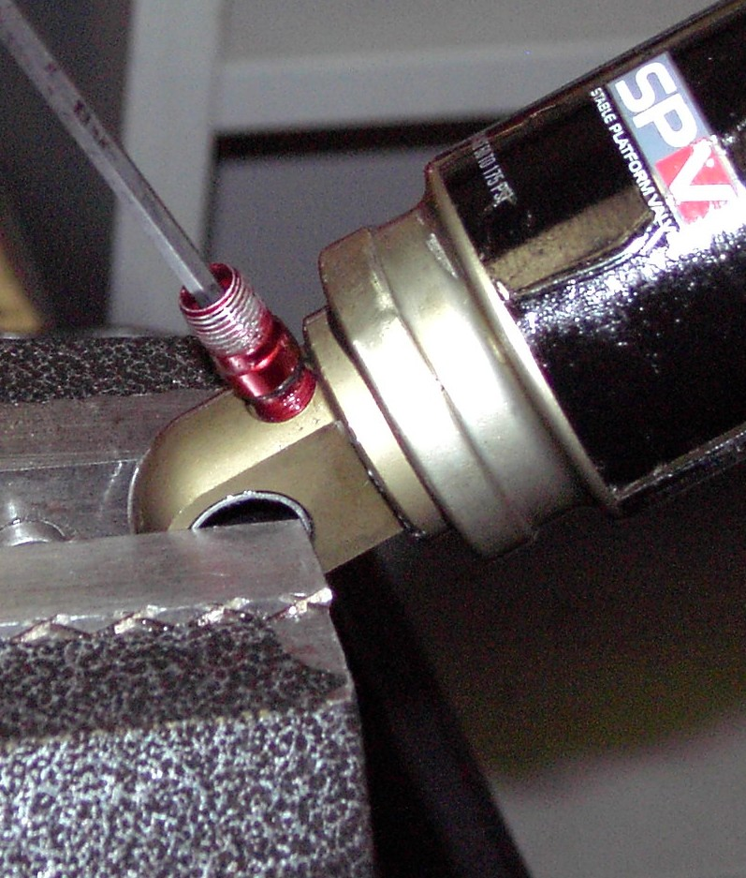
16. Clamp the adjuster eyelet in the soft jaw vise. Grease the air canister threads and screw the canister on to the eyelet. Tighten using strap wrench on canister to 13-21 in/lbs or 15-24 Kg/cm.  17. Add air to re-pressurize the SPV air preload per instructions in the Owner’s Manual.  18. Reinstall shock mounting hardware and install in bike per manufacturers instructions. Add air to air canister per the sag setting instructions in the owner's manual. | 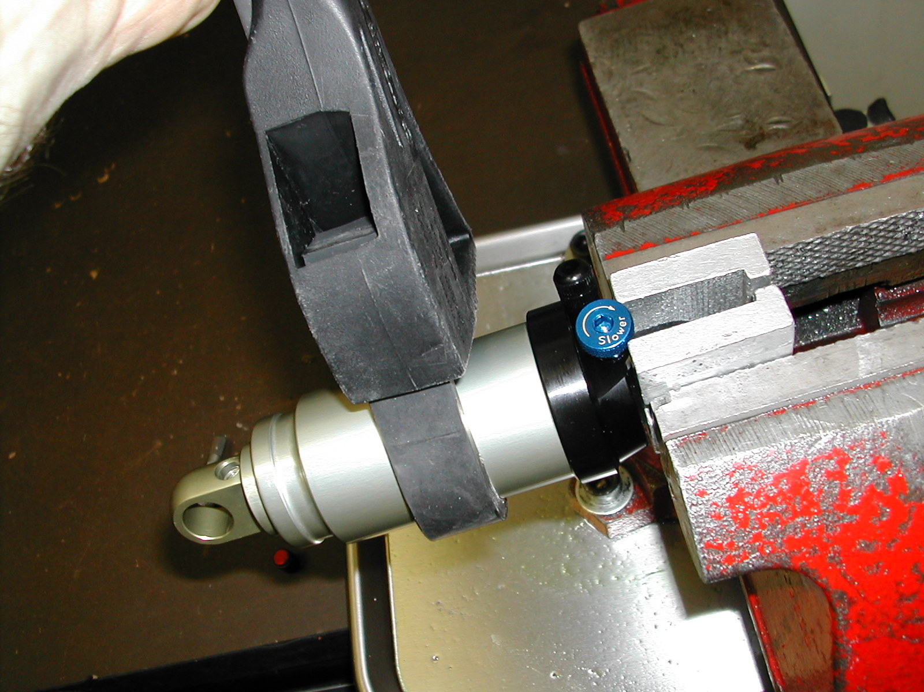

SECTION 15: DAMPING SYSTEM BLEEDING - SWINGER 4 WAY AIR SHOCKS

WARNING: The Swinger Air uses compressed air to provide resistance to compression in place of a coil spring. You must be certain that the air canister is relieved of all pressure prior to servicing the air system. Failure to relieve air pressure could result in injury or possible death.
1. Release All air pressure from air canister and air preload reservoir.  2. Remove hardware as shown under HARDWARE REMOVAL. Place adjuster eyelet in a vise using soft jaws. Using a rubber strap wrench to prevent damage, loosen the air canister completely. Pull back the air canister to expose the 10mm damper shaft.  Note: If the only service necessary is to repair a leak from the adjuster end of the air canister, replace the air canister o-ring that is found inside the adjuster eyelet. Reassemble the shock as described at the end of this section | Air release Schrader valve  Air Reservoir Schrader Valve  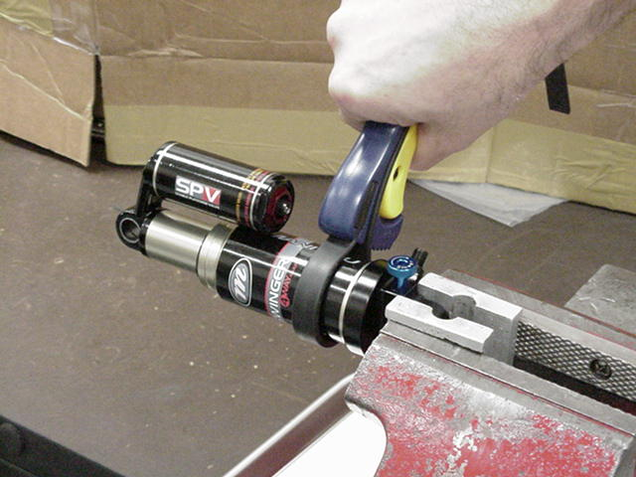
3. Unscrew air preload assembly | 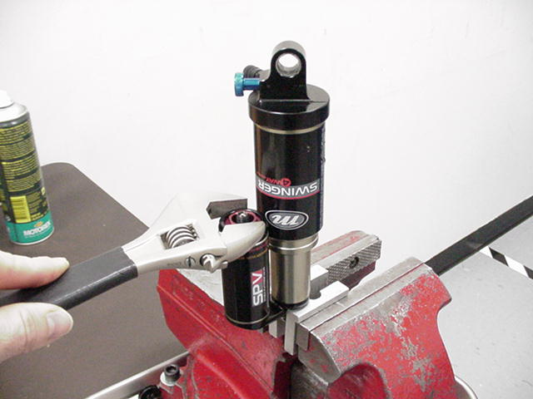
4. Using 10mm soft jaws, clamp the damper shaft and remove the eyelet as shown. | 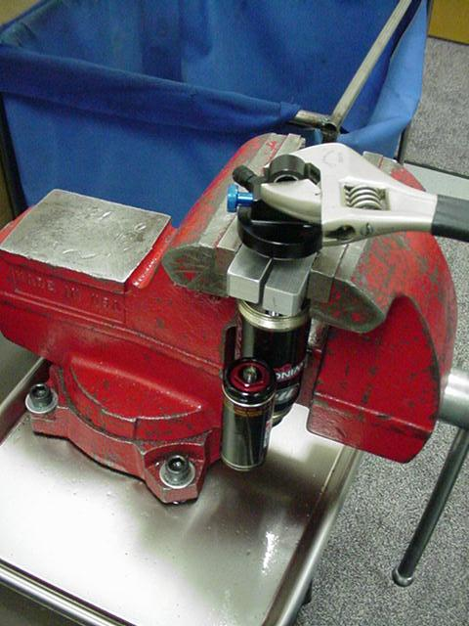

DAMPING SYSTEM BLEEDING - SWINGER 4 WAY AIR SHOCKS (CONT.)

5. Clamp the damper body eyelet in a vise using soft jaws and remove the damper assembly by removing the air piston and damper assembly using an 18mm socket as shown.  Remove from vise and drain damper oil into a container and discard. | 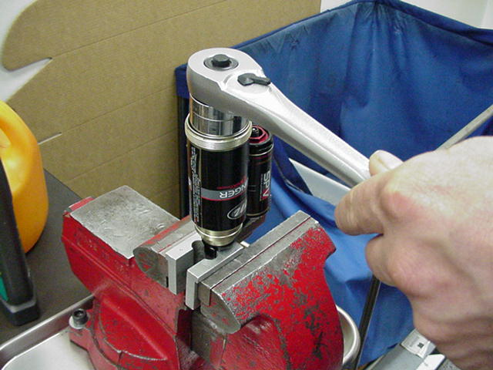
6. Remove the air canister. | 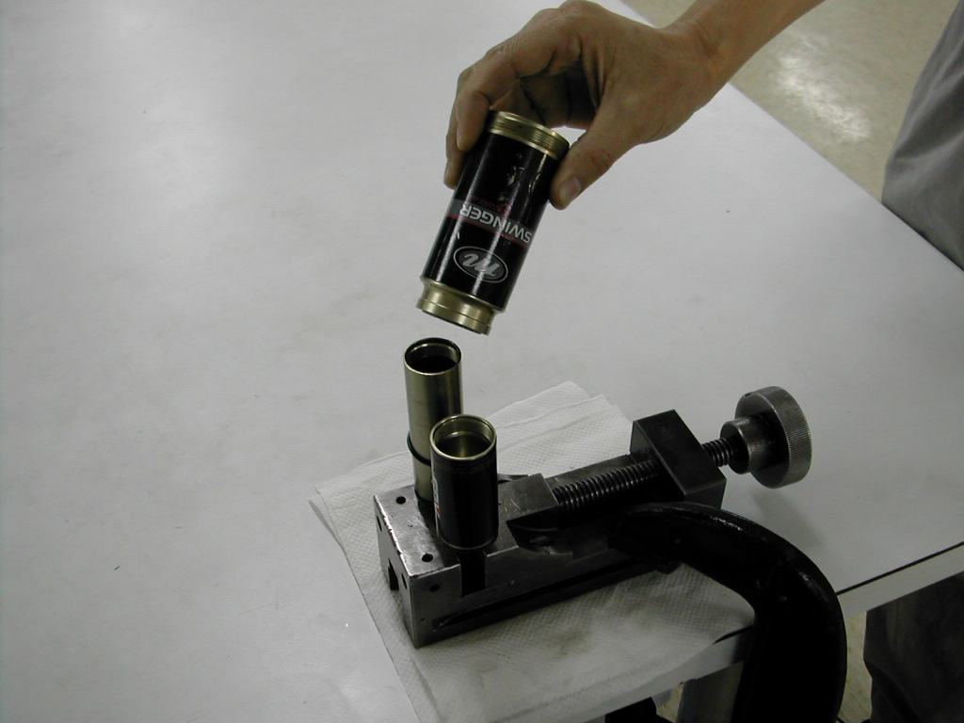
7. Remove air piston from canister  NOTE: Apply grease to the open canister end prior to removing the air piston, this will assist removal. You can also use a hex socket and extension to help push out the piston:  1. Select a socket with an outside diameter of 1.025 - 1.045" (26.0 - 26.5mm) and add an extension to make it longer than the air canister.  2. Install into air canister  3. Hold air canister and lightly tap socket extension on a soft surface.  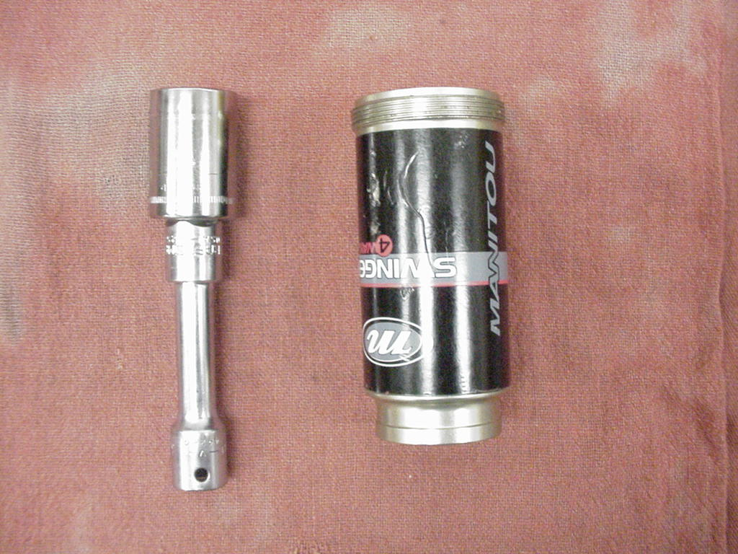 | Air Piston  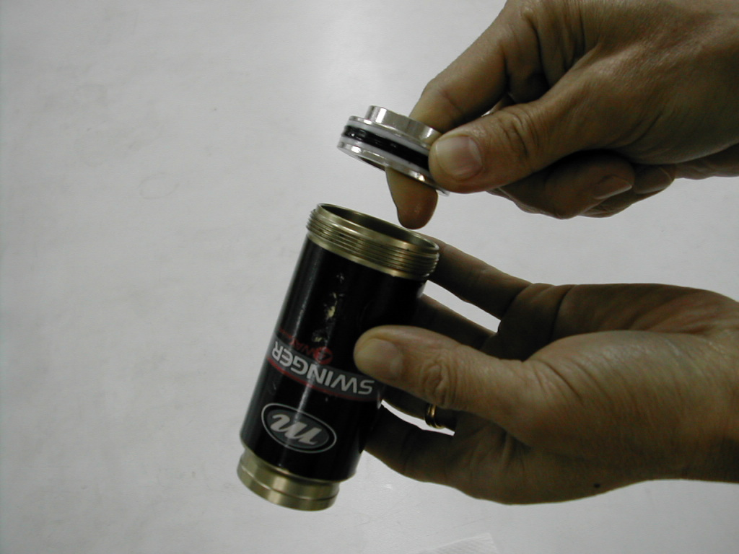  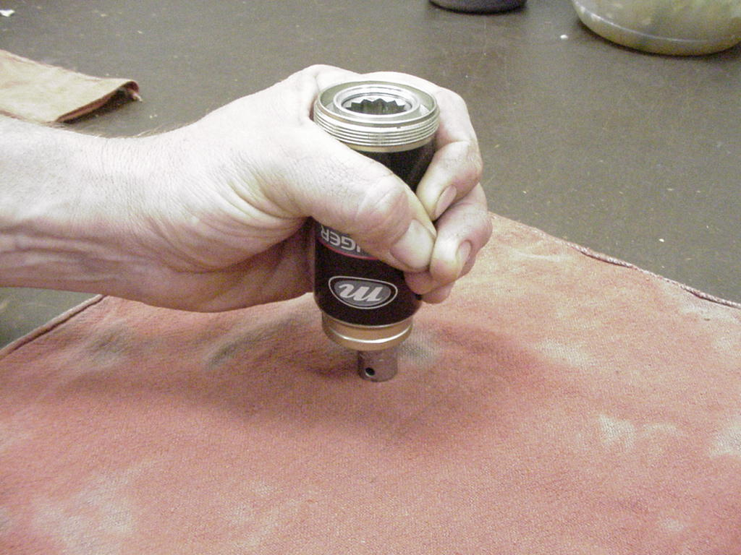

DAMPING SYSTEM BLEEDING - SWINGER 4 WAY AIR SHOCKS (CONT.)

8. Remove IFP (Internal Floating Piston) using IFP removal tool (85-4413). Insert the removal tool into the top of the damper body. Cover hole in tool with your thumb. Point the reservoir body away from you and push the tool to the bottom of the damper body.  WARNING: This action creates backpressure behind the IFP to eject it. The reservoir body should not be pointed at anyone during this step | 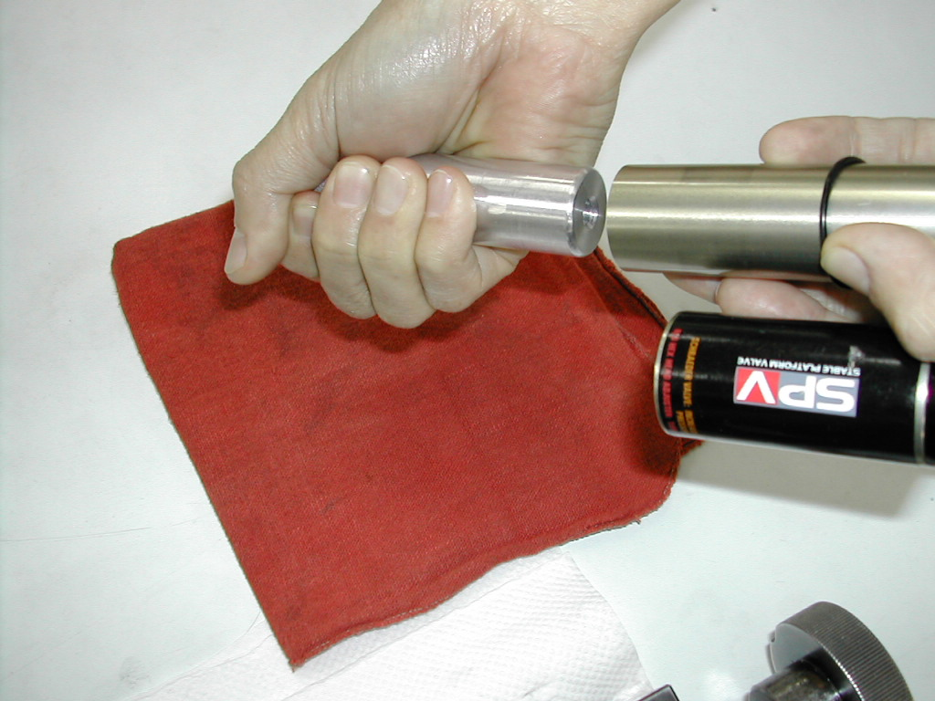
9. Change out o-rings and seals where indicated (#of o-rings/seals in each assembly noted in photo) and grease with a thick grease such as Motorex Bike Grease 2000 | (1) (2) (3)  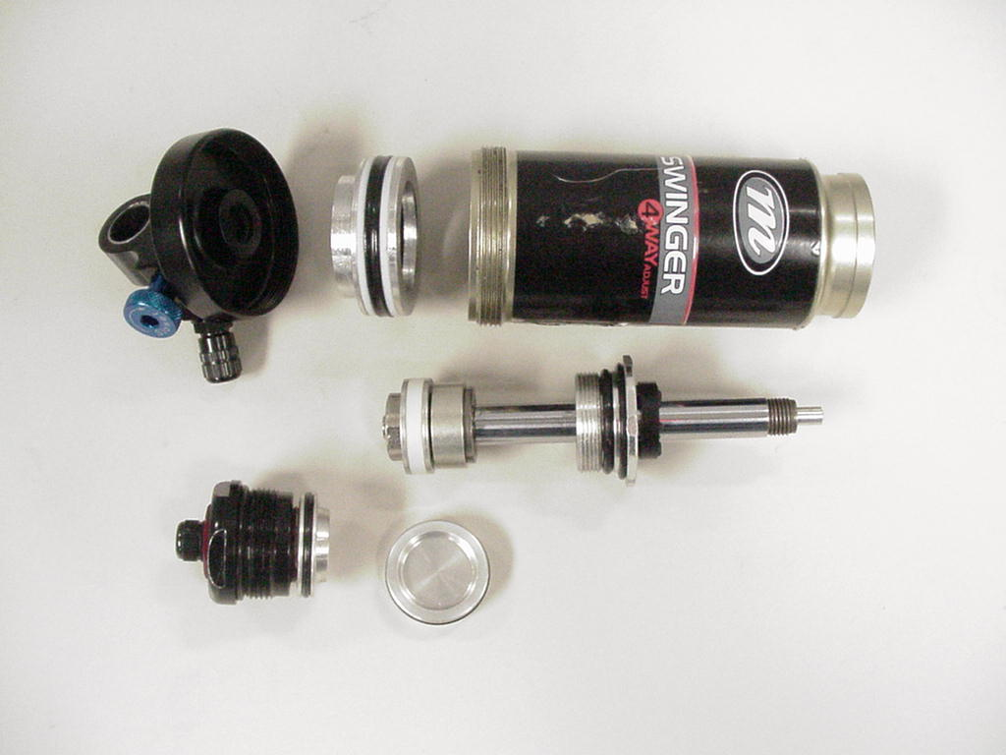  (2) (1) (2)
10. Install Air Canister Seal Guide onto damper body. Lightly grease damper body and slide air canister over body. Remove guide. | Air Canister Seal Guide  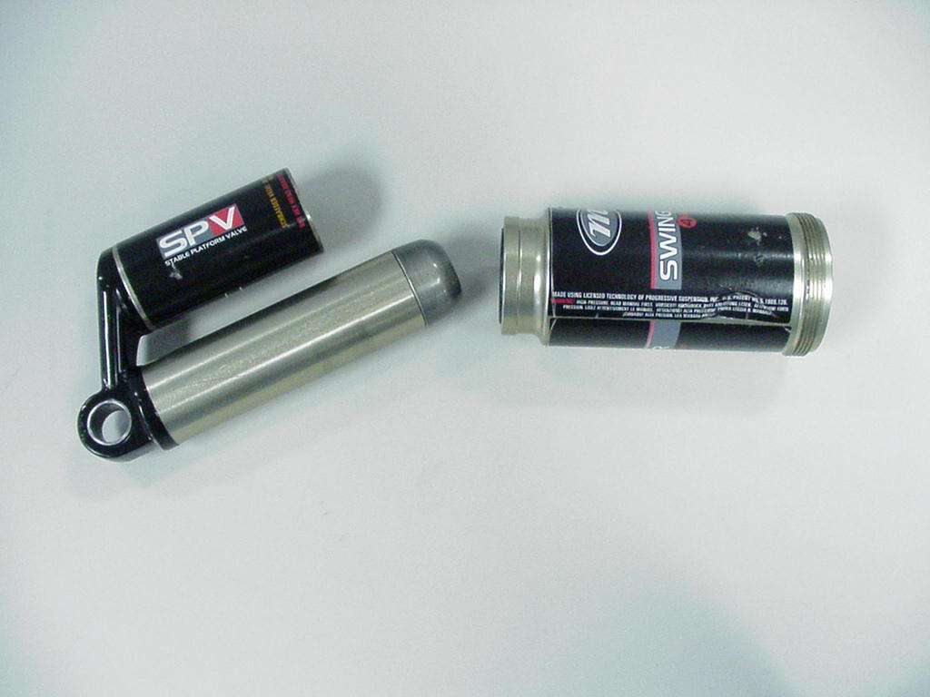

DAMPING SYSTEM BLEEDING - SWINGER 4 WAY AIR SHOCKS (CONT.)

11. Grease inside of air canister and install air canister as shown. The seal end of the air piston is installed first. | 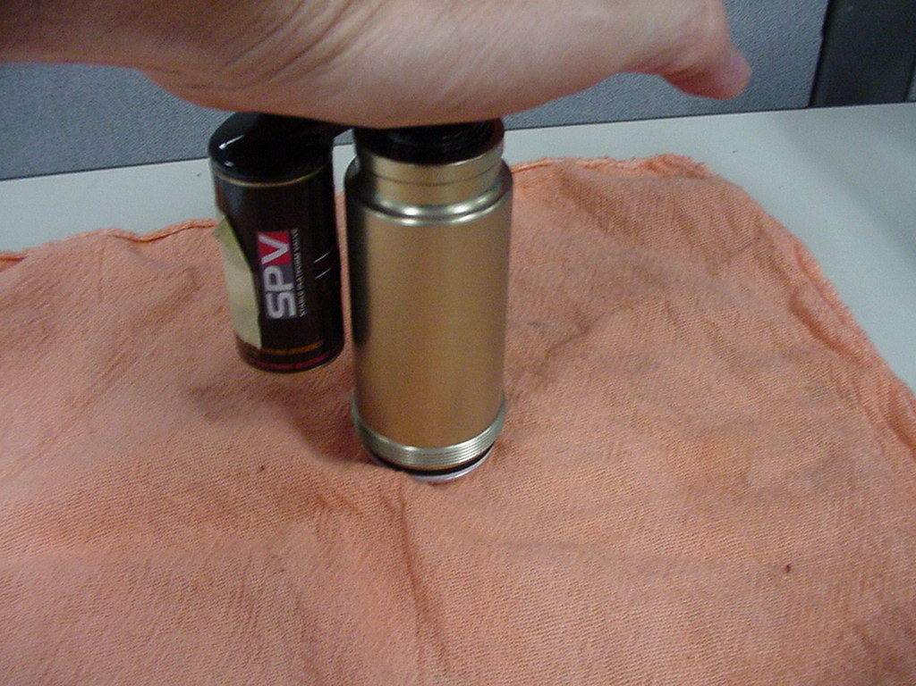
12. Slide air piston on damper shaft assembly so that it is at the edge of the oil return port on the shaft. | Oil Return Port
NOTE: The following bleed procedures will work on all model years of the Swinger 4 way Air shocks.  13. Slide the air piston down on the damper shaft so that it is at the edge of the oil return port.  14. Fill the damper body and reservoir with 5wt Motorex fork oil. Using the IFP Removal tool cycle the oil thru the damping circuits between the main body and the reservoir. Top up the oil level in both the damper and the reservoir.  15. Push the damper shaft back into the main body; tap the assembly to remove any air that maybe trapped in the ports of the piston. | 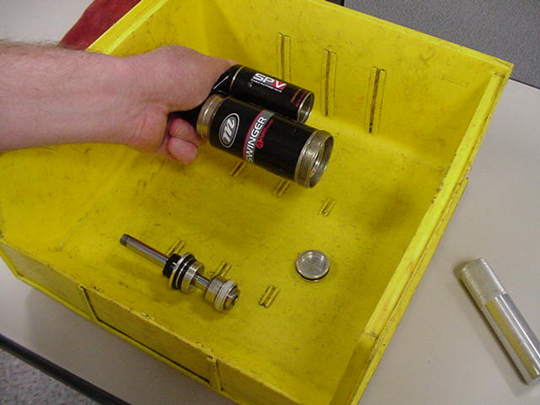

DAMPING SYSTEM BLEEDING - SWINGER 4 WAY AIR SHOCKS (CONT.)

18. Hold the assembly over the oil container, Install rebound adjuster needle, pointed end first. Push until the needle and o-ring fully seat in the damper shaft. | 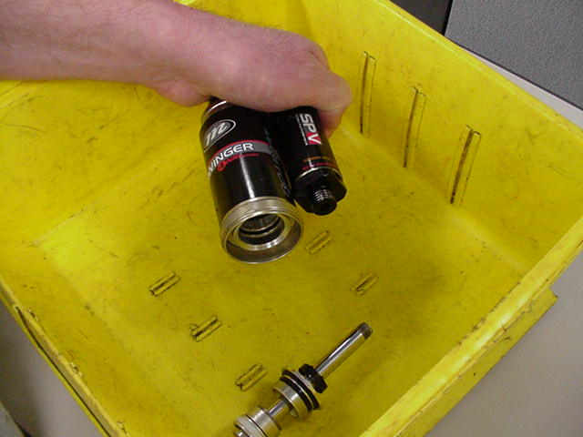
20. Remove the assembly from the oil, keeping the open end of the damper shaft pointing up. Using soft jaws to protect the eyelet clamp the reservoir eyelet and torque the air piston per Table 1. | 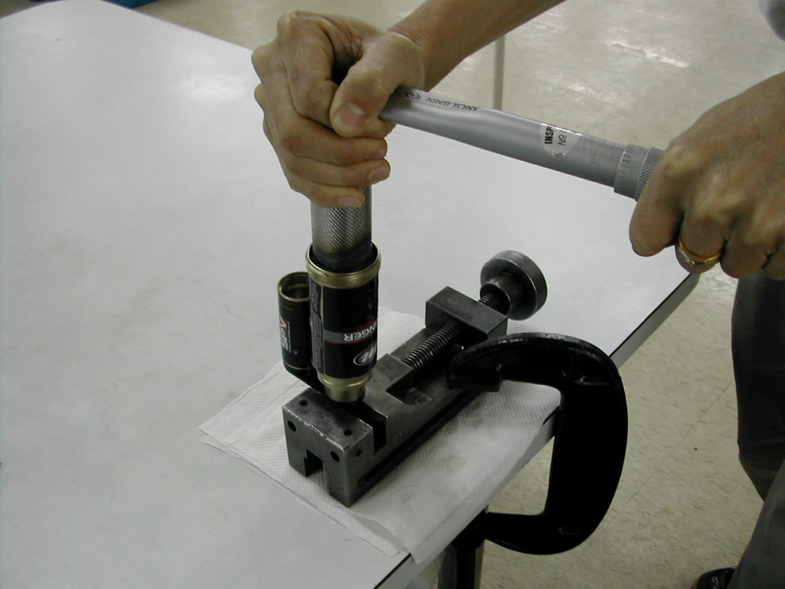
16. Top up the oil level in the reservoir. In a small container of oil tap the IFP to get the air out from under the o-ring. Insert the IFP into the reservoir starting at about a 45 degree angle so that you burp the air out of the piston cavity. Push the IFP past the threads in the reservoir. Only press the piston in just beyond the reservoir threads. | 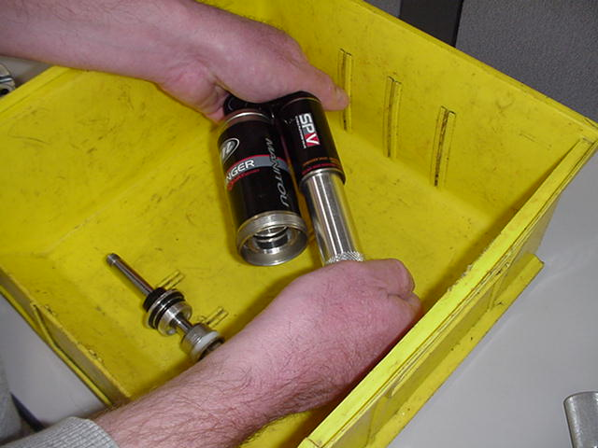
17. Back the IFP tool out fully as pictured. Using the IFP tool push the IFP piston fully into the reservoir. Screw the tool in hand tight until the flange is flush with the air reservoir body. Using a 6mm hex wrench, adjust the IFP Locating Tool so that the indicated travel matches the shock travel. Make sure that the travel indication line is flush to the top of the tool.

24. Remove the IFP location tool. Once the tool is removed DO NOT move the damper shaft | 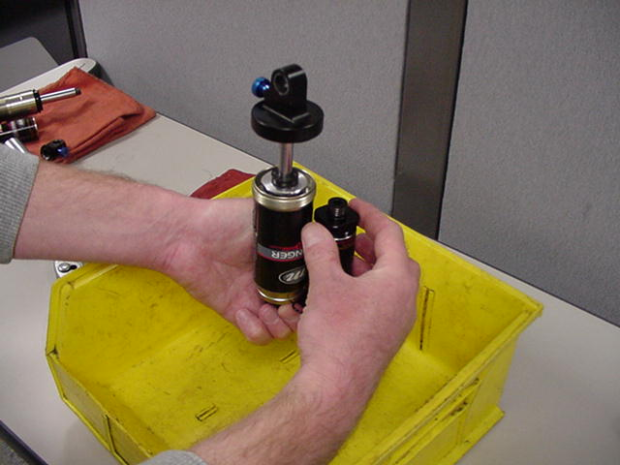
25. Clean the air preload threads with alcohol. Apply blue loctite #242 to air preload adjuster threads and grease threads. Install the air preload adjuster and torque per Table 1. | 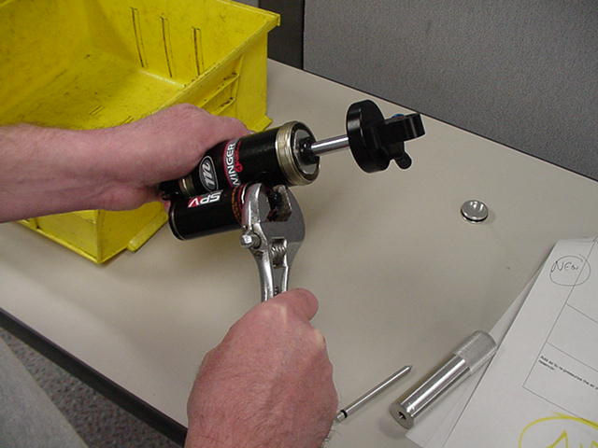
26. Clamp adjuster eyelet in soft jaws. Grease air canister threads, and screw canister onto eyelet. Tighten using strap wrench on canister.  27. Add air to re-pressurize the air preload reservoir per instructions in the Owner’s Manual.  28. Reinstall shock mounting hardware and install in bike per manufacturers instructions. Add air to air canister per the Setting Sag instructions in the owner's manual. | 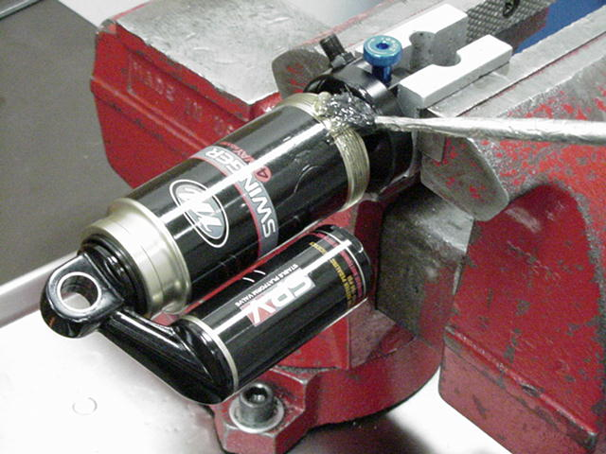

SECTION 16: SWINGER SHOCK TROUBLESHOOTING CHART

Symptom | Cause | Solution | Service Section
ALL SHOCKS
Damping System
Cannot set pedaling platform | Air loss from SPV system: SPV Schrader valve leaks | Tighten or replace Schrader core or replace Schrader assembly. | 4
Cannot set pedaling platform | SPV Valve failure | Close rebound knob (clockwise). If the shock rebounds fast after compression, the SPV valve may be defective. If the rebound is very slow, the valve is probably OK. Inspect and replace if necessary | 12 - 15
Cannot set pedaling platform | Air in damping system | Bleed damping system | 12 - 15
SPV Schrader valve snapped off at base on 3 Way Air and Coil Swingers. | Interference with suspension linkage or other frame components | Replace. Confirm clearance after Schrader replacement | 4
Adjusting rebound knob has no effect. | Air in damping system | Bleed damping system | 12 - 15
Oil comes out of the SPV Schrader valve | Damping oil has leaked past the IFP | Replace o-ring on the IFP and bleed the damping system | 12 - 15
Mounting Hardware
Play in shock eyelets when mounted in bike | Worn DU bushing or mounting hardware | Replace | 6 -7
SWINGER AIR
Air Spring
Air loss from air spring | Air spring Schrader valve leaks | Tighten or replace Schrader core or replace Schrader assembly. | 4
Air loss from air spring | Seal failure on Air Canister | Replace seal(s) | 4
Air loss from air spring | Seal failure on Air Piston | Replace seal(s) | 4
Air shock does not return to full travel but has adequate air spring pressure | Failure of negative spring | Replace air canister and seals | 4
Oil comes out of the Air Spring Schrader valve | Damping oil has leaked past the damper cap | Replace seals on the damper cap and bleed the damping system | 14 - 15

SWINGER SHOCK TROUBLESHOOTING CHART (CONT.)

Symptom | Cause | Solution | Service Section
SWINGER AIR
Air Spring
Hard Bottomout | Air spring pressure too low | Increase air canister air pressure | 4
Hard Bottomout | Worn bottomout bumper | Replace bottomout bumper | 14 - 15
Hard top out | Failure of negative spring | Replace air canister and seals | 4
Air Volume adjuster on 4 Way Swinger has no affect on damping rate. | Damaged adjuster piston o-ring | Replace o-ring | 15
Oil leak at base of air canister | Worn or damaged seals allowing oil to escape from damper chamber | Replace seals and bleed damping system | 4
SWINGER COIL
Spring System
Hard bottomout | Spring rate too low | Replace with firmer spring | 8
Hard bottomout | Worn bottomout bumper | Replace bottomout bumper | 9
Hard top out | Air in damping system | Bleed damping system | 12 - 13
Damping System
Oil leak at high and low speed compression adjuster screws | Worn or damaged adjuster needles and/or o-ring allowing oil to escape | Replace adjuster needle and/or o-rings | 13
Oil leak at damper shaft | Worn or damaged seals allowing oil to escape from damper chamber | Replace seals and bleed damping system | 12 - 13
Broken rebound knob on coil shocks | User attempted to remove knob during spring replacement | Replace rebound knob | 11
Air Volume adjuster on 4 or 6 Way Swinger has no affect on damping rate. | Damaged adjuster piston o-ring | Replace o-ring | 13

SECTION 17

TABLE 1
FASTENER TORQUE REQUIREMENTS

Feature | Torque
Swinger Air
Air Canister | 15 – 24KgCm (13 – 21inlbs)
Air Piston to Damper | 70 - 90 KgCm ( 61 to 78 inlbs)
Air Volume Adjuster, Swinger Air 4 Way | 70 - 90 KgCm ( 61 to 78 inlbs)
Damper Piston Bolt | 70 - 90 KgCm ( 61 to 78 inlbs)
Damper Shaft to Control Eyelet | 70 - 90 KgCm ( 61 to 78 inlbs)
Schrader Valve Stem | 5 – 10 KgCm ( 4 to 9 inlbs)
Swinger Coil
Air Volume Adjuster, Swinger Coil 4&6 Way | 70 - 90 KgCm ( 61 to 78 inlbs)
Damper Cap | 70 - 90 KgCm ( 61 to 78 inlbs)
Damper Piston Bolt | 70 - 90 KgCm ( 61 to 78 inlbs)
Damper Shaft to Control Eyelet | 90 - 110 KgCm ( 78 to 95 inlbs)
Schrader Valve Stem | 5 – 10 KgCm ( 4 to 9 inlbs)
SECTION 18: 2005 SWINGER REAR SHOCK SERVICE KITS

Kit Description | Kit | Swinger
 |  | 3-Way Air | 4-Way Air | 3-Way Coil | 4-Way Coil | 6-Way Coil
Air Canister
Regular Mount 32mm Travel (1.25") | A | 83-2221
Regular Mount 38mm Travel (1.5") | A | 83-2222
Regular Mount 40mm Travel (1.6") | A | 83-2224
Regular Mount 45mm Travel (1.75") | A | 83-2226
Regular Mount 50mm Travel (2.00") | A | 83-2227
Regular Mount 56mm Travel (2.25") | A | 83-2228
Regular Mount 63mm Travel (2.55") | A | 83-2229
Regular Mount 70mm Travel (2.80") | A | 83-2230
LRS Air Canister | A | 83-2271
Trunion Mount 38mm Travel - Can'dale 85-11433/20001 | A | 85-6038
Trunion Air Canister for Shock 38mm Travel (1.5") | A | 83-2223
Trunion Air Canister for Shock 44mm Travel (1.75") | A | 83-2225
Schrader Valves
Swinger Schrader Valve Assy, Black | A | 83-2231
Swinger Schrader 90 Valve Assy, Black | A | 83-2233
Swinger SPV Schrader Valve Assy, Red | A | 83-2233
Swinger SPV Schrader 360 Valve Assy, Red | A | 83-2241
Swinger SPV Schrader 360 Valve Assy, Red | A |  |  | 83-2242
Swinger SPV Schrader 360 Valve Assy, Red | A |  |  |  | 83-2243
Complete Shock, Without Hardware, Spring
152mm Eye to Eye, 32mm Travel | B | 85-6576 | 85-6154
165mm Eye to Eye, 38mm Travel | B | 85-6577 | 85-6583
178mm Eye to Eye, 40mm Travel | B | 85-6647
184mm Eye to Eye, 45mm Travel | B | 85-6578 | 85-6584
190mm Eye to Eye, 50mm Travel | B | 85-6579 | 85-6585 | 85-6589 | 85-6595 | 85-6602
200mm Eye to Eye, 50mm Travel | B | 85-6580 | 85-6586 | 85-6590 | 85-6596 | 85-6603
200mm Eye to Eye, 57mm Travel | B | 85-6648 |  |  | 85-6597
210mm Eye to Eye, 50mm Travel | B | 85-6581
215mm Eye to Eye, 63mm Travel | B | 85-6582 | 85-6587 | 85-6591 | 85-6598 | 85-6604
222mm Eye to Eye, 70mm Travel | B |  | 85-6588 | 85-6592 | 85-6599 | 85-6605
230mm Eye to Eye, 70mm Travel | B |  |  | 85-6593 | 85-6600 | 85-6606
240mm Eye to Eye, 76mm Travel | B |  |  | 85-6594 | 85-6601 | 85-6607
LRS Heim Joints | D | 83-2272
Swinger 6W Remote Reservoir Hose Kit | B |  |  |  |  | 85-6280
Swinger 6W Remote Reservoir Seal Kit | B |  |  |  |  | 85-6276
Swinger 6W Remote Reservoir Hose Fitting Kit | B |  |  |  |  | 85-6281
Swinger SPV Air Volume Adjuster Kit | B |  | 85-4493 |  | 85-4493
Swinger Coil Rebound Adjuster Knob | B |  |  | 85-4492
2005 SWINGER REAR SHOCK SERVICE KITS (CONT.)

Kit Description | Kit | Swinger
 |  | 3-Way Air | 4-Way Air | 3-Way Coil | 4-Way Coil | 6-Way Coil
6 Way Compression Adjuster Knob/Needles Kit
2mm Adj. Hex | B |  |  |  |  | 83-2234
SPV Valve | B | 85-4457 |  | 85-6098
Seal Kit | C | 85-6099 |  | 85-6135
Swinger 3W LRS Seal Kit | C | 85-6277
Swinger Air Seal Kit | C | 83-2237
Swinger Coil Seal Kit | C |  |  | 83-2238
Mounting Hardware Kits | D | (Contact Answer Products)
Hardware Bushing Kit | E
DU Bushing | E | 85-6105
Heim Joint - Swinger 3W LRS | E | 85-6275
Sticker Kit | F
Sticker Kit, Swinger 3-Way Air | F | 83-2250
Sticker Kit, Swinger 4-Way Air | F |  | 83-2251
Sticker Kit, Swinger 3-Way Coil | F |  |  | 83-2252
Sticker Kit, Swinger 4-Way Coil | F |  |  |  | 83-2253
Sticker Kit, Swinger 6-Way Coil | F |  |  |  |  | 83-2254
Ride Kits - Springs for Coil Shocks | G
Spring Retention Collar | G |  |  | 85-5437
190 or 200 Eye to Eye x 70, Rate: 600 | G |  |  | 85-6671
190 or 200 Eye to Eye x 70, Rate: 650 | G |  |  | 85-6672
190 or 200 Eye to Eye x 70, Rate: 700 | G |  |  | 85-6673
190 or 200 Eye to Eye x 70, Rate: 750 | G |  |  | 85-6674
200 Eye to Eye x 57, Rate: 250 | G |  |  |  | 85-6700
200 Eye to Eye x 57, Rate: 300 | G |  |  |  | 85-6701
200 Eye to Eye x 57, Rate: 350 | G |  |  |  | 85-6702
200 Eye to Eye x 57, Rate: 400 | G |  |  |  | 85-6703
200 Eye to Eye x 57, Rate: 450 | G |  |  |  | 85-6704
200 Eye to Eye x 57, Rate: 500 | G |  |  |  | 85-6705
200Eye to Eye x 57, Rate: 550 | G |  |  |  | 85-6706
200 Eye to Eye x 57, Rate: 600 | G |  |  |  | 85-6707
200 Eye to Eye x 57, Rate: 650 | G |  |  |  | 85-6708
200 Eye to Eye x 57, Rate: 700 | G |  |  |  | 85-6709
200 Eye to Eye x 57, Rate: 750 | G |  |  |  | 85-6710
240 Eye to Eye x 76, Rate: 150 | G |  |  | 85-6711
240 Eye to Eye x 76, Rate: 200 | G |  |  | 85-6712
215 Eye to Eye x 63, Rate: 600 | G |  |  | 85-6675
215 Eye to Eye x 63, Rate: 650 | G |  |  | 85-6676
215 Eye to Eye x 63, Rate: 700 | G |  |  | 85-6677
215 Eye to Eye x 63, Rate: 750 | G |  |  | 85-6678
2005 SWINGER REAR SHOCK SERVICE KITS (CONT.)

Kit Description | Kit | Swinger
 |  | 3-Way Air | 4-Way Air | 3-Way Coil | 4-Way Coil | 6-Way Coil
222 or 230 Eye to Eye x 70, Rate: 600 | G |  |  | 85-6679
222 or 230 Eye to Eye x 70, Rate: 650 | G |  |  | 85-6680
222 or 230 Eye to Eye x 70, Rate: 700 | G |  |  | 85-6681
222 or 230 Eye to Eye x 70, Rate: 750 | G |  |  | 85-6682
240 Eye to Eye, Rate: 250 | G |  |  | 85-6194
240 Eye to Eye, Rate: 300 | G |  |  | 85-6195
240 Eye to Eye, Rate: 350 | G |  |  | 85-6196
240 Eye to Eye, Rate: 400 | G |  |  | 85-6197
240 Eye to Eye, Rate: 450 | G |  |  | 85-6198
240 Eye to Eye, Rate: 500 | G |  |  | 85-6199
240 Eye to Eye, Rate: 550 | G |  |  | 85-6201
240 Eye to Eye, Rate: 600 | G |  |  | 85-4460
222 or 230 Eye to Eye x 70, Rate:300 TI | G |  |  | 85-6686
222 or 230 Eye to Eye x 70, Rate:350 TI | G |  |  | 85-6687
222 or 230 Eye to Eye x 70, Rate:400 TI | G |  |  | 85-6688
222 or 230 Eye to Eye x 70, Rate:450 TI | G |  |  | 85-6689
222 or 230 Eye to Eye x 70, Rate:500 TI | G |  |  | 85-6690
222 or 230 Eye to Eye x 70, Rate:550 TI | G |  |  | 85-6691
240 Eye to Eye x 76, Rate:300 TI | G |  |  | 85-6692
240 Eye to Eye x 76, Rate:350 TI | G |  |  | 85-6693
240 Eye to Eye x 76, Rate:400 TI | G |  |  | 85-6694
240 Eye to Eye x 76, Rate:450 TI | G |  |  | 85-6695
240 Eye to Eye x 76, Rate:500 TI | G |  |  | 85-6696
240 Eye to Eye x 76, Rate:550 TI | G |  |  | 85-6697
Tools | H
Tool for adjusting Swinger Reservoir Volume | H |  | 85-3007 |  | 85-3007
Tool for locating Swinger IFP during bleed process | H |  | 85-6107 |  | 85-6107
DU Bushing Tool | H | 85-6075
Guide for Air Canister Seals over Damper Body | H | 85-4430
Plunger for Removal of IFP Piston, Swinger Air | H |  | 85-4413
Plunger for Removal of IFP Piston , Swinger Coil | H |  |  |  | 85-4423
Tool for Bleeding Swinger Reservoir Shocks | H |  | 85-4414 |  | 85-4414
Fixture to Hold and Compress Shocks | H | 85-3008
Fixture for Clamping 10mm Swinger Air Damper Shaft | H | 85-4406
Fixture for Clamping .500 Swinger Coil Damper Shaft | H |  |  | 85-5148
Shock Pump - Air Canister | H | 85-4069
Shock Pump - SPV Reservoir | H | 85-4161
Fixture for Clamping Reservoir and Damper Body | H | 85-6031

05 Swinger Rear Shock Service Kits - Description

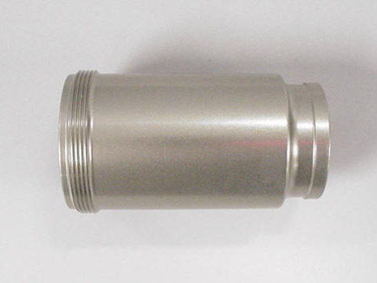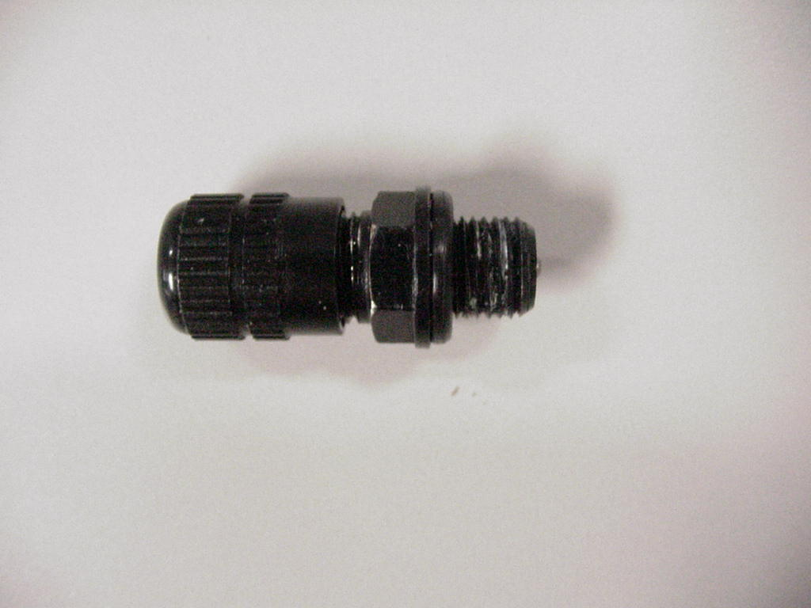
A - Air Canister A - Air Valve Assembly

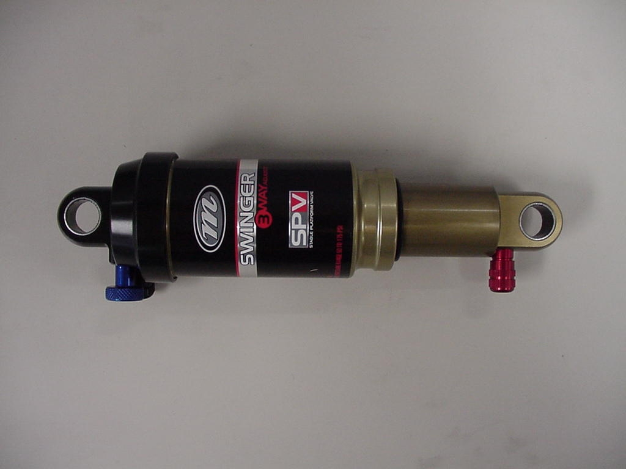
B – 3 Way Swinger Air Shock, No Hardware B – 4 Way Swinger Air Shock, No Hardware

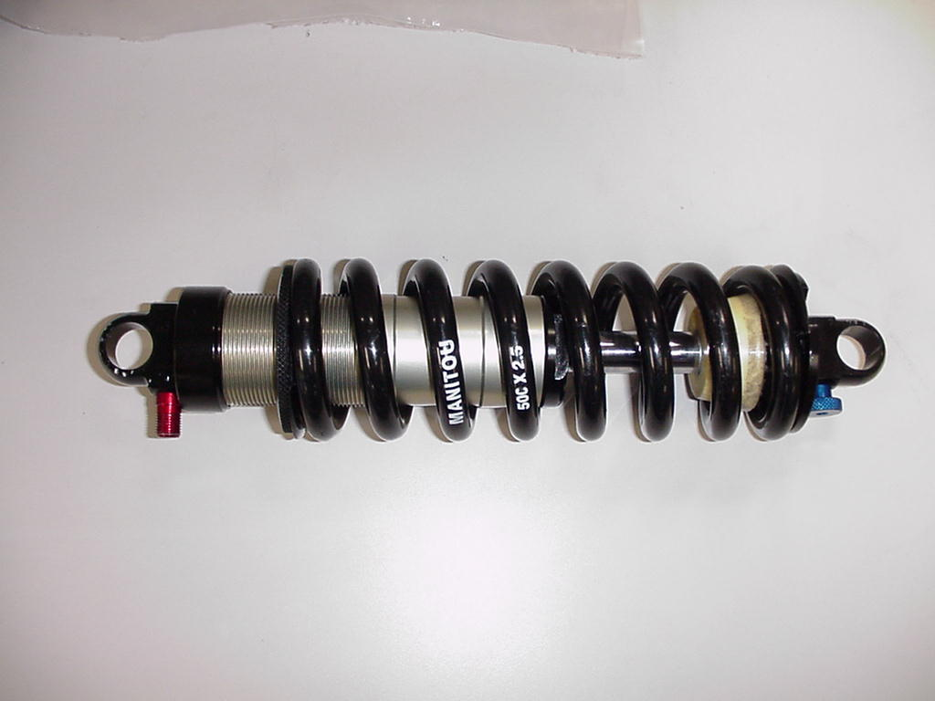
B – 3 Way Swinger Coil Shock, No Hardware, No Coil B – 4 & 6 Way Swinger Coil Shock, No Hardware, No Coil

B - Low and High Speed Adjuster Kit B- Rebound Adjuster Knob Kit

05 Swinger Rear Shock Service Kits - Description (CONT.)

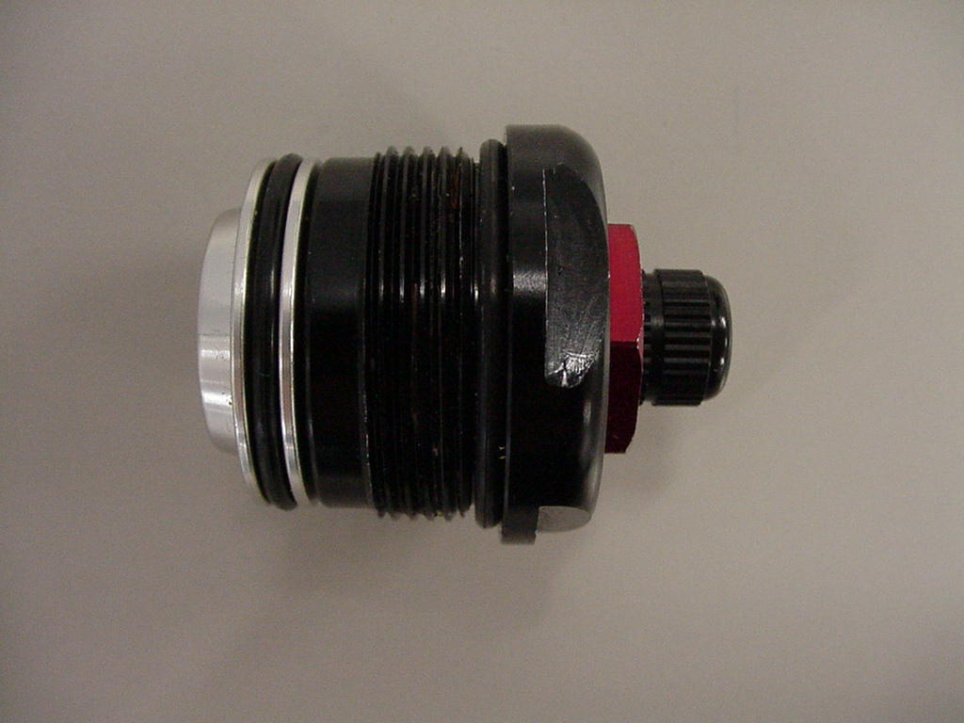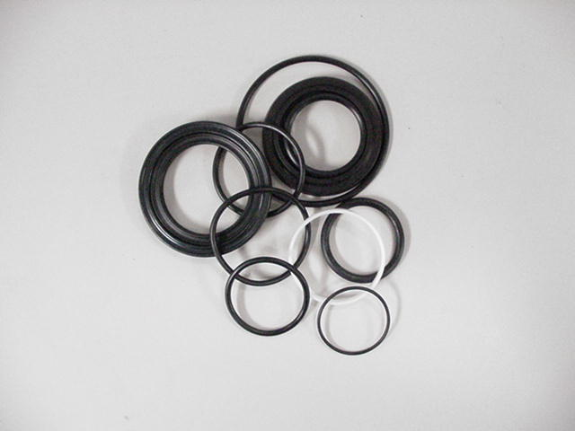
B- SPV Air Preload C - Seal Kit

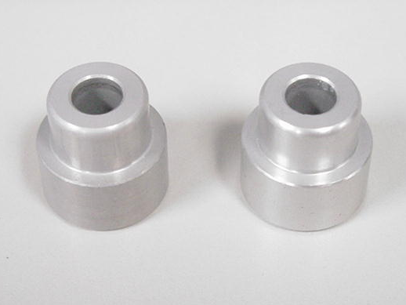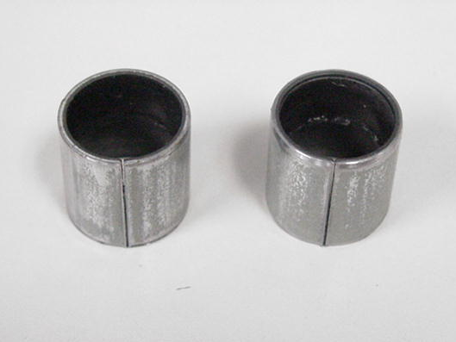
D - Hardware E - DU Bushing Kit

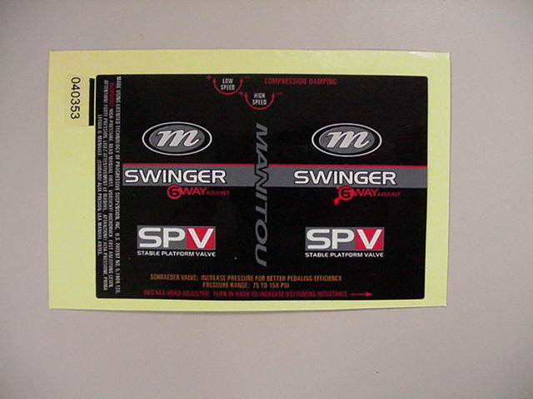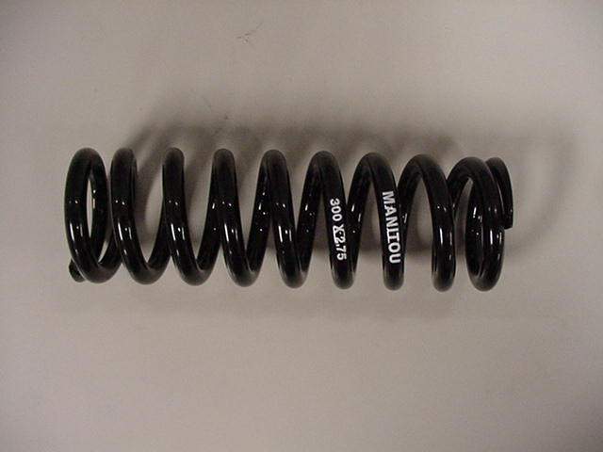
F - Sticker Kit G - Ride Kits

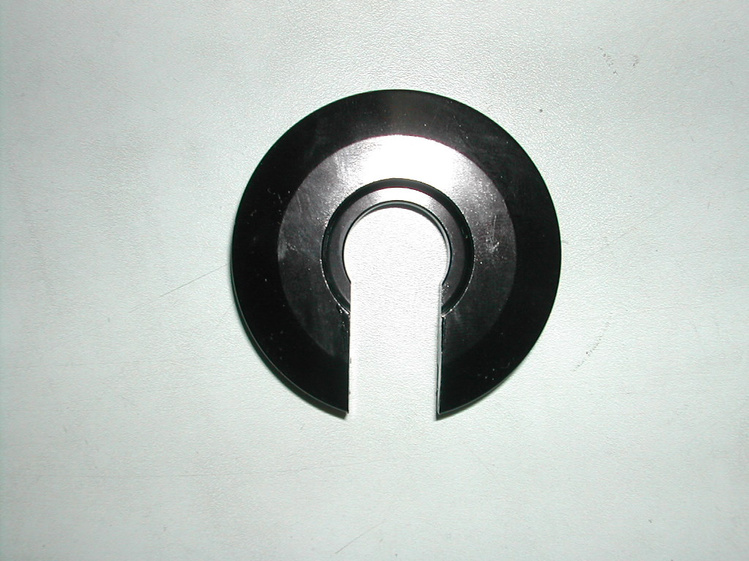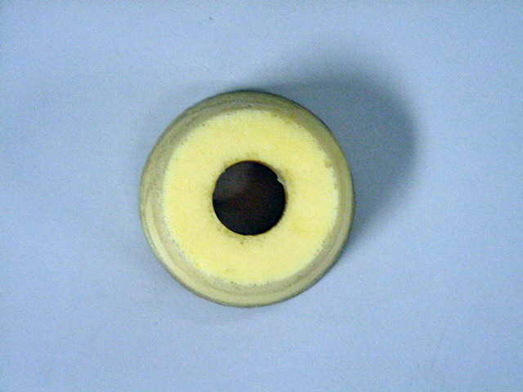
G – Spring Collar G - Bottomout Bumper
05 Swinger Rear Shock Service Kits - Description (CONT.)

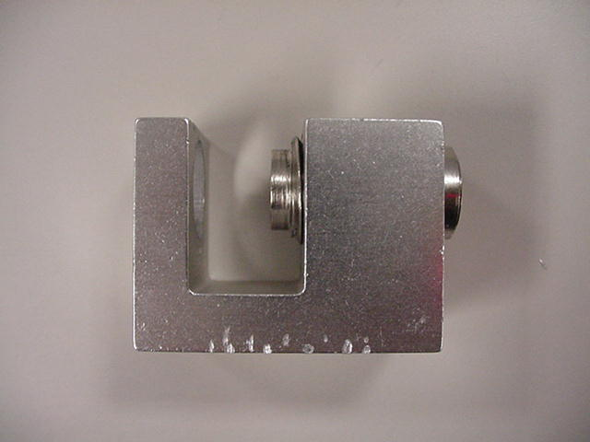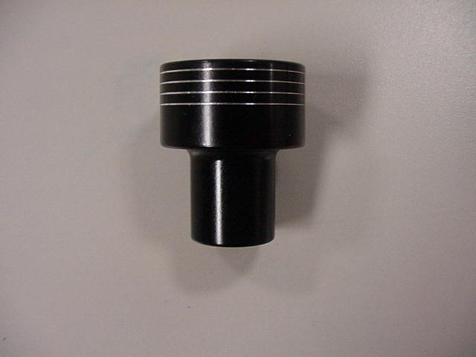
H - DU Bushing Tool H - Swinger Air Reservoir Volume Tool

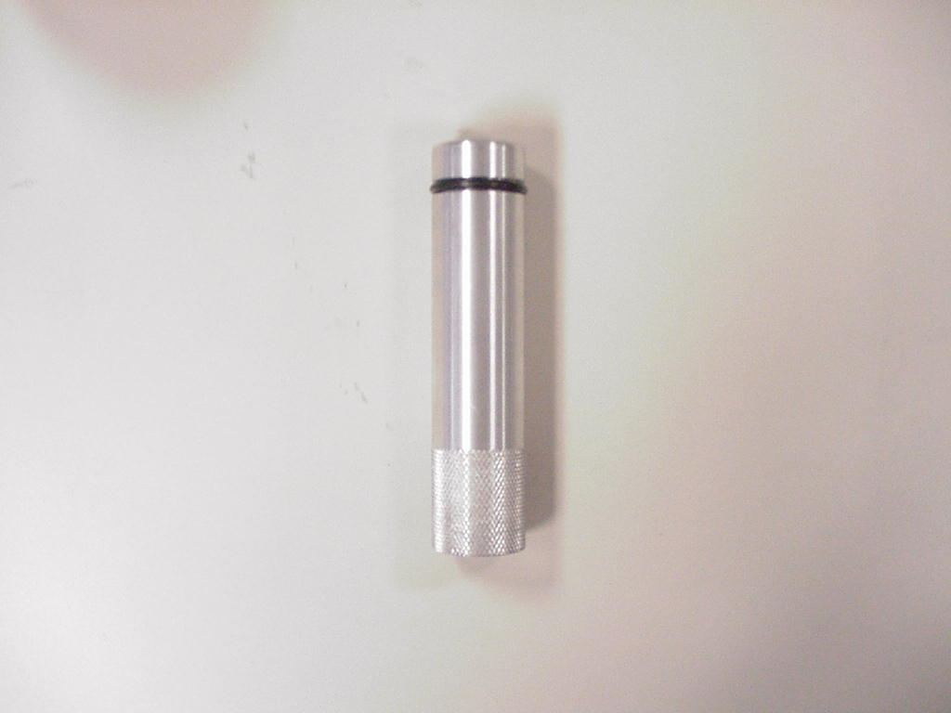
H - Swinger IFP Locating Tool H - Swinger Air IFP Removal Tool

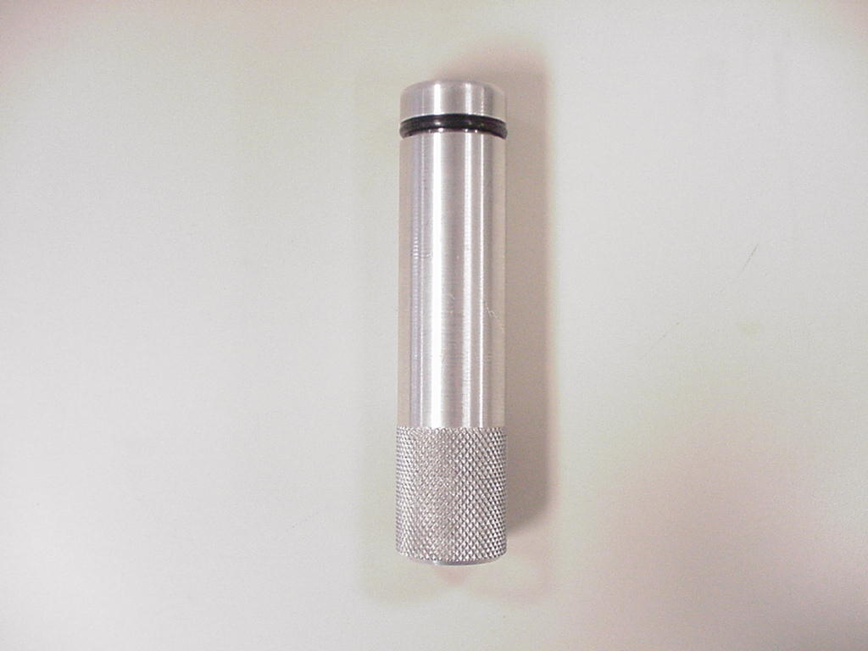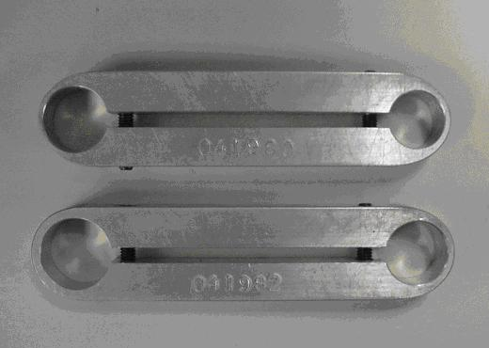
H - Swinger Coil IFP Removal Tool H - 6 Way Damper Body and Reservoir Clamp

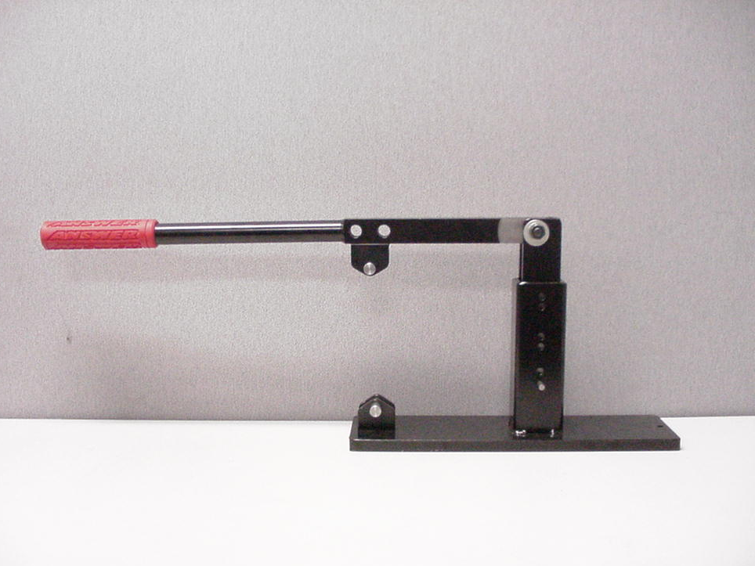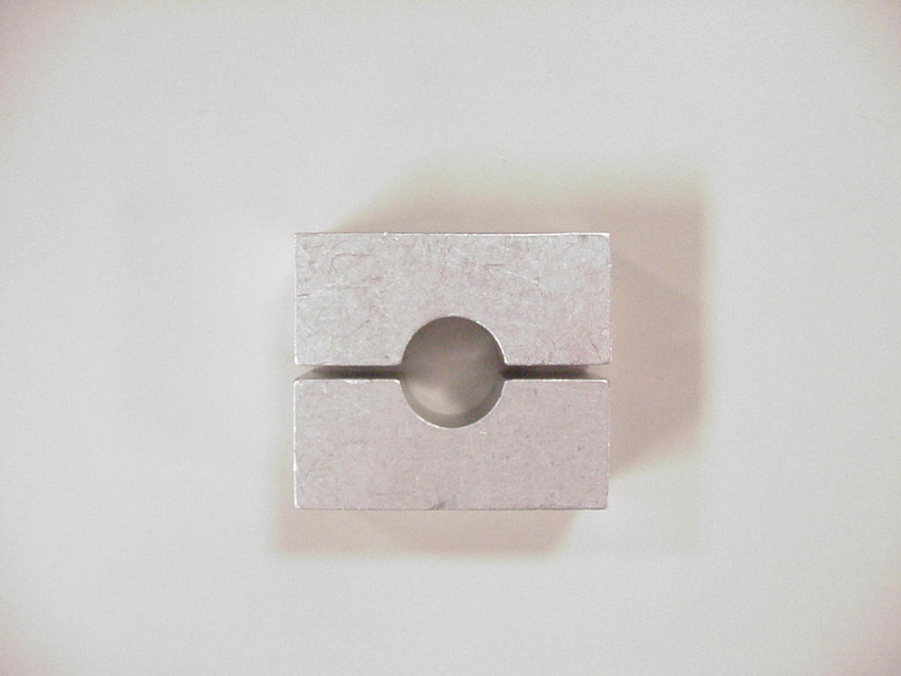
H - Rear Shock Compression Test Fixture H - 1/2" Soft Jaws

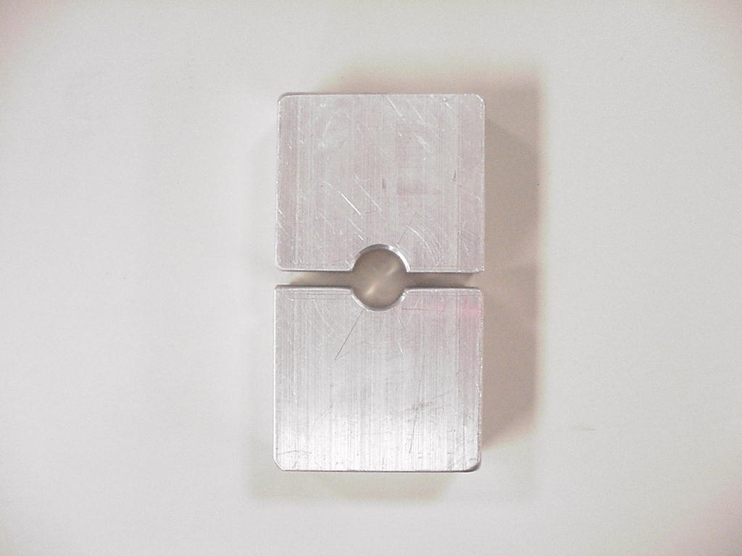
H - 10mm Soft Jaws

