2004 Black Service Manual

Rev NC

Table of Contents

Description | Page

Introduction | 3
Front Suspension Terminology | 4
Disassembly Instructions | 8
Assembly Instructions | 11
Travel Adjust Systems: Wind Down | 14
Bushing Removal and Installation Instructions | 17
Troubleshooting Chart | 21
Black 1 Schematic and Torque Specifications | 23
Black 2 Schematic and Torque Specifications | 24
Black 3 Schematic and Torque Specifications | 25
Black Service Kit Chart | 26

Contact Information

Answer Products Customer Service Department
28209 Ave. Stanford
Valencia, CA 91355

Toll Free: (800) 423-0273
Direct: (661) 257-4411
FAX: (661) 775-1798
E-mail: warranty@answerproducts.com
tech@answerproducts.com
Web site: www.answerproducts.com



INTRODUCTION

This manual is intended to guide the user through basic service of Manitou Black front forks. Service is supported by the identification of common parts and assemblies that have been assembled into Service Kits. The purpose of this manual will be to describe conditions that may drive the need for service and to provide installation instructions for the kits.

Due to the time-consuming nature suspension fork service, at this time our primary focus is to offer service kits that minimize the amount of downtime and labor involved.

Important information is highlighted in this manual by the following notations:

WARNING
Failure to follow WARNING instructions could result in severe injury or death to the person inspecting or repairing the suspension fork or the user.

CAUTION
A CAUTION a caution indicates special precautions that must be taken to avoid damage to the product.

NOTE
A NOTE provides key information to make procedures easier or clearer

GENERAL WARNING: Suspension forks by design contain gases and fluids under extreme pressure and warnings contained in this manual must be observed to reduce the possibility of injury or possible death. Following these instructions can help you reduce the risk of being injured. Any questions in regards to the information in this manual should be directed to Answer Products Customer Service at (661) 257-4411.

WARNING Suspension forks use compressed air to provide fluid pressure in the damping system and spring resistance in Air models. BOTH systems must be relieved of pressure prior to servicing these systems. Failure to relieve air pressure could result in injury or possible death.

CAUTION: The Black suspension fork uses precision machined aluminum and other soft alloy components. Using correct tools for assembly is essential to prevent damage.

GLOSSARY OF TERMS

Air Cap – Top cap that threads into top of air/spring leg (this is the left leg of the fork as you are seated on the seat). Forks may be controlled with an air/spring or a coil spring. The air cap contains the Schrader Valve, which is used to control the spring rate or SAG of air forks.

Air Spring – A mechanism that is used to control the SAG of an air fork.

Arch – A support that connects the two outer lower legs of the casting so as to keep them moving in unison.

Boss – The word used to describe an outer casting that has brake posts for V-brakes or cantilever brakes.

Bottom Out Bumper – A rubber or elastomer device that absorbs the shock that occurs when a suspension is compression to its limit.

Bushings – A cylindrical sleeve between a fork stanchion tube (inner leg) and a fork outer casting (slider), which facilitates the sliding movement between these two parts.

Coil Spring – A coiled piece of metal that acts as a spring to help suspend a fork.

Compression – The phase of the suspension operation in which the wheel travels up, or travels closer to the frame. The suspension forks reaction to a bump in the trail.

Compression Damping – Restriction of the rate that the suspension compresses under load.

Crown Steerer Assembly – the stanchion legs (inner legs), the fork crown, and the steer tube pressed together as one assembly. This assembly is then finished by adding all of the fork internals and then outer casting (slider).

Damping – A function that modifies the rate of suspension compression or rebound.

Detent – An indentation that causes a rotating adjuster to stop at fixed increments.

Drop Out – The end of an outer casting (slider) where the wheel attaches.

FFD – Fluid Flow Damping. A Manitou patented low cost oil damping system. The compression damping is non-adjustable and the rebound damping may be non-adjustable or adjustable damping.
GLOSSARY OF TERMS (CONT.)

Fork Crown – The component that joins the stanchion tubes (inner legs) to the steer tube of the fork.

Hydraulic Fork Oil – Oil used in suspension designs to provide damping. It has special characteristics that determine how it reacts when exposed to compressed air, how it changes viscosity when its temperature changes, and how it moves through valves.

Hydraulic Lock Out – a condition caused when the mixture of air and damping oil is out of balance. It is caused when there is too little air space in a chamber, not allowing the fork to compress through its travel.

Lock Out – a special function that restricts the compression of the fork from moving. It is generally controlled by an external knob that is activated when a rider does not want the fork to move, thus eliminating extra energy needed to overcome the bobbing forces of the fork.

MCU – (Micro-Cellular Urethane) Special urethane that is filled with tiny air cells that act like springs when the elastomer is compressed.

No Boss - The word used to describe an outer casting that has no brake posts for V-brakes or cantilever brakes. This casting is to be used for disk brakes only.

Oil Damping – A system that uses the resistance to oil flow through holes in a valve to provide a means to alter the rate of suspension compression or rebound.

Oil Level – The level of damping oil needed for the optimal damping performance of a suspension. It is measured as the air space distance between the top of the stanchion leg (inner leg) and the height of the oil inside of the leg. The fork must be completely extended in order to get an accurate measurement.

O-Ring – A soft, flexible neoprene or Buna rubber ring with a round cross-section, which is used for sealing and retention.

Oil Weight – A description of the relative viscosity of oil, such as hydraulic oil. Oil with low weight numbers (5wt or 7wt) flow through valves with less resistance than higher weight numbers (10or 15 wt).

Outer Casting – (see Slider)

Preload – A condition of compressing a spring or elastomer before the operating loads are put on the suspension, so that it provides a stiffer spring rate.

Piston – In front suspension, the part of the damper that slides back and forth inside of the damping leg that houses the valves. It can also refer to the air piston in the air/spring assembly that slides back and forth compressing the air, thus causing a change in the spring rate of the suspension.
GLOSSARY OF TERMS (CONT.)

Porosity – The condition or property of having pores in a material that will allow gas or liquid to pass through it.

Rebound – The phase of the suspension operation in which the wheel returns to its original position on the ground after compression.

Rebound Damping – Restriction of the rate that the suspension rebounds when the compression load is relived.

Reverse Arch Technology – Also known as RA. It is a system that is designed to move the arch of a fork to the backside of a fork, rather than the conventional front position. It was designed to provide greater rotational torque strength to an outer casting (slider), without adding additional weight to the fork.

SAG – The amount a suspension fork compresses at rest with a normal load (rider’s weight).

Schrader Valve – Valve used to introduce air into a chamber.

Seal – A part, usually neoprene rubber or Buna, that keeps contaminants out and/or working fluids in.

Semi Bath – A lubrication system that uses a lubricating oil to keep the bushing surface and stanchion legs (inner legs) as friction free as possible during movement of the stanchion legs.

Spring Rate – The rate at which the resistance of a spring increases as it is compressed.

SPV – (Stable Platform Valve) new damping system that allows the rider to set the pedaling platform that he desires to pedal most efficiently in all situations. It is dependent on the pressure that the SPV valve experiences from the movement of the wheel vs. the terrain and the platform that is set by pressure introduced to other side of the SPV valve through changes of air pressure working on the damping oil.

Slider/Outer Casting – The tube (outer casting leg) of the suspension fork that remains fixed to the wheel. It slides up and down on the stanchion leg (inner leg).

Stanchion Clamps - (Double-Triple Clamps) the portions of the fork crown that clamp around the stanchion legs above and below the head tube of the bicycle frame on specific long travel applications.

Stanchion Legs – The suspension tube (inner leg) fixed to the fork crown. It remains stationary during the operation of the suspension.

Steer Tube – The long cylindrical tube that extends from the top of the fork crown. Its function is to be inserted into the bicycle head tube and attach the suspension to the bicycle frame.
GLOSSARY OF TERMS (CONT.)

Top Out Bumper – A rubber, coil spring, or elastomer device that absorbs the shock that occurs when the load is taken off a suspension so that it is allowed to rebound to its limits

TPC – (Twin Piston Chamber) a patented damping system that has independent pistons for rebound and compression. The system utilizes a mixture of air and oil in the damping leg of the fork to enhance the damping performance.

Travel – The amount that a wheel moves between the most compressed and the most extended states of the suspension

Viscosity – A description of how a liquid flows. Liquids with higher viscosity are thicker flow less easily or quickly than liquids with low viscosity. This has an affect on the damping speeds of rebound and compression.

Volume Control – A new system designed to work with SPV as a control of the compression ramp up rate of the fork. It has a range of adjustments from linear to very progressive.

Wiper Seal – A rubber material that is used as a seal to keep dirt and water out of the outer casting legs. It is not designed to keep air pressure or extreme oil pressure in. Manitou has the new Evil Genius wiper seals.

2004 Black Forks Disassembly and Rebuild Instructions

Disassembly Instructions

Removal of Outer Casting

Disassembly of Crown Steer/Leg Assembly

Bushing Removal and Installation

Assembly Instructions

Reassembly of Crown Steer/Leg Assembly

Installation of Outer Casting

Bushing Removal & Installation

Bushing Removal

(Note: use appropriate removal ring that corresponds to the leg diameter of the fork being repaired)

Leg Diameter | Answer Kit #
25.4mm (1”) | 85-5191
28.6mm (11/8”) | 85-5189
30mm | 85-5194
32mm | 85-5192

Bushing Removal Tool Components  - Slide Hammer  - Threaded Handle  - Slide  - Threaded Shaft  - Removal Ring | 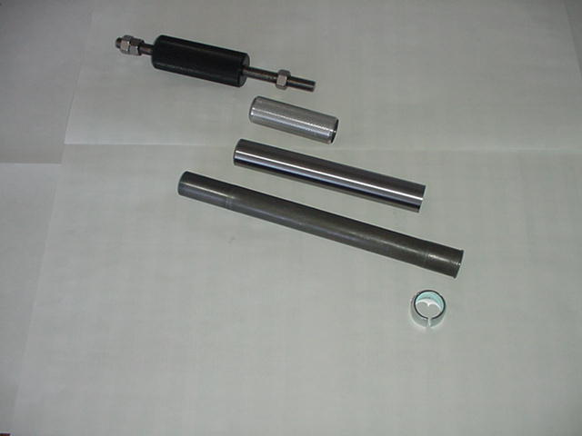
Bushing Removal Tool Assembly | 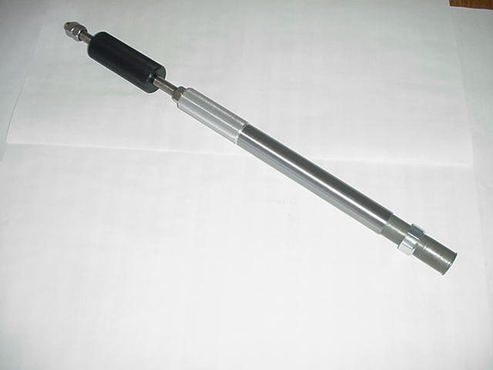

Bushing Removal (CONT.)

Bushing Removal Instructions  - Install 25.4mm Removal ring on the shiny, smaller diameter threaded shaft. Be sure to install the ring with the tapered, chamfered end first, followed by the long slide tube. This tapered end leads the tool through the bushing.  - Start the procedure by removing the Dust/Wiper seal with a screwdriver, prying it out.  - Insert Removal tool past the upper bushing and then stop. It is important to pull one bushing out at a time. Push the slide on the threaded shaft down towards the removal ring. Hold the casting with one hand and the slide hammer with your other hand. Now move the slide hammer in a motion away from the casting and repeat this action until the bushing comes out.  - For all other leg diameters: use the larger diameter (dark colored) threaded shaft and repeat steps A-C. | 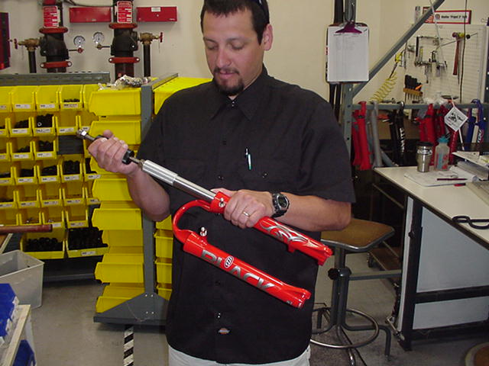

Bushing Installation

(Note: Sizer kits listed in above chart contain the sizers needed for each specific leg diameter.)

Bushing Installation Tool Components  - Installation Mandrel  - Threaded Rod w/nuts  - Sizer rings  - Spacer  - Washer  - Nut | (1) (2)  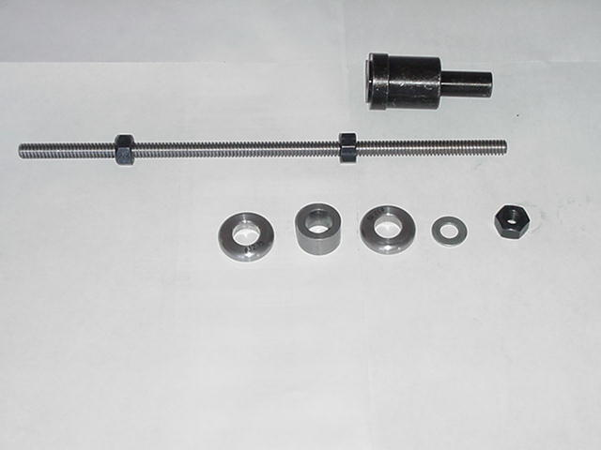  (3) (4) (3) (5) (6)

Bushing Installation (CONT.)

Bushing Installation Tool Assembly  With weighted handle | 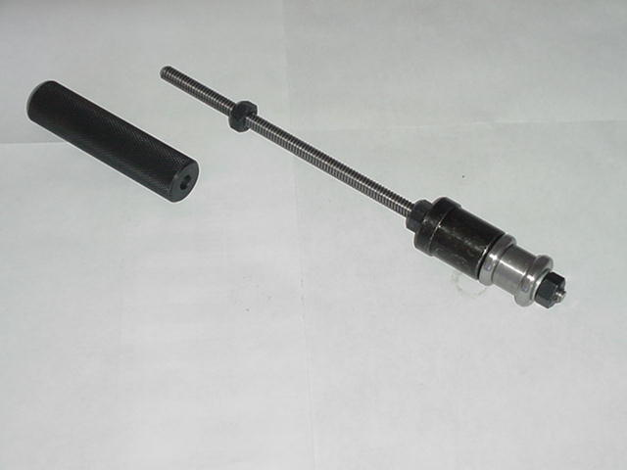
When selecting sizer rings to install bushings, choose the two rings that are in the middle of the size run to start with.  - Assemble installation tool as shown in picture above. Each leg diameter kit has all of the needed pieces to remove and install bushings for forks with serviceable bushings. Some of the kits come with gauges to tell you how far to drive in the lower bushings. Upper bushings are driven in as far as the stop in the top of the casting will allow. The general rule of thumb is that the lower bushings must not be driven any deeper than 5” into a casting leg. If they do go deeper, call Customer Service at Answer Products – 800-423-0273 for a new outer casting.  - Always assemble Mandrel with the larger diameter sizer ring being placed on the mandrel first, then the spacer, the next largest sizer ring, followed by the washer and the nut to hold it in place. Be sure to lock the nut above the Mandrel and below the Mandrel against each other. | 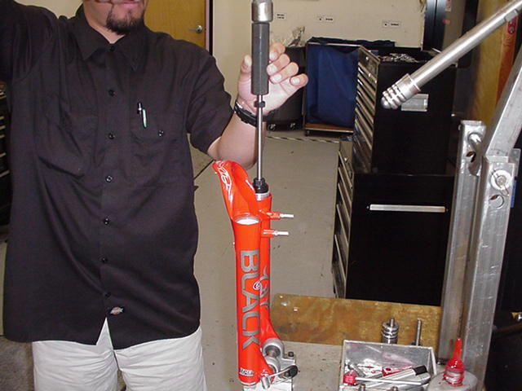
- Replace the lower bushing (bushing with a thicker wall diameter) first. Place a small amount of Prep M grease onto the sizer rings to help the rings come through the bushings when pulling them out. Slide bushing onto Mandrel until it stops. Apply a bead of Red Loctite all the way around the outside of the bushing. Hold casting on top of bench with a rag under the end of the legs and insert installation tool with bushing into casting leg. | 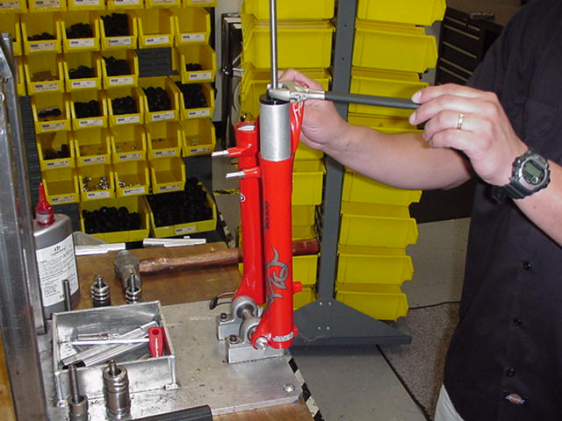
Bushing Installation (CONT.)

- Slide weighted handle onto end of threaded rod and tap rod into casting with rubber Mallet until proper depth is achieved. If using depth gage, slide gage onto rod before installing weighted handle and let it settle on of Mandrel. Tap rod until appropriate line on gage is even with top of casting leg.

- Remove weighted handle and gage (if applicable).

- For sizing of the lower bushing:

- Use slotted top cap from sizer kit and set it into the top of the casting leg, straddling the threaded rod. Spin the extra nut with washer down to the top cap and using a wrench, socket, or speeder wrench, tighten the nut in a clockwise direction. This will cause the Mandrel to be pulled through the bushing, thus sizing it. Keep turning the nut until the tool is all the way through the bushing and can be pulled out of the leg.

- To install top bushings, repeat steps B-E. Note that the top bushing gets inserted until it stops against the step inside of the casting. The extra sleeve that comes with the sizer kit is used to space the top cap off of the casting, so that there is enough room to pull the sizers out of the casting without bottoming on the cap.

- If you find that the bushings are too tight after installing them, use the sizer Mandrel that does not have a stop on it to hold the bushing while installing it into the casting. This is available in the 25.4mm leg kit (85-5191) to go back in and resize the bushings.

- To resize bushings, Choose the next larger size rings and repeat the above process.

- When satisfied with the results, reinstall Dust/wiper seals and then reassemble fork

TROUBLESHOOTING

Symptom | Cause | Solution | Service Manual Page
Air Loss | Schrader Valve leaks | Tighten Valve core, replace bad parts as needed.
 | Air Cap O-ring leaks | Make sure O-ring is seated properly, replace parts as needed.
 | Air Piston leaks | Check oil volume on top of piston, replace parts as needed.
 | Air Top Cap leaks | Check O-ring, tighten cap to proper Torque, replace parts as needed.
Oil leaks from Wiper Seals | Seal not seated properly | Remove Casting from Inner Legs, reinstall or replace seals
 | Nicks or scratches on inner legs | Replace Crown/Steerer/Inner Leg Assembly
 | Too much Semi Bath oil | Follow instructions for removal and installation of Outer Casting
 | Wear | Remove Casting from Inner Legs, reinstall or replace seals
Oil leaks from bottom of Casting | Rebound damper shaft leaks | Replace Rebound Damping assembly
 | Rebound damper shaft O-ring damaged | Replace O-ring on threaded end of Rebound Damping assembly
 | Compression Rod Bolt leaks | Check O-ring on bolt to see if it is damaged and then reinstall
Lack of Travel | Tight Bushings | Resize bushings or replace with new ones if damaged
 | Hydraulic lock out | Replace Rebound Damping assembly
 | Semi Bath oil volume | Follow instructions for removal and installation of Outer Casting
 | Damper oil volume | Check oil level, Replace Rebound Damping assembly if needed
 | Fork alignment | Visually inspect fork, call Answer Products Customer Service
Loss of SPV damping | SPV valve not functioning | Inspect for damage, check valve gap, replace assembly if needed
 | Damper oil volume | Check oil level, refer to "Oil leaks from bottom of Casting"
 | Rebound knob does not turn | Replace Rebound Damping Assembly
 | Loss of SPV air pressure | Refer to "Air Loss- Schrader valve leaks and Air Cap O-ring Leaks"

TROUBLESHOOTING (CONT.)

Symptom | Cause | Solution | Service Manual Page
Fork Top out | Loss of Rebound Damping | Replace Rebound Damping assembly
 | SPV Valve not functioning | Refer to " Loss of SPV Damping - SPV valve not functioning"
 | Top out spring damaged | Inspect and replace Top out spring if needed.
 | Damping oil volume not correct | Check oil level, Replace Rebound Damping assembly if needed
Fork Bottom out | Too much SAG | Refer to SAG Set up in Tuning section of Owners Manual
 | Bottom out Bumper damaged | Inspect and replace Bottom out Bumper if needed
 | Damping oil volume not correct | Check oil level, Replace Rebound Damping assembly if needed
Play in Fork | Loose bushings | Resize bushings or replace with new ones if damaged
 | Loose Compression Rod bolt | Tighten bolt to specified torque
 | Loose Rebound damping shaft | Tighten Shaft to specified torque
 | Loose press fit tolerances | Call Answer Products Customer Service

Black Comp & Elite: Fastener Torque and Setup Levels

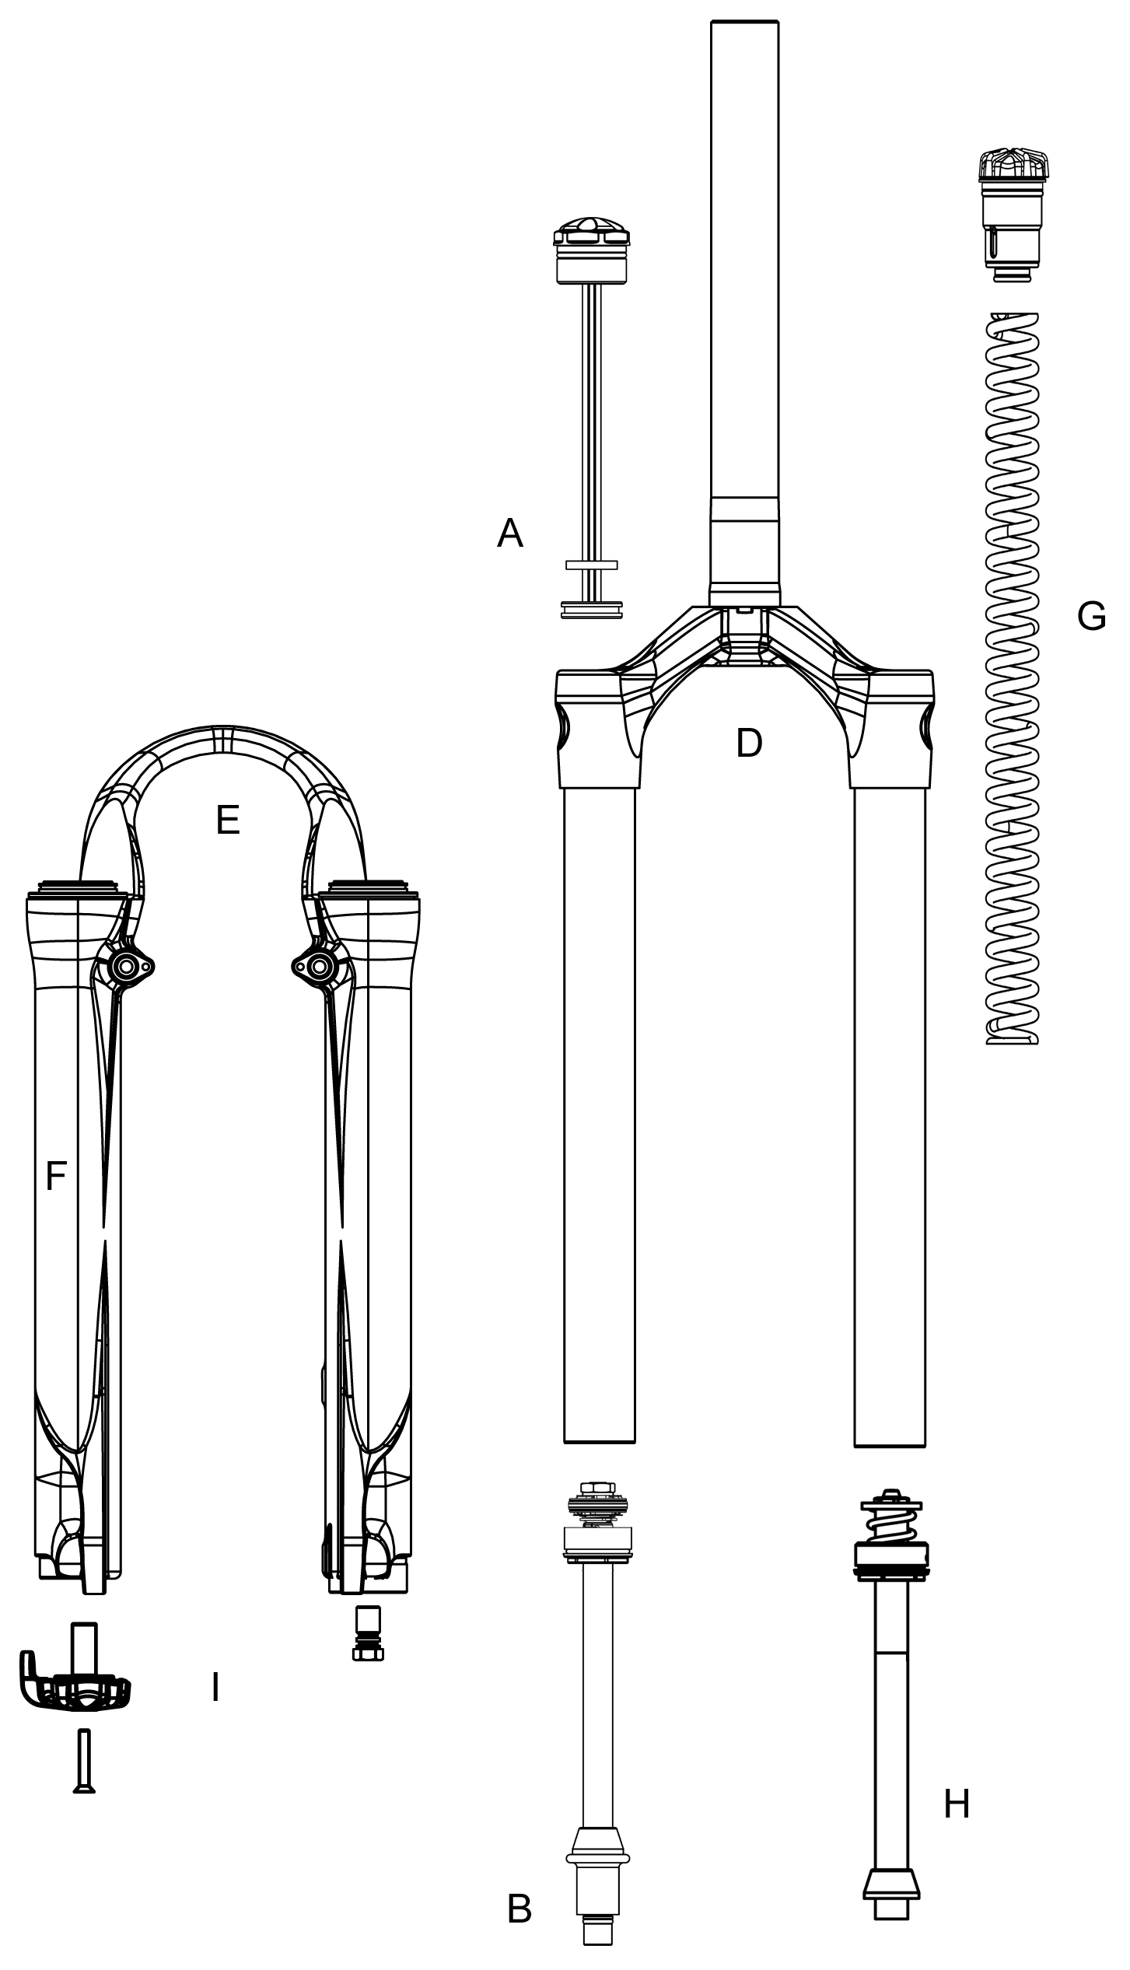

Model: Black Comp & Elite

Description | Torque Values
Torque – Brake Post | 90–110inlbs (10.2-12.4nm)
Bushing Depth – Upper | 13.8mm (.5”) Min
Bushing Depth – Lower | 98 – 110mm (3.9 – 4.3”)
Leg Caps | 25–35inlbs (2.8-4.0nm)
Torque - Comp Rod Screw | *15 – 61KgCm (13 – 53inlbs)
Torque - Damper Screw | *15 – 24KgCm (13 – 20inlbs)
Adjuster caps & Top Caps | 35-50inlbs (4.0-5.7nm)
Semi Bath Oil Volume | 16cc per leg
Damping Oil
Damping oil Level – Non SPV | 110 – 120mm (4.3 – 4.7”)

Black Super: Fastener Torque and Setup Levels

Black Super Air Black Super Air SPV

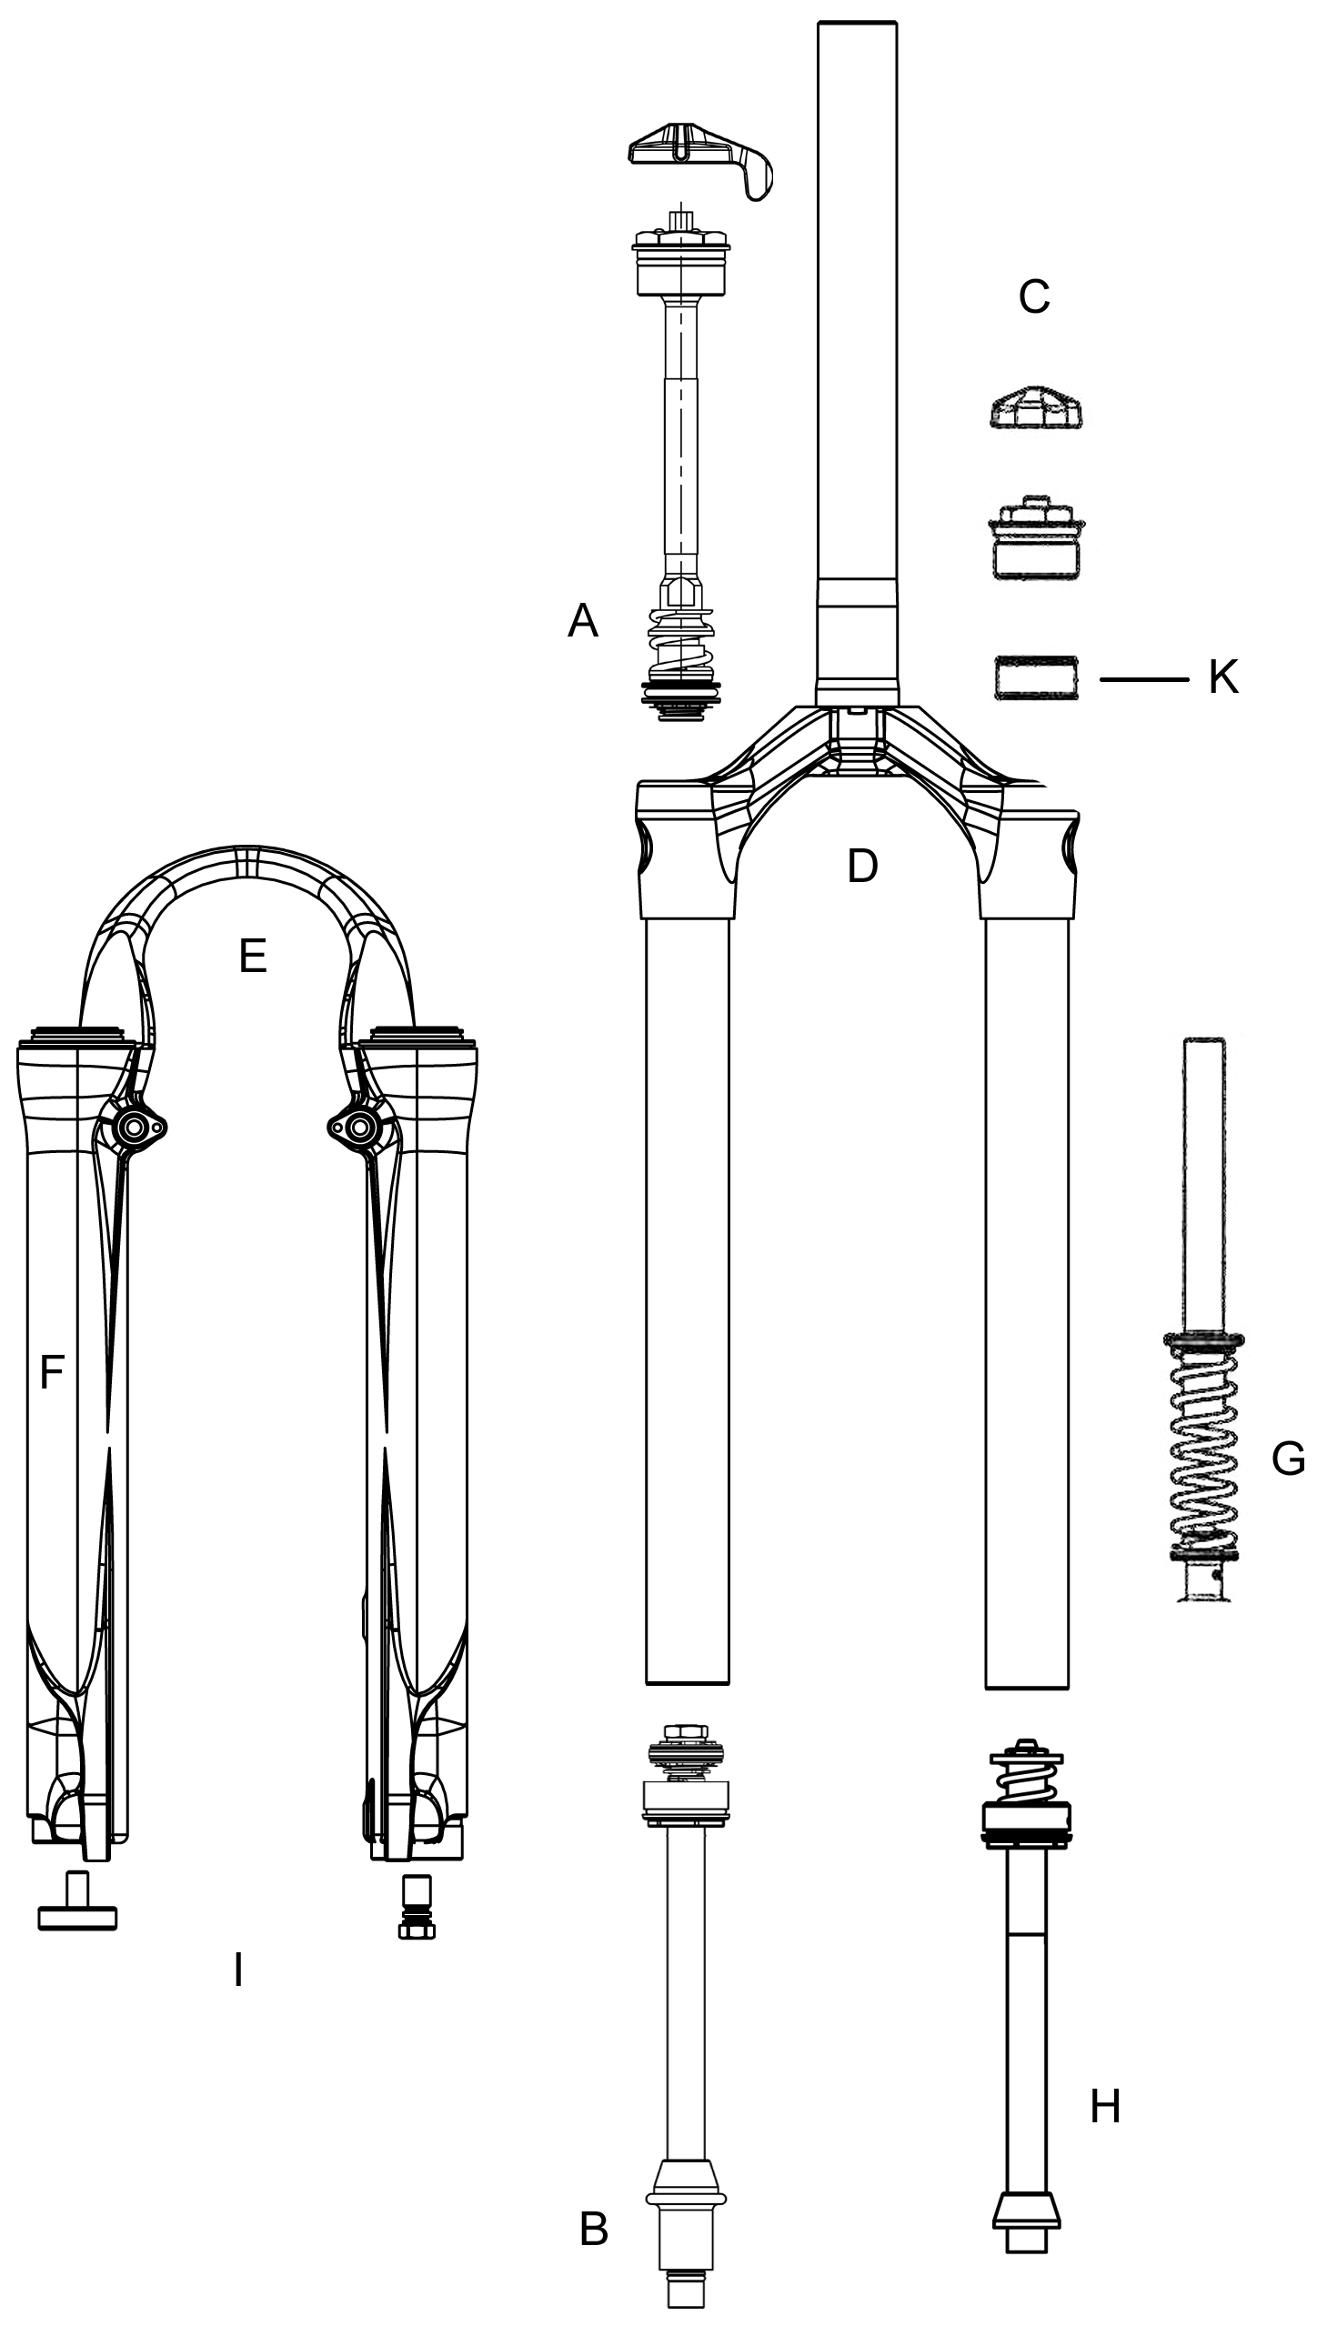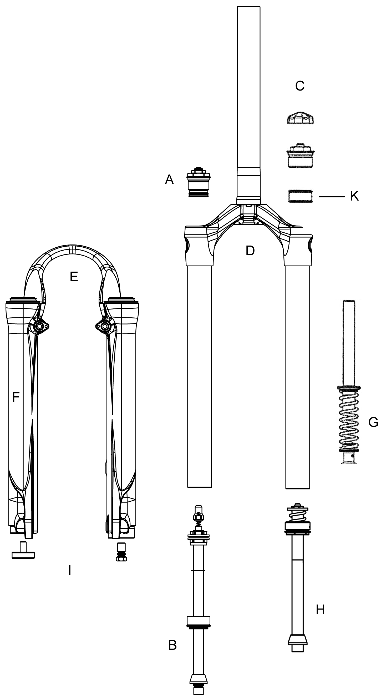

Model: Black Super Air and Super Air SPV

Description | Torque Values
Torque – Brake Post | 90–110inlbs (10.2-12.4nm)
Bushing Depth – Upper | 13.8mm (.5”) Min
Bushing Depth – Lower | 98 – 110mm (3.9 – 4.3”)
Air Preload Cap:
Torque | 50inlbs (5.7nm)
Schrader Valve Torque | 3-5inlbs (.34-.57nm)
Leg Caps | 25–35inlbs (2.8-4.0nm)
Torque - Comp Rod Screw | *15 – 61KgCm (13 – 53inlbs)
Torque - Damper Screw | *15 – 24KgCm (13 – 20inlbs)
Adjuster caps & Top Caps | 35-50inlbs (4.0-5.7nm)
Semi Bath Oil Volume | 16cc per leg
Damping Oil
Damping oil Level - Non SPV | 110 – 120mm (4.3 – 4.7”)
Damping oil Level – SPV 80mm Travel Forks | 68 – 72mm (2.7 – 2.8 ”)
Damping oil Level – SPV 100mm Travel Forks | 73 – 77mm (2.9 – 3.0 ”)
Damping oil Level – SPV 120mm Travel Forks | 78 – 82mm (3.1 – 3.2 ”)

Black Platinum: Fastener Torque and Setup Levels

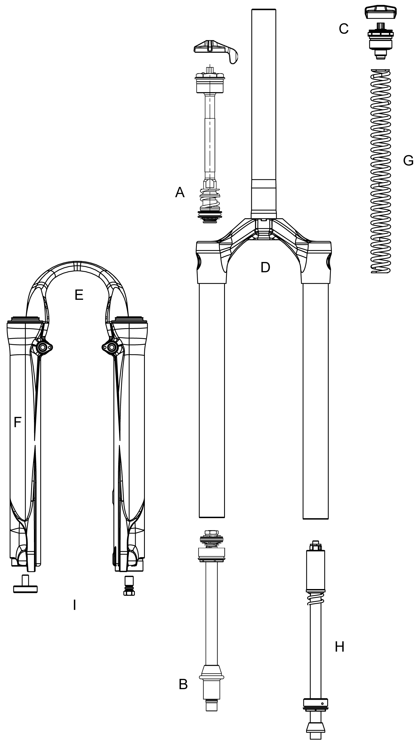

Model: Black Platinum

Description | Torque Values
Torque – Brake Post | 90–110inlbs (10.2-12.4nm)
Bushing Depth – Upper | *8.9mm Min. (.35”)
Bushing Depth – Lower | *99 – 106 mm (3.9 - 4.2”)
Leg Caps | 25–35inlbs (2.8-4.0nm)
Torque - Comp Rod Screw | *15 – 61KgCm (13 – 53inlbs)
Torque - Damper Screw | *15 – 24KgCm (13 – 20inlbs)
Adjuster caps & Top Caps | 35-50inlbs (4.0-5.7nm)
Semi Bath Oil Volume | 16cc per leg
Damping Oil
Damping oil Level - Non SPV | 110 – 120mm (4.3 – 4.7”)

Black Service Kits

Model |  | Comp |  | Elite |  | Super |  |  | Platinum
Code |  | K-410 | K-411 | K-420 | K-421 | K-425 | K-426 | K-427 | K-430
Travel (mm) |  | 100 | 120 | 100 | 120 | 80 | 100 | 120 | 90-120
Comp Damp | A | 85-5800 |  |  |  |  |  |  | 85-5868
Rbnd Damp | B | 85-5556 | 85-5365 | 85-5306 | 85-5802 | 85-5322 | 85-5306 | 85-5802
Pre Load Adj/Top Cap | C | 85-4472 |  |  |  |  |  |  | 85-5304
Air Cap | C |  |  |  |  | 85-5803
Crn/Str/Leg | D
 | Steel S/T (26") | 85-4838
 | AL S/T(26") STD |  |  |  |  | 85-4446 | 85-4447 | 85-4448 | 85-4469
 | AL S/T(26") SPV | 85-4450 | 85-4451 | 85-4450 | 85-4451 | 85-4452 | 85-4453 | 85-4454 | 85-4451
Outer Leg Assy | E
STD | Black (26") | 85-5806
STD | Silver (26") | 85-5807
STD | Red (26") | 85-5808
STD | White | 85-5809
STD | Cobalt | 85-5824
STD | Orange | 85-5825
STD | Yellow | 85-5826
STD | Candy Chrome | 85-5827
STD | Candy Red | 85-5828
STD | Candy Blue | 85-5829
No Boss | Black (26") | 85-5830
No Boss | Silver (26") | 85-5831
No Boss | Red (26") | 85-5832
No Boss | White | 85-5833
No Boss | Cobalt | 85-5834
No Boss | Orange | 85-5835
No Boss | Yellow | 85-5836
No Boss | Candy Chrome | 85-5837
No Boss | Candy Red | 85-5838
No Boss | Candy Blue | 85-5839
Sticker Kit | F - Silver | 85-5840 |  | 85-4441 |  | 85-4443 |  |  | 85-4445
 | F - Black | 85-5841 |  | 85-4440 |  | 85-4442 |  |  | 85-4444
Ride Kits | G
 | ***X-Soft | 85-5842 | 85-5843 | 85-5842 | 85-5843 | 85-5573 |  |  | 85-4468
 | ***Soft | 85-5845 | 85-5846 | 85-5845 | 85-5846 | 85-5575 | 85-4985 | 85-4988 | 85-5847
 | ***Medium | 85-5848 | 85-5849 | 85-5848 | 85-5849 | 85-5577 | 85-4986 | 85-4989 | 85-5850
 | ***Firm | 85-5851 | 85-5852 | 85-5851 | 85-5852 | 85-5579 | 85-4987 | 85-4990 | 85-5853
 | ***X-Firm | 85-5854 | 85-5855 | 85-5854 | 85-5855 | 85-5581

Black Service Kits (Cont.)
Model |  |  | Comp |  |  |  | Elite |  |  |  | Super |  |  |  |  |  | Platinum
Code |  |  | K-410 |  | K-411 |  | K-420 |  | K-421 |  | K-425 |  | K-426 |  | K-427 |  | K-430
Travel (mm) |  |  | 100 |  | 120 |  | 100 |  | 120 |  | 80 |  | 100 |  | 120 |  | 90-120
Comp Rod/ |  | H
 |  | 80 |  |  |  |  |  |  |  |  |  | 85-5857
 |  | 100 |  | 85-5858 |  |  |  | 85-5858 |  |  |  |  |  | 85-5860
 |  | 120 |  |  |  | 85-5859 |  |  |  | 85-5859 |  |  |  |  |  | 85-5860
 |  | 90-120 RT Wind Down |  |  |  |  |  |  |  |  |  |  |  |  |  |  | 85-5864
 |  | End Cap Assy |  | 85-5364
Air Push Rods
 |  | 80 |  |  |  |  |  |  |  |  |  | 85-4422
 |  | 100 |  |  |  |  |  |  |  |  |  |  |  | 85-4427
 |  | 120 |  |  |  |  |  |  |  |  |  |  |  |  |  | 85-4428
Knob Kit |  | I |  | 85-5865 |  |  |  |  |  |  |  | 85-5866 |  |  |  |  | 85-5867
Seal Kit |  | K |  | 85-5281
Air Piston Kit |  | G |  |  |  |  |  |  |  |  |  | 85-5266
Bumper Kit |  | K |  | 85-5283
O-Ring Kit |  | K |  | 85-5282
Bushing Kit |  | E |  | 85-5321
Options:
*Damping
**Lock Out |  | A |  | 85-5868
**SPV Rebound |  | B |  | 85-5869
**SPV Volume Adj. |  | A |  | 85-5871
*Travel
**Wind Down |  | G |  | 85-5870

