2004 Minute Service Manual

Rev NC

Table of Contents

Description | Page

Introduction | 3
Front Suspension Terminology | 4
Disassembly Instructions | 8
Assembly Instructions | 11
Travel Adjust Systems: Rapid Travel I | 13
Travel Adjust Systems: Wind Down | 14
Bushing Removal and Installation Instructions | 17
Troubleshooting Chart | 21
Minute 1 Schematic and Torque Specifications | 23
Minute 2 Schematic and Torque Specifications | 24
Minute 3 Schematic and Torque Specifications | 25
Minute Service Kit Chart | 26

Contact Information

Answer Products Customer Service Department
28209 Ave. Stanford
Valencia, CA 91355

Toll Free: (800) 423-0273
Direct: (661) 257-4411
FAX: (661) 775-1798
E-mail: warranty@answerproducts.com
tech@answerproducts.com
Web site: www.answerproducts.com



INTRODUCTION

This manual is intended to guide the user through basic service of Manitou Minute front forks. Service is supported by the identification of common parts and assemblies that have been assembled into Service Kits. The purpose of this manual will be to describe conditions that may drive the need for service and to provide installation instructions for the kits.

Due to the time-consuming nature suspension fork service, at this time our primary focus is to offer service kits that minimize the amount of downtime and labor involved.

Important information is highlighted in this manual by the following notations:

WARNING
Failure to follow WARNING instructions could result in severe injury or death to the person inspecting or repairing the suspension fork or the user.

CAUTION
A CAUTION a caution indicates special precautions that must be taken to avoid damage to the product.

NOTE
A NOTE provides key information to make procedures easier or clearer

GENERAL WARNING: Suspension forks by design contain gases and fluids under extreme pressure and warnings contained in this manual must be observed to reduce the possibility of injury or possible death. Following these instructions can help you reduce the risk of being injured. Any questions in regards to the information in this manual should be directed to Answer Products Customer Service at (661) 257-4411.

WARNING: The Minute uses compressed air to provide fluid pressure in the damping system and spring resistance in Air models. BOTH systems must be relieved of pressure prior to servicing these systems. Failure to relieve air pressure could result in injury or possible death.

CAUTION: The Minute suspension fork uses precision machined aluminum and other soft alloy components. Using correct tools for assembly is essential to prevent damage.

GLOSSARY OF TERMS

Air Cap – Top cap that threads into top of air/spring leg (this is the left leg of the fork as you are seated on the seat). Forks may be controlled with an air/spring or a coil spring. The air cap contains the Schrader Valve, which is used to control the spring rate or SAG of air forks.

Air Spring – A mechanism that is used to control the SAG of an air fork.

Arch – A support that connects the two outer lower legs of the casting so as to keep them moving in unison.

Boss – The word used to describe an outer casting that has brake posts for V-brakes or cantilever brakes.

Bottom Out Bumper – A rubber or elastomer device that absorbs the shock that occurs when a suspension is compression to its limit.

Bushings – A cylindrical sleeve between a fork stanchion tube (inner leg) and a fork outer casting (slider), which facilitates the sliding movement between these two parts.

Coil Spring – A coiled piece of metal that acts as a spring to help suspend a fork.

Compression – The phase of the suspension operation in which the wheel travels up, or travels closer to the frame. The suspension forks reaction to a bump in the trail.

Compression Damping – Restriction of the rate that the suspension compresses under load.

Convertible Travel – A system used to alter the travel of a suspension fork. It requires moving a travel clip on the compression rod to a different position. This operation is accomplished by disassembling the fork and physically moving the travel clip on the compression rod.

Crown Steerer Assembly – the stanchion legs (inner legs), the fork crown, and the steer tube pressed together as one assembly. This assembly is then finished by adding all of the fork internals and then outer casting (slider).

Damping – A function that modifies the rate of suspension compression or rebound.

Detent – An indentation that causes a rotating adjuster to stop at fixed increments.

Drop Out – The end of an outer casting (slider) where the wheel attaches.

Dust Boot – Usually a piece of rubber in the shape of a cylinder with baffles to allow it to compress as the fork compresses through its travel. Its function is to help keep dirt and water from getting into the inner legs of the fork.

FFD – Fluid Flow Damping. A Manitou patented low cost oil damping system. The compression damping is non-adjustable and the rebound damping may be non-adjustable or adjustable damping.
GLOSSARY OF TERMS (CONT.)

Fork Crown – The component that joins the stanchion tubes (inner legs) to the steer tube of the fork.

Hydraulic Fork Oil – Oil used in suspension designs to provide damping. It has special characteristics that determine how it reacts when exposed to compressed air, how it changes viscosity when its temperature changes, and how it moves through valves.

Hydraulic Lock Out – a condition caused when the mixture of air and damping oil is out of balance. It is caused when there is too little air space in a chamber, not allowing the fork to compress through its travel.

Lock Out – a special function that restricts the compression of the fork from moving. It is generally controlled by an external knob that is activated when a rider does not want the fork to move, thus eliminating extra energy needed to overcome the bobbing forces of the fork.

MCU – (Micro-Cellular Urethane) Special urethane that is filled with tiny air cells that act like springs when the elastomer is compressed.

Micro Lube – Lubrication system that is operated by injecting small quantities of grease directly into ports that are inserted into outer casting legs. This enables the lubrication of the fork without having to disassemble it.

No Boss - The word used to describe an outer casting that has no brake posts for V-brakes or cantilever brakes. This casting is to be used for disk brakes only.

Oil Damping – A system that uses the resistance to oil flow through holes in a valve to provide a means to alter the rate of suspension compression or rebound.

Oil Level – The level of damping oil needed for the optimal damping performance of a suspension. It is measured as the air space distance between the top of the stanchion leg (inner leg) and the height of the oil inside of the leg. The fork must be completely extended in order to get an accurate measurement.

O-Ring – A soft, flexible neoprene or Buna rubber ring with a round cross-section, which is used for sealing and retention.

Oil Weight – A description of the relative viscosity of oil, such as hydraulic oil. Oil with low weight numbers (5wt or 7wt) flow through valves with less resistance than higher weight numbers (10or 15 wt).

Outer Casting – (see Slider)

Preload – A condition of compressing a spring or elastomer before the operating loads are put on the suspension, so that it provides a stiffer spring rate.

Piston – In front suspension, the part of the damper that slides back and forth inside of the damping leg that houses the valves. It can also refer to the air piston in the air/spring assembly that slides back and forth compressing the air, thus causing a change in the spring rate of the suspension.
GLOSSARY OF TERMS (CONT.)

Porosity – The condition or property of having pores in a material that will allow gas or liquid to pass through it.

Rapid Travel I, II, Wind Down – Systems that are used to control the travel of suspension forks. Also known as RTI, RTII, and WD. RTI and RTII are used for the specific purposes of controlling the travel in two conditions: climbing and descending. WD is an incremental travel adjustment between to set limits and does not affect the spring rate of the fork as severely as RTI and RTII.

Rebound – The phase of the suspension operation in which the wheel returns to its original position on the ground after compression.

Rebound Damping – Restriction of the rate that the suspension rebounds when the compression load is relived.

Reverse Arch Technology – Also known as RA. It is a system that is designed to move the arch of a fork to the backside of a fork, rather than the conventional front position. It was designed to provide greater rotational torque strength to an outer casting (slider), without adding additional weight to the fork.

SAG – The amount a suspension fork compresses at rest with a normal load (rider’s weight).

Schrader Valve – Valve used to introduce air into a chamber.

Seal – A part, usually neoprene rubber or Buna, that keeps contaminants out and/or working fluids in.

Semi Bath – A lubrication system that uses a lubricating oil to keep the bushing surface and stanchion legs (inner legs) as friction free as possible during movement of the stanchion legs.

Spring Rate – The rate at which the resistance of a spring increases as it is compressed.

SPV – (Stable Platform Valve) new damping system that allows the rider to set the pedaling platform that he desires to pedal most efficiently in all situations. It is dependent on the pressure that the SPV valve experiences from the movement of the wheel vs. the terrain and the platform that is set by pressure introduced to other side of the SPV valve through changes of air pressure working on the damping oil.

Slider/Outer Casting – The tube (outer casting leg) of the suspension fork that remains fixed to the wheel. It slides up and down on the stanchion leg (inner leg).

Stanchion Clamps - (Double-Triple Clamps) the portions of the fork crown that clamp around the stanchion legs above and below the head tube of the bicycle frame on specific long travel applications.

Stanchion Legs – The suspension tube (inner leg) fixed to the fork crown. It remains stationary during the operation of the suspension.

Steer Tube – The long cylindrical tube that extends from the top of the fork crown. Its function is to be inserted into the bicycle head tube and attach the suspension to the bicycle frame.
GLOSSARY OF TERMS (CONT.)

Thru Axle – A device used for mounting a thru axle hub to special outer legs that are not made for standard quick release hubs. Manitou’s Thru Axle system is a special patented system utilizing a hex shaped end that increases the stiffness of the fork and reduces slippage in the joint between the axle clamps and the axle.

Top Out Bumper – A rubber, coil spring, or elastomer device that absorbs the shock that occurs when the load is taken off a suspension so that it is allowed to rebound to its limits

TPC – (Twin Piston Chamber) a patented damping system that has independent pistons for rebound and compression. The system utilizes a mixture of air and oil in the damping leg of the fork to enhance the damping performance.

TPC+ - A variation of TPC that has added a floating piston to the compression damper to enhance the performance of the compression damping under the load of bigger hits.

Travel – The amount that a wheel moves between the most compressed and the most extended states of the suspension

Viscosity – A description of how a liquid flows. Liquids with higher viscosity are thicker flow less easily or quickly than liquids with low viscosity. This has an affect on the damping speeds of rebound and compression.

Volume Control – A new system designed to work with SPV as a control of the compression ramp up rate of the fork. It has a range of adjustments from linear to very progressive.

Wiper Seal – A rubber material that is used as a seal to keep dirt and water out of the outer casting legs. It is not designed to keep air pressure or extreme oil pressure in. Manitou has the new Evil Genius wiper seals.

2004 Minute Forks Disassembly and Rebuild Instructions

Disassembly Instructions

Removal of Outer Casting

- On forks with Rapid Travel Adjust or Wind Down, be sure to set travel to its longest setting. For Rapid Travel, rotate knob on bottom right of fork leg clockwise towards the front of the fork and then push down on the fork to release its travel into the longest mode. For Wind Down, rotate adjuster on top left of fork crown counterclockwise until it stops. This will relieve spring tension on the fork. More complete instructions for servicing Travel Adjust systems may be found in the “Travel Adjust “section.
- Turn the fork upside down and remove the fixing screws that attach the Rebound Adjuster Knob (Blue) and/or the Rapid Travel 1, (Red) Travel Adjust knob. Set both knobs and screws aside.
- (Note: there will be three small pieces under the Red knob – wave washer, detent spring, and a plastic detent plate.)
USE: 2mm Allen wrench to unscrew fixing screws.
- Remove the 11mm Compression Rod bolt from the bottom of the left leg (From the rider's perspective).
USE: 11mm socket, nut driver, or open-end wrench.
- Insert 8mm Allen wrench into the end of the Rebound Damper Shaft on the bottom of the right leg. Turn the wrench in a Clock Wise direction in order to loosen the damper shaft in the casting (See Figure below). You are turning the Damper Shaft in a way that causes it to disappear into the casting leg.

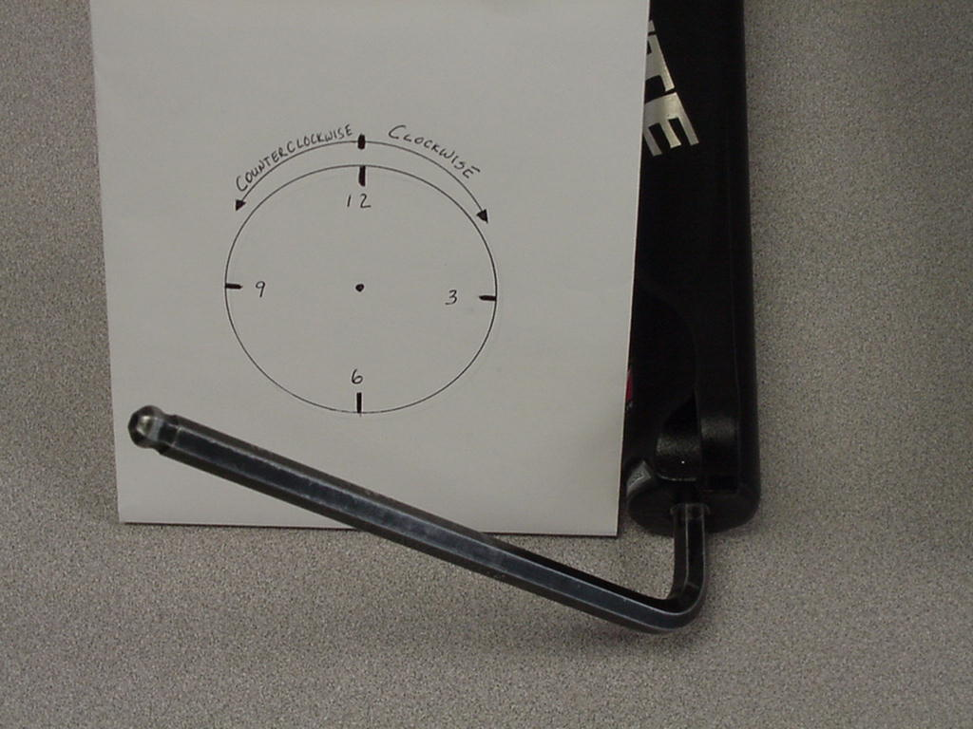

USE: 8mm Allen wrench
6. Working with the “Semi Bath” lubrication system:
- Position the bottom of the fork legs over a drain pan that is on the ground. Pull the casting downward towards the pan, allowing the Semi Bath oil in the casting to drip into the pan. Pull the casting completely off of the inner legs and wipe any excess oil off of inner legs and inside of casting.
USE: Drainage pan and extra rags

Removal of SPV Compression Damping Assembly

- Remove Schrader valve dust cap from Red Hex Shaped Top Cap on the top right of the crown. Release all air pressure from the Schrader valve.

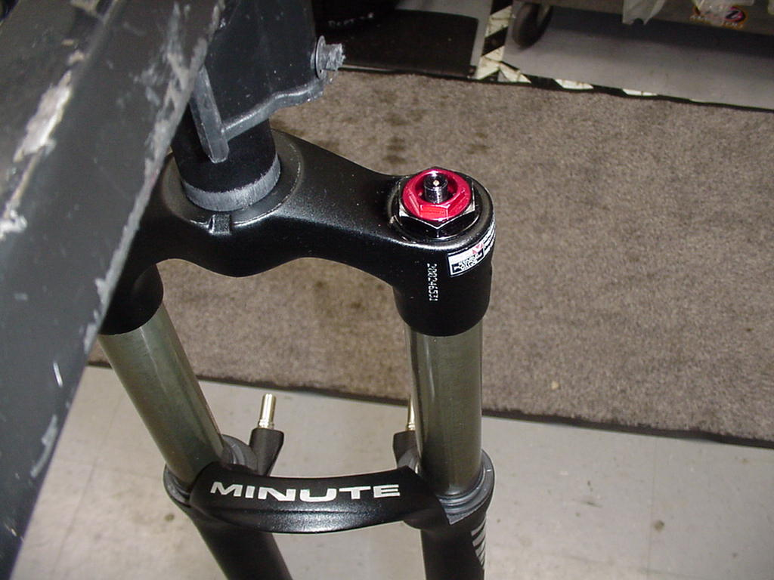

- Remove SPV Volume Control Cap (Red Hex Shaped Top Cap) from top right of the crown with a 24mm Socket. Turn fork upside down over drainage pan to empty Damping oil from the inner leg. Stroke the Damper shaft on the bottom of the inner leg 3-5 times to purge the leg of oil that is caught below the oil piston.
USE: 24mm Socket, Valve core removal tool or small object that
can be used to depress valve stem

Removal of SPV Rebound Damping Assembly

- Unscrew Damper end cap from the bottom of the right leg and then pull the SPV
- Damping assembly out of inner leg.

- 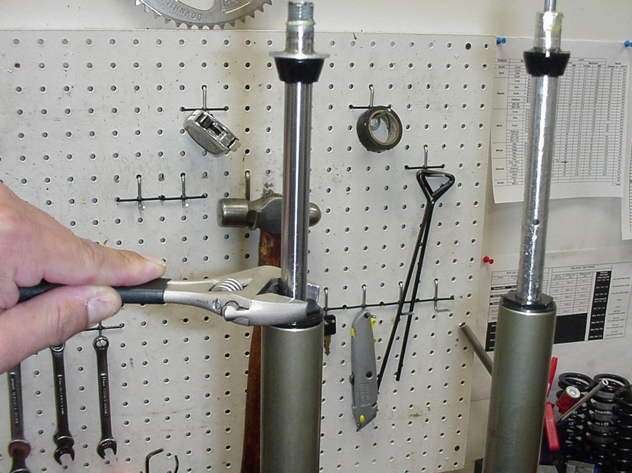

- (2) Checking the function of the SPV valve:
- Visually inspect the gap between the SPV valve and the bottom of the damping
- piston. It should have approximately 1mm of space. The valve should also spring back to its
- open rested position after compressing it with your fingers. If the valve is not responsive or all the time closed, it is bad and the assembly needs to be replaced
USE: 24mm Open-end wrench or 8-10” Adjustable wrench

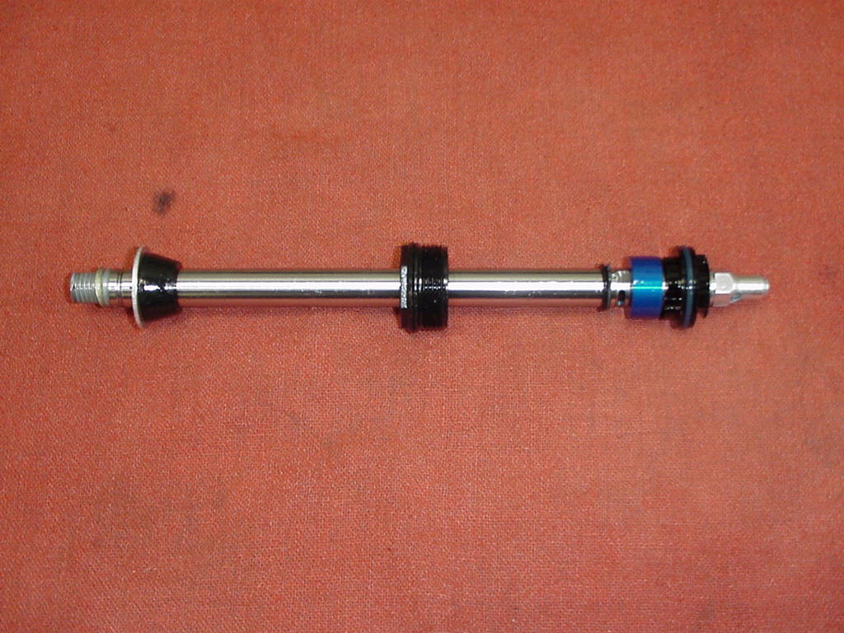
Check for 1mm gap between the blue SPV valve and the black piston

Removal of Spring and Compression Rod Assembly

- For Minute 2 & 3 forks (Air/spring systems as the spring): Remove all of the air pressure from the Schrader valve on top of the crown on the left side (Black top cap), by depressing the Schrader valve. Be sure to hold fork with the top of the crown facing upwards. (Note: When the air is released, this is a mixture of the oil and air inside the leg).
- If you have not removed the Outer casting, refer to the above section on Removal of Outer Casting, then proceed to next step.
- Unscrew the end cap on the bottom of the inner leg and remove compression rod assembly. This will consist of a compression rod, bottom and top out bumpers, the end cap, and should be followed by a coil spring and then another rod (air push rod). This spring is the one that would be changed if the fork’s SAG needed to be changed beyond the capabilities of the air pressure.
- For Minute 1 forks (Coil Springs only): Remove the adjuster knob from the top of the pre load adjuster assembly on the top of the crown on the right side of the fork, by unscrewing the 2mm Allen head screw. Use a 20mm socket and unscrew the remainder of the assembly from the crown. The spring will be attached to the bottom of the assembly, when you pull it form the inner leg.
- Pull the spring from the assembly and it can be substituted with a different rated spring if necessary.
- The compression rod assembly on a Coil fork may be removed in the same
- procedure as described above in the removal of an air spring.
  - USE: 24mm Open-end wrench or 8-10” Adjustable wrench,
    - 2mm Allen wrench, 24mm socket
- For more specific details on Wind Down, Rapid Travel I, refer to “Travel Adjust” section of this manual.

Removal of Air Piston on Forks with Air Spring

- Follow step1 in Forks that use Air/spring systems.
- There are now two ways to remove the air piston from the inner leg.
- An Air Piston Removal tool has been developed that will enable you to remove the piston without having to take the fork apart. (P/N: 85-8062). Without this new tool, you will need to follow the procedures in steps 2 & 3 in the above section, “Removal of Air/Spring as the spring”. Then proceed to step 3, below.
- Once the compression rod assembly is removed from the inner leg and the air cap is removed from the top of the inner leg, a long rod (at least 18”/460mm long and no larger in diameter than ¼” or 6-7mm) will be inserted through the bottom of the inner leg. Be sure to keep the end of the rod that is being inserted as centered as possible, it must go through the middle of the piston seat and then intersect the bottom of the piston. Once contact is made with the piston, use a Rubber mallet and tap the piston out through the top of the inner leg.

Bushing Removal & Installation

Please refer to section on Bushing Removal & Installation.

Assembly Instructions

Reassembly of Crown Steer/Leg Assembly

For Air Forks (Minute 2 & Minute 3)

- Grease the outside of the air piston and then apply a thin film of grease to the threads at the top of the inner leg. It is recommended to use Prep M grease (P/N: 85-0031). Push the piston into the top of the left inner leg with the metallic side of the piston facing you, using your thumb. Push the piston past the threads and then pour approximately 3-4cc’s of a 20-50wt oil (P/N: 85-0022) into the top of the piston. This oil needs to be checked about every 6-8 weeks of riding time. It will dissipate over time and then you may experience some air leakage and increased stiction in the fork movement.
- Install the air cap and tighten it to value given on fork schematic.
- Turn crown/steer/leg assembly over, so that the bottoms of the inner legs are facing you. In the same leg that you just installed the air piston and air cap into; insert the air push rod (longer end in first), then the positive spring (this is your ride kit spring) onto the short end of the push rod, then install the compression rod assembly, and tighten end cap into leg. Tighten to torque values that are listed on fork schematic.
- Now, install SPV damping assembly into bottom of other inner leg. Be sure to check the function of the SPV valve and apply a thin layer of Prep M grease onto o-ring that is around the piston at top of assembly. Install the assembly and tighten end cap to specified torque value.
- Turn Crown/steer/leg assembly right side up, so that the crown of the assembly is facing you. Extend the SPV damping assembly all the way out and then pour damping oil (P/N: 85-0023) into the right inner leg. Fill leg about ¼ of the way up. Take a rag and cover the top of the right inner leg and then stroke the SPV damping assembly up and down about 5times. This will insure that oil gets below the piston and not create an air space. Extend the damping assembly all the way out and then fill the inner leg to the specified oil level.
- Insert the Volume control assembly into the top of the right inner leg and tighten it to specified torque value. Be sure that you unscrew the red 16mm Hex shaped Volume control nut all of the way counterclockwise after you tighten the entire assembly into the inner leg.
- The crown/steer/leg assembly is now complete.
- Use: 8-10” adjustable wrench, Manitou Volume Control Adjuster (P/N: 85-3007), 24mm socket, metric ruler.
For Coil spring Forks (Minute 1):

- Turn the crown/steer/leg assembly over so that the bottoms of the inner legs are facing you. Install the compression rod assembly into the bottom of the left inner leg (the leg that was the left side of the fork when you are sitting on the bicycle) and tighten the end cap to specified torque value.
- Refer to step 4 above, for installation of SPV damping assembly.
- Refer to step 5 & 6 above, for completing the installation of the components of the damper leg.
- Refer to Wind Down assembly service instructions for reassembly of Wind Down assembly.
- The crown/steer/leg assembly is now complete.

Installation of Outer Casting

For Minute 1:

- Turn completed crown/steer/leg assembly upside down, so that the compression rod and SPV damper shaft are facing you. You will see a bottom out bumper on the SPV damper shaft; slide this bumper down towards the end cap that is threaded into the inner leg. This will help in keeping the shaft extended as you install the outer casting. You could also insert air into the damper leg through the Schrader valve on top of the right leg. This extra pressure will help to keep the shaft from moving.
- Press inner legs into casting about half way and then inject Semi Bath oil (5/40wt. synthetic oil, P/N: 85-0022) into outer casting, holding fork at 45 degree angle to the ground with bottom of fork in the air (drop outs up). Inject 16cc’s of oil into each outer leg. It is recommended to use a syringe to inject oil.
- Press inner leg assembly into outer leg casting until damper shaft contacts casting. (It is recommended to extend rebound damper out from end cap as far as it will go and then slide bottom out bumper towards the end cap as far as it will go. The bumper will help to hold the damper shaft in place as you are inserting the inner legs into the casting). Adjuster hex shaft should protrude slightly from casting.
- Use an 8mm hex wrench to turn the damper shaft counterclockwise, threading it into the casting. Torque to 20inlbs.
- Install rebound adjuster knob if applicable. Knob should turn uninhibited until the indicator is stopped by the casting. If not, remove knob and reinstall on hex shaft in 1/6 turn increments until full travel is reached.
- Install the compression rod screw and torque to 20inlbs
- Now follow steps 2 – 5 from the Wind Down Travel Adjust assembly instructions.

For Minute 2 Forks:

Follow steps 1-7 from Minute 1 Outer casting installation instructions, above.

For Minute 3 Forks: Follow steps 1-11 from Minute Rapid Travel I service (assembly) instructions.

Use: 8mm Allen wrench, 2mm Allen wrench, 11mm Nut Driver or open end wrench,
Syringe for Semi Bath Oil, Air pump

Travel Adjust Systems: Rapid Travel 1

Disassembly:

- Switch fork to longest travel setting.
- Place the fork upside down (dropouts up) and slowly remove the travel adjust knob using a 2mm Allen wrench. Three parts are found underneath the knob: wave washer, detent clip, and detent plate. Remove all parts to expose the 7/16 compression rod screw.
- Use a 7/16 wrench to remove the compression rod screw.
- Remove rebound adjuster knob if applicable using a 2mm Allen wrench.
- From the right leg dropout, use an 8mm Allen wrench to turn the damper shaft clockwise until it can be pushed into the casting.
- Remove crown/steer/inner leg assembly from the outer leg casting over a drain pan, due to Semi Bath oil may leak out of the bottom of the casting. Set casting aside in drain pan to allow all oil to drain from casting.
- Remove left leg end cap and travel adjust assembly from inner leg.

Assembly:

- Install travel adjust assembly into the left inner leg. Be sure that the adjuster dogs are retracted into the shaft allowing the spring to ride at the top of the rod. Twist the hex shaft (shaft where knob is attached) if necessary to retract the dogs, do not pull on the shaft. Start threads by hand and then torque to 20inlbs.
- Pull out damper shaft as far as it will go.
- Press inner legs into casting about half way and then inject Semi Bath oil (P/N: 85-0022) into outer casting, holding fork at 45 degree angle to the ground with bottom of fork in the air (drop outs up). Inject 16cc’s of oil into each outer leg. It is recommended to use a syringe to inject oil.
- Press inner leg assembly into outer leg casting until damper shaft contacts casting. (It is recommended to extend rebound damper out from end cap as far as it will go and then slide bottom out bumper towards the end cap as far as it will go. The bumper will help to hold the damper shaft in place as you are inserting the inner legs into the casting). Adjuster hex shaft should protrude slightly from casting.
- Use an 8mm hex wrench to turn the damper shaft counterclockwise, threading it into the casting. Torque to 20inlbs.
- Install rebound adjuster knob if applicable. Knob should turn uninhibited until the indicator is stopped by the casting. If not, remove knob and reinstall on hex shaft in 1/6 turn increments until full travel is reached.
- Install the compression rod screw and torque to 20inlbs.
- Install detent plate and clip over the travel adjust screw so that the clip points to the center of the fork. Your fork will have a raised area in the detent plate that locates in a keyway in the casting. This features help prevent the plate from rotating. Place the wave washer on top of the detent plate, using a small amount of grease to hold it in place.
- Install knob on top of the detent plate and washer, with its indicator pointing to the longest travel position. The underside of the knob has cutouts that the detent clip will nest in. Secure knob onto assembly with 2mm fixing screw.

Rapid Travel I Subassembly & Compression Rod Bolt

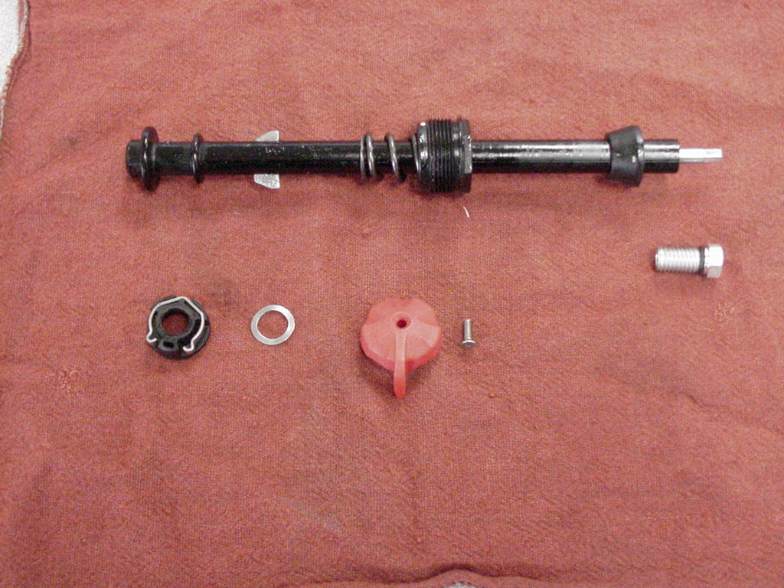

Detent Plate & Clip Wave Washer Travel Adjust Knob & Screw

Travel Adjust Systems: Wind Down

Wind Down Travel Adjust Service Instructions

Disassembly

- Turn travel adjust knob (clear plastic knob on top of the left side of the crown) in a counterclockwise direction until it stops. This insures that the fork is in its longest travel and reduces any spring preload on the fork.
- Remove the 2mm Allen screw from the knob. Use a 28mm socket to unscrew the top cap assembly from the crown. (Refer to Figure 1)
- Pull spring out of inner leg. If spring will not come out, you must take the outer casting off of inner legs (refer to Removal of Outer Casting instructions). Then remove the end cap from the bottom of the left leg and remove the Wind Down compression rod assembly and spring as a single unit through the bottom of the leg. You will find that on earlier production fork models, that there is a nylon washer at the top of the compression rod assembly that is holding the spring in place. Hold the spring in one hand and the compression rod assembly in your other hand and pull the apart from each other at a slight angle to each other. Once you have the two apart, remove the Allen bolt on top of the compression rod with a 4mm Allen wrench and remove the nylon washer (Fig 2). Re-install the bolt without the washer, it will not affect the operation of the Wind Down mechanism and insure that you will not have to take the whole fork apart in the future to change ride kit springs. (Note: the spring that you remove should have another spring (booster spring) intertwined within it)
Tools needed: 28mm socket, 2mm Allen wrench, 8 or 10” Adjustable wrench, 11mm nut driver or open end wrench.

Assembly

- If you had to remove the outer casting, reassemble the compression rod assembly and then follow instructions for Installation of Outer Casting.
- Optional Ride Kits - If you need to adjust to overall ride characteristics either softer or firmer, purchase and/or install as follows (Kit Part Numbers can be found in the Service Part section of this manual):

  - Soft - Remove the Booster Spring
  - Firm - Purchase Firm Ride Kit and install the Booster Spring
  - Extra Firm - Purchase Extra Firm Ride Kit and install the Booster Spring

- To remove the booster spring from the main spring; grasp the flat end of the booster spring with a pair of needle nose pliers and twist it in a clockwise direction to unscrew it from the main spring.
- To install a booster spring into a main spring catch the flat end of the booster spring under the flat end of the main spring and twist it counterclockwise into the main spring. Make sure that the booster spring is threaded all of the way down into and contained by the main spring. Before inserting it back into the inner leg.

- Generously grease the spring and insert it into the inner leg. The spring needs to seat onto the top of the compression rod.
- Insert the wind down top cap assembly into the spring; the "D" shaped portion of the adjuster assembly must fit into the "D" shaped end of the main spring. Screw the assembly into the inner leg and tighter per the fastener torque guide at the end of this manual...
- Install adjuster knob and 2mm hex screw. Turn the knob counterclockwise until it stops. This insures that the fork is in its longest travel position. If the travel indicator arrow on the crown is not lined up with the maximum travel point on the indicator dial, loosen the compression rod bolt on the bottom of the outer casting and continue to turn the knob counterclockwise until the indicator point to maximum travel. Retighten the compression bolt per the fastener torque guide at the end of this manual.

Wind Down Travel Adjust Assembly

Top Cap Assembly & Spring

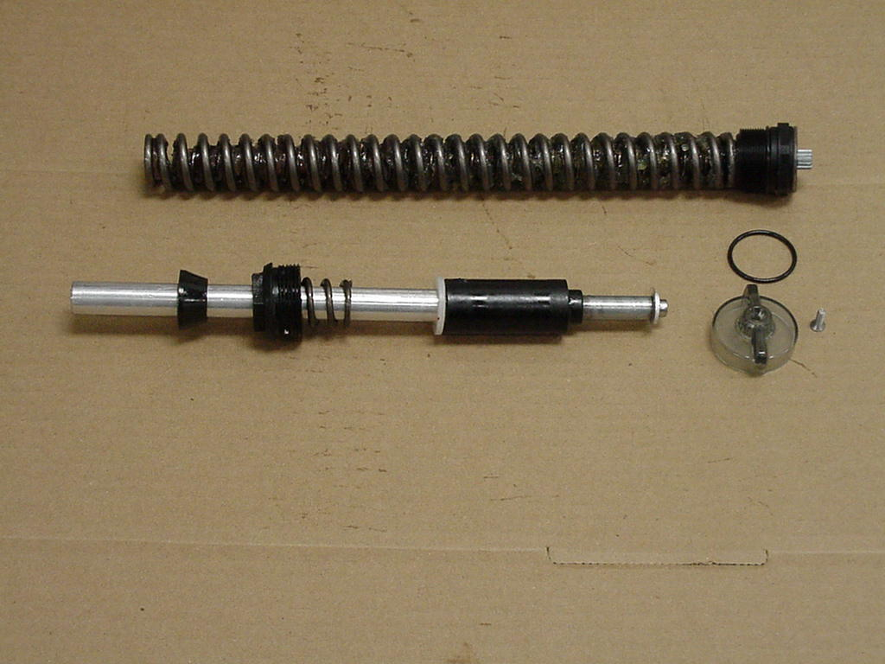
Figure 1
Travel adjust assembly & End Cap Adjuster knob O-ring, knob, & 2mm screw

Remove Nylon washer that rests on top of aluminum washer
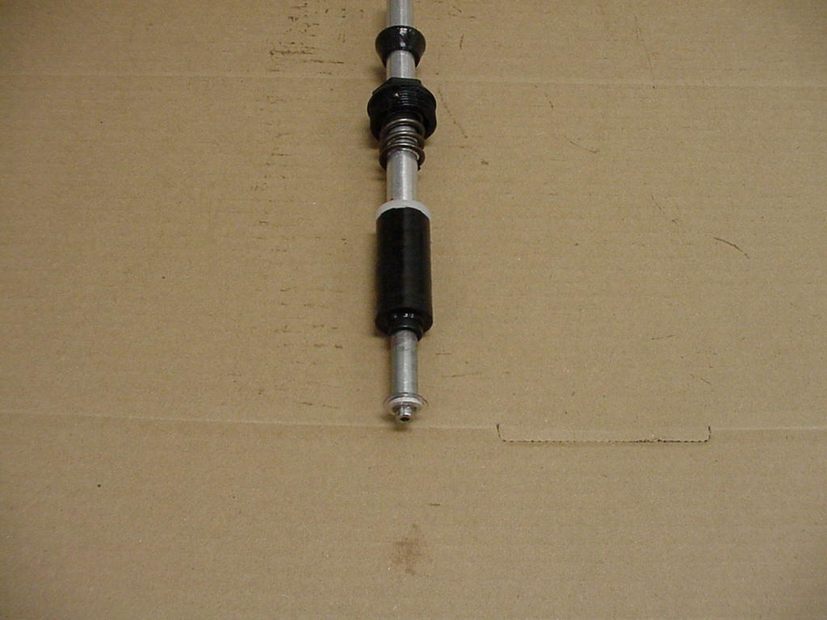
Figure 2
4mm recessed Allen bolt

Bushing Removal & Installation

Bushing Removal

(Note: use appropriate removal ring that corresponds to the leg diameter of the fork being repaired)

Leg Diameter | Answer Kit #
25.4mm (1”) | 85-5191
28.6mm (11/8”) | 85-5189
30mm | 85-5194
32mm | 85-5192

Bushing Removal Tool Components  - Slide Hammer  - Threaded Handle  - Slide  - Threaded Shaft  - Removal Ring | 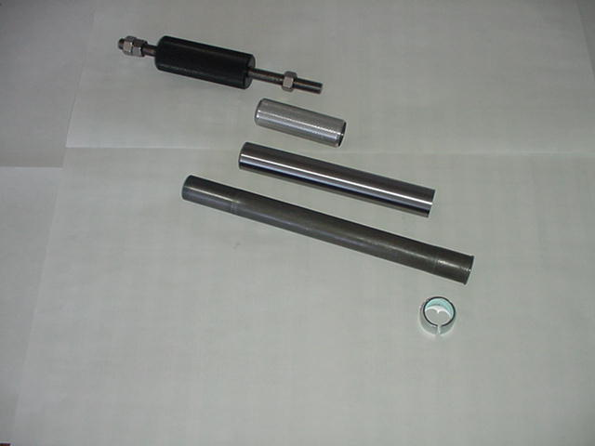
Bushing Removal Tool Assembly | 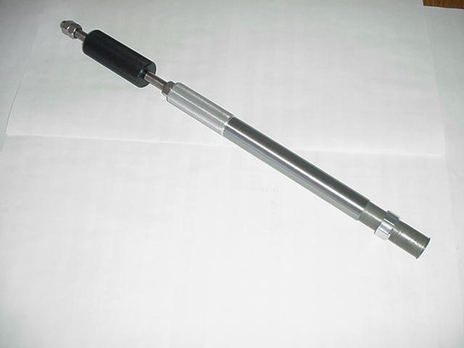

Bushing Removal (CONT.)

Bushing Removal Instructions  - Install 25.4mm Removal ring on the shiny, smaller diameter threaded shaft. Be sure to install the ring with the tapered, chamfered end first, followed by the long slide tube. This tapered end leads the tool through the bushing.  - Start the procedure by removing the Dust/Wiper seal with a screwdriver, prying it out.  - Insert Removal tool past the upper bushing and then stop. It is important to pull one bushing out at a time. Push the slide on the threaded shaft down towards the removal ring. Hold the casting with one hand and the slide hammer with your other hand. Now move the slide hammer in a motion away from the casting and repeat this action until the bushing comes out.  - For all other leg diameters: use the larger diameter (dark colored) threaded shaft and repeat steps A-C. | 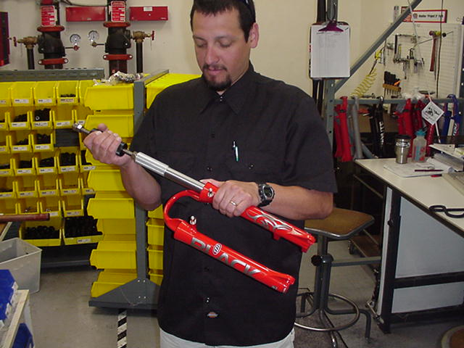

Bushing Installation

(Note: Sizer kits listed in above chart contain the sizers needed for each specific leg diameter.)

Bushing Installation Tool Components  - Installation Mandrel  - Threaded Rod w/nuts  - Sizer rings  - Spacer  - Washer  - Nut | (1) (2)  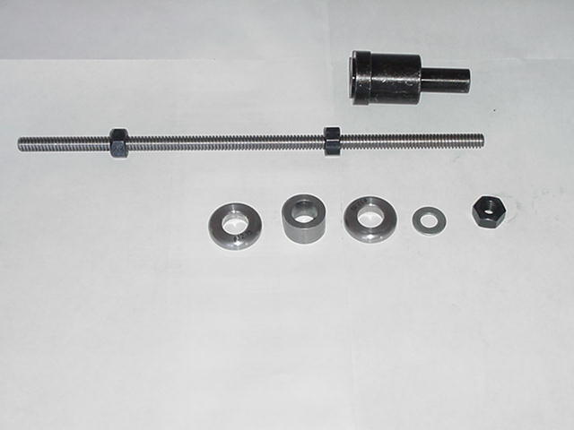  (3) (4) (3) (5) (6)

Bushing Installation (CONT.)

Bushing Installation Tool Assembly  With weighted handle | 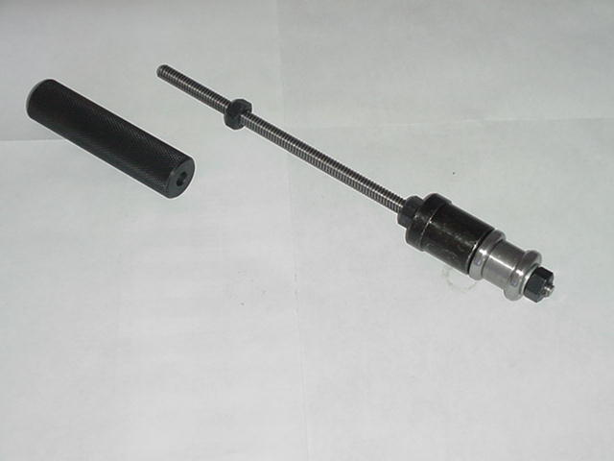
When selecting sizer rings to install bushings, choose the two rings that are in the middle of the size run to start with.  - Assemble installation tool as shown in picture above. Each leg diameter kit has all of the needed pieces to remove and install bushings for forks with serviceable bushings. Some of the kits come with gauges to tell you how far to drive in the lower bushings. Upper bushings are driven in as far as the stop in the top of the casting will allow. The general rule of thumb is that the lower bushings must not be driven any deeper than 5” into a casting leg. If they do go deeper, call Customer Service at Answer Products – 800-423-0273 for a new outer casting.  - Always assemble Mandrel with the larger diameter sizer ring being placed on the mandrel first, then the spacer, the next largest sizer ring, followed by the washer and the nut to hold it in place. Be sure to lock the nut above the Mandrel and below the Mandrel against each other. | 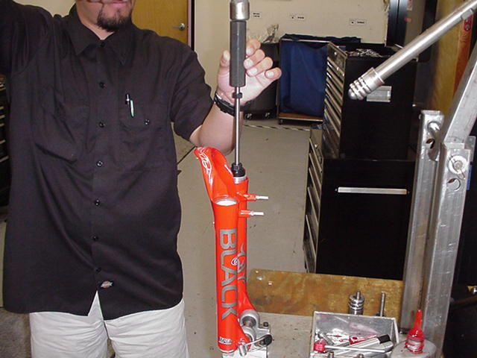
- Replace the lower bushing (bushing with a thicker wall diameter) first. Place a small amount of Prep M grease onto the sizer rings to help the rings come through the bushings when pulling them out. Slide bushing onto Mandrel until it stops. Apply a bead of Red Loctite all the way around the outside of the bushing. Hold casting on top of bench with a rag under the end of the legs and insert installation tool with bushing into casting leg. | 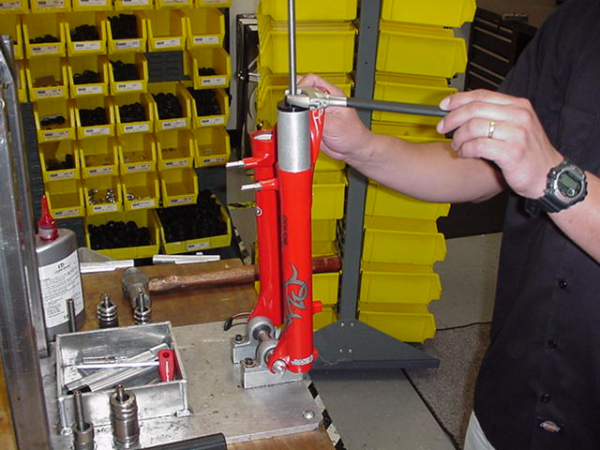
Bushing Installation (CONT.)

- Slide weighted handle onto end of threaded rod and tap rod into casting with rubber Mallet until proper depth is achieved. If using depth gage, slide gage onto rod before installing weighted handle and let it settle on of Mandrel. Tap rod until appropriate line on gage is even with top of casting leg.

- Remove weighted handle and gage (if applicable).

- For sizing of the lower bushing:

- Use slotted top cap from sizer kit and set it into the top of the casting leg, straddling the threaded rod. Spin the extra nut with washer down to the top cap and using a wrench, socket, or speeder wrench, tighten the nut in a clockwise direction. This will cause the Mandrel to be pulled through the bushing, thus sizing it. Keep turning the nut until the tool is all the way through the bushing and can be pulled out of the leg.

- To install top bushings, repeat steps B-E. Note that the top bushing gets inserted until it stops against the step inside of the casting. The extra sleeve that comes with the sizer kit is used to space the top cap off of the casting, so that there is enough room to pull the sizers out of the casting without bottoming on the cap.

- If you find that the bushings are too tight after installing them, use the sizer Mandrel that does not have a stop on it to hold the bushing while installing it into the casting. This is available in the 25.4mm leg kit (85-5191) to go back in and resize the bushings.

- To resize bushings, Choose the next larger size rings and repeat the above process.

- When satisfied with the results, reinstall Dust/wiper seals and then reassemble fork

TROUBLESHOOTING

Symptom | Cause | Solution | Service Manual Page
Air Loss | Schrader Valve leaks | Tighten Valve core, replace bad parts as needed.
 | Air Cap O-ring leaks | Make sure O-ring is seated properly, replace parts as needed.
 | Air Piston leaks | Check oil volume on top of piston, replace parts as needed.
 | Air Top Cap leaks | Check O-ring, tighten cap to proper Torque, replace parts as needed.
Oil leaks from Wiper Seals | Seal not seated properly | Remove Casting from Inner Legs, reinstall or replace seals
 | Nicks or scratches on inner legs | Replace Crown/Steerer/Inner Leg Assembly
 | Too much Semi Bath oil | Follow instructions for removal and installation of Outer Casting
 | Wear | Remove Casting from Inner Legs, reinstall or replace seals
Oil leaks from bottom of Casting | Rebound damper shaft leaks | Replace Rebound Damping assembly
 | Rebound damper shaft O-ring damaged | Replace O-ring on threaded end of Rebound Damping assembly
 | Compression Rod Bolt leaks | Check O-ring on bolt to see if it is damaged and then reinstall
Lack of Travel | Tight Bushings | Resize bushings or replace with new ones if damaged
 | Hydraulic lock out | Replace Rebound Damping assembly
 | Semi Bath oil volume | Follow instructions for removal and installation of Outer Casting
 | Damper oil volume | Check oil level, Replace Rebound Damping assembly if needed
 | Fork alignment | Visually inspect fork, call Answer Products Customer Service
Loss of SPV damping | SPV valve not functioning | Inspect for damage, check valve gap, replace assembly if needed
 | Damper oil volume | Check oil level, refer to "Oil leaks from bottom of Casting"
 | Rebound knob does not turn | Replace Rebound Damping Assembly
 | Loss of SPV air pressure | Refer to "Air Loss- Schrader valve leaks and Air Cap O-ring Leaks"

TROUBLESHOOTING (CONT.)

Symptom | Cause | Solution | Service Manual Page
Fork Top out | Loss of Rebound Damping | Replace Rebound Damping assembly
 | SPV Valve not functioning | Refer to " Loss of SPV Damping - SPV valve not functioning"
 | Top out spring damaged | Inspect and replace Top out spring if needed.
 | Damping oil volume not correct | Check oil level, Replace Rebound Damping assembly if needed
Fork Bottom out | Too much SAG | Refer to SAG Set up in Tuning section of Owners Manual
 | Bottom out Bumper damaged | Inspect and replace Bottom out Bumper if needed
 | Damping oil volume not correct | Check oil level, Replace Rebound Damping assembly if needed
Play in Fork | Loose bushings | Resize bushings or replace with new ones if damaged
 | Loose Compression Rod bolt | Tighten bolt to specified torque
 | Loose Rebound damping shaft | Tighten Shaft to specified torque
 | Loose press fit tolerances | Call Answer Products Customer Service

Minute One: Fastener Torque and Setup Levels

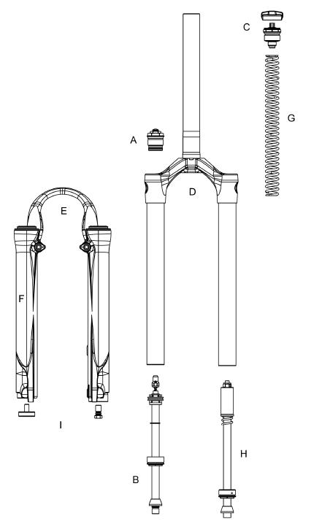

Model: Minute 1(Wind Down)
Description | Torque Values
Torque – Brake Post | 90–110inlbs (10.2-12.4nm)
Bushing Depth Left Lower | 4.25 – 4.50in (108-113mm)
Bushing Depth Right Lower | 4.25 – 4.50 (108-113mm)
Leg Caps - Not Cross-Threaded | 25–35inlbs (2.8-4.0nm)
Torque – Damper Screw | 10-30inlb (1.1-3.4nm)
Torque - Comp Rod Screw | 10-30inlb (1.1-3.4nm)
Adjuster caps & Top Caps
Torque | 35-50inlbs (4.0-5.7nm)
Semi Bath Oil Volume | 16cc per leg
Damping oil Level (100-130mm Travel) | 3.9in, 75mm, 120cc
SPV air pressure | 40-100psi

Minute Two: Fastener Torque and Setup Levels
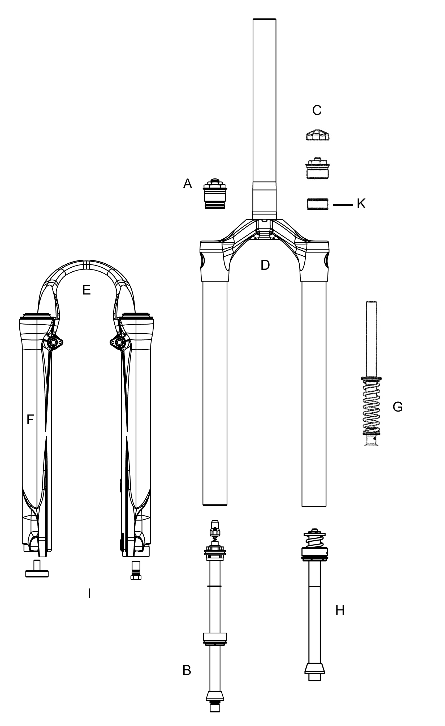
Model: Minute Two
Description | Torque Value
Torque – Brake Post | 90–110inlbs (10.2-12.4nm)
Bushing Depth Left Lower | 4.25 – 4.50in (108-113mm)
Bushing Depth Right Lower | 4.25 – 4.50 (108-113mm)
Leg Caps - Not Cross-Threaded | 25–35inlbs (2.8-4.0nm)
Torque – Damper Screw | 10-30inlb (1.1-3.4nm)
Torque - Comp Rod Screw | 10-30inlb (1.1-3.4nm)
Air Preload Cap:
Torque | 50inlbs (5.7nm)
Schrader Valve Torque | 3-5inlbs (.34-.57nm)
Adjuster caps:
Torque | 35-50inlbs (4.0-5.7nm)
Semi Bath oil Volume | 16 cc per leg
Damping Oil Level:
*****100mm travel | 2.9in, 74mm, 105cc
*****130mm travel | 3.3in, 84mm, 120cc
SPV air pressure | 40-100psi
Air/Spring air pressure | 80-190psi

Minute Three: Fastener Torque and Setup Levels
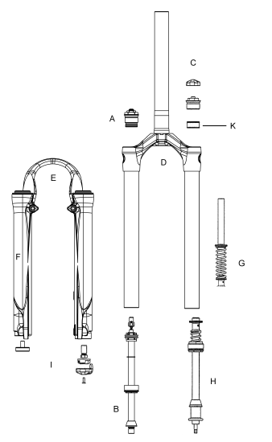

Model: Minute Three
Description | Torque Value
Torque – Brake Post | 90–110inlbs (10.2-12.4nm)
Bushing Depth Left Lower | 4.25 – 4.50in (108-113mm)
Bushing Depth Right Lower | 4.25 – 4.50 (108-113mm)
Leg Caps - Not Cross-Threaded | 25–35inlbs (2.8-4.0nm)
Torque – Damper Screw | 10-30inlb (1.1-3.4nm)
Torque - Comp Rod Screw | 10-30inlb (1.1-3.4nm)
Air Preload Cap:
Torque | 50inlbs (5.7nm)
Schrader Valve Torque | 3-5inlbs (.34-.57nm)
Adjuster caps:
Torque | 35-50inlbs (4.0-5.7nm)
Semi Bath oil Volume | 16 cc per leg
Damping Oil Level: | 3.3in, 84mm, 120cc
SPV air pressure | 40-100psi
Air/Spring air pressure | 80-190psi

Minute Service Kits

Model |  | One | Two |  | Three
Code |  | P-410 | P-430 | P-431 | P-420
Travel (mm) |  | 100-130 | 100 | 130 | 100/130
Comp Damp | A | 85-5871
Rbnd Damp | B | 85-5872
Pre Load Adj/Top Cap | C | 85-5950
Air Cap | C |  | 85-5873
Crn/Str/Leg | D
 | ***Blk AL S/T(26") STD/SM | 85-5874 | 85-5875 | 85-5951 | 85-5951
Outer Leg Assy | E
STD | Matte Black | 85-5876
STD | Matte Black, Integrated | 85-5953
STD | Matte Silver | 85-5877
No Boss | Matte Black | 85-5878
No Boss | Matte Black, Integrated | 85-5952
No Boss | Matte Silver | 85-5879
Sticker Kit | F - Silver | 85-5861
 | F - Black | 85-5862
Ride Kits | G
 | ***WD Booster | 85-5954
 | ***X-Soft | 85-5880
 | ***Soft | 85-5881 | 85-5883 | 85-5882 | 85-5882
 | ***Medium | 85-5884 | 85-5886 | 85-5885 | 85-5885
 | ***Firm | 85-5886 | 85-5888 | 85-5887 | 85-5887
Comp Rod/ | H
 | 100 |  | 85-5889
 | 130 |  |  | 85-5890
 | 100/130 |  |  |  | 85-5891
 | 100-130 RT Wind Down | 85-5892
Air Push Rods
 | 100 |  | 85-5955
 | 130 |  |  | 85-5956 | 85-5956
Knob Kit | I | 85-5893
Seal Kit | K | 85-5281
Air Piston Kit | G |  | 85-5266
Bumper Kit | K | 85-5894
O-Ring Kit | K | 85-5895
Bushing Kit | E | 85-5321
Options:
*****Lock Out | A | 85-5896

