202005 RADIUM SHOCK SERVICE MANUAL

PN XXXXX, REV NC.
2005 RADIUM SHOCK SERVICE MANUAL INDEX

Section | Description | Page
1 | INTRODUCTION | 3
2 | SETUP, TUNING, PERIODIC MAINTENANCE | 3
3 | GLOSSARY | 4
4 | COMPLETE SHOCK LESS HARDWARE | 5
5 | HARDWARE REMOVAL AND INSTALLATION | 5
6 | DU BUSHING REMOVAL AND INSTALLATION | 6
7 | AIR CANISTER | 8
8 | AIR CANISTER REMOVAL AND SEAL SERVICE | 9
9 | DAMPING SYSTEM | 11
10 | TROUBLESHOOTING | 12
11 | TABLE 1: FASTENER TORRADIUMUE RERADIUMUIREMENTS | 13
12 | RADIUM SHOCK SERVICE KITS | 14

Contact Information

Answer Products Customer Service Department
28209 Ave. Stanford
Valencia, CA 91355

Toll Free: (800) 423-0273
Direct : (661) 257-4411
FAX: (661) 775-1798
E-mail: warranty@answerproducts.com
tech@answerproducts.com
Web site: www.answerproducts.com



SECTION 1: INTRODUCTION

This manual is intended to guide the user through basic service of Manitou Radium rear shocks. Service is supported by the identification of common parts and assemblies that have been assembled into Service Kits. The purpose of this manual will be to describe conditions that may drive the need for service and to provide installation instructions for the kits.

Due to the time-consuming nature rear shock service, at this time our primary focus is to offer service kits that minimiRadiume the amount of downtime and labor involved. As the program matures, and we are able to gather feed back from our customers, we may offer kits to a more detailed level.

GENERAL WARNING: Rear shocks by design contain gases and fluids under extreme pressure and warnings contained in this manual must be observed to reduce the possibility of injury or possible death. Following these instructions can help you reduce the risk of being injured. Any questions in regards to the information in this manual should be directed to Answer Products Customer Service at (661) 257-4411.

CAUTION: The Radium Shock uses compressed air to provide fluid pressure in the damping system and spring resistance. These systems must be relieved of pressure prior to servicing. Failure to relieve air pressure could result in injury or possible death.

CAUTION: The Radium Shock uses precision machined aluminum and other soft alloy components. Using correct tools for assembly is essential to prevent damage.

SECTION 2: SETUP, TUNING, PERIODIC MAINTENANCE

Instructions for shock setup, tuning, and periodic rider maintenance is not covered in detail in this manual. Please refer to the Manitou Radium Rear Shock Owner's Manual for that information. If you did not receive a manual, you can download one at www.answerproducts.com or contact Answer Products Customer Service at (661) 257-4411.

SECTION 3: GLOSSARY OF TERMS

Air Canister – Can that holds the air spring air in an air shock.

Bottom Out – Point at which a shock reaches full compression.

Control Eyelet (C-End) – Eyelet that is on the rebound adjuster end of a shock. The air canister is attached to this end on air shocks.

Damper Eyelet (D-End) - Eyelet that is on the damper body end of a shock.

Damper Body – Section of shock that contains the damping system

Damper Shaft – Shaft attached to the damper piston that connects the two moving sections (damping system and control eyelet) of the shock together.

Damping System - Controls compression and rebound rate (speed).

DU Bushing – Teflon guide bushing pressed into the eyelets. Mounting hardware is inserted into the DU bushings and rotates within the bushing as need by the suspension design.

Eyelet – Found on each end of the shock, it is where the DU bushing and mounting hardware are and provides the connection between the shock and bicycle.

Internal Floating Piston (IFP) - A floating piston that separates damping oil from the damping system air chamber.

Lockout - Found on RADIUMRL shocks. The Manitou lockout significantly increases the amount of load reRADIUMuired to compress the shock. The lockout does not prevent compression under load, only increases the amount of load required to compress the shock.

Mounting Hardware – Hardware that allows shocks to be mounted into the wide variety of suspension designs.

Schrader, Air – Black in color, it is the valve for adding or releasing pressure from the air canister in an air shock

Seals: O-Rings - Black synthetic rubber with a round cross section. Primarily used for fluid
sealing.

Seals: Quad Seals - : Black synthetic rubber with an “X” cross section, primarily used for sealing air.

Seals: Wipers – Teflon ring, used for keeping debris out of quad seals, guiding the damper piston, and providing support.

Top Out – Point at which a shock returns to its full extension.

SECTION 4: COMPLETE SHOCK LESS MOUNTING HARDWARE

The highest-level kit offered will be a complete shock without mounting hardware. These kits are offered as a fast replacement where all that is need is to change out the hardware or damping unit.

RADIUM Shock – Less Mounting Hardware

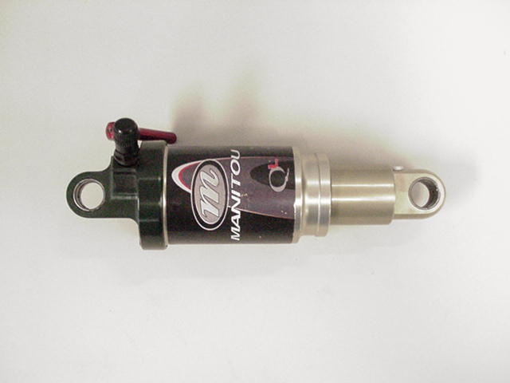

SECTION 5: HARDWARE REMOVAL AND INSTALLATION

Mounting hardware is used to mount shocks to the various frame configurations. Over time, hardware may wear between the mounting bolts or DU Bushing which will result in play in the connection.

Remove hardware using pliers as shown in Figure 1 DU Bushing Eyelet

.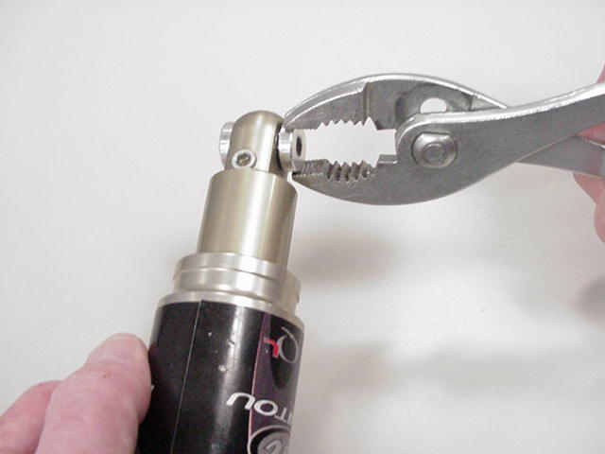 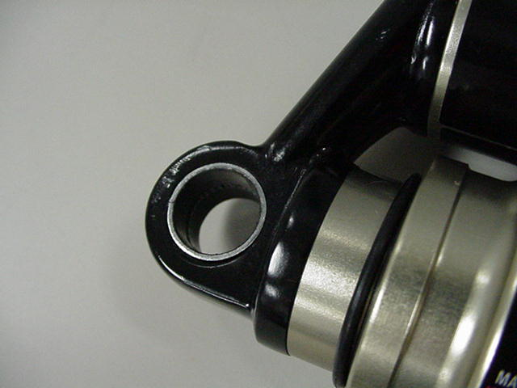
Figure 1 Figure 2

HARDWARE REPLACEMENT

Hardware should have a slight press fit into the DU bushing and can be tapped in place with a rubber mallet or soft jaws in a vise. Apply a small amount of thick grease such as Motorex Bike Grease 2000 (PN 85-0033) to the hardware before installation.

There are virtually an infinite number of hardware combinations in use on bikes today. When ordering hardware from Answer Products, It will be necessary to identify the overall eyelet width, eyelet width, and mounting hole diameter.

HARDWARE REMOVAL AND INSTALLATION- (CONT.)

- Measure the overall eyelet width.  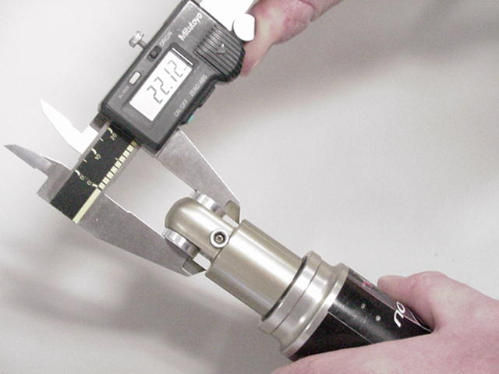 | - Measure hole size. Current hardware are designed to accept a 6mm or 8mm fastener.  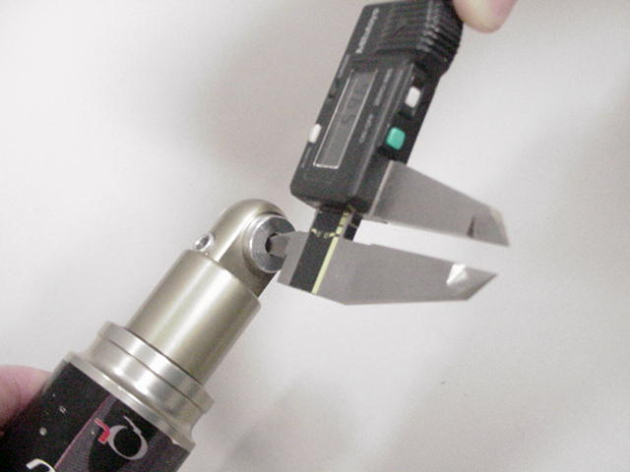
- Measure eyelet width.

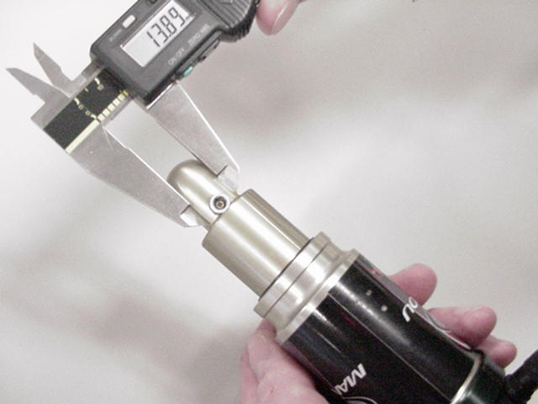

SECTION 6: DU BUSHING REMOVAL AND INSTALLATION

DU bushings are press fit into the shock eyelets at each end of the shock. The hardware fit into the bushings and will rotate slightly within the bushing during suspension compression. DU Bushings, like hardware, may wear over time. Removal and installation is accomplished using tool PN 85-6075.

REMOVAL  - Remove hardware from the shock.  - Insert unthreaded end of punch into the removal tool first and screw in about half a turn.  Punch | 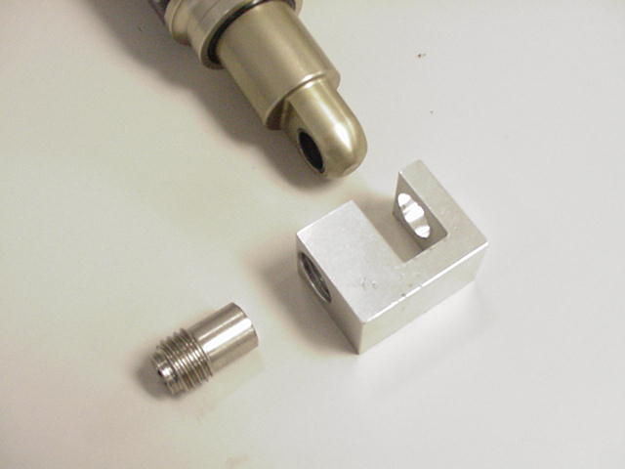

DU BUSHING REMOVAL AND INSTALLATION (CONT.)

- Clamp removal tool in vise.  - Insert eyelet into tool.  - Use 6mm hex wrench to screw in punch, making sure that it is centered on the bushing. This will press out the bushing. | 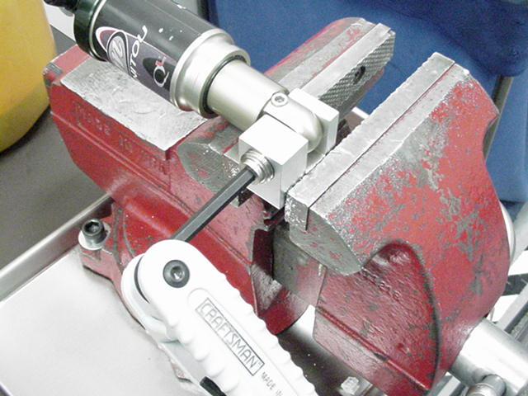
INSTALLATION  - Place a bushing onto the threaded end of the punch and into the removal tool; screw in about half a turn.  Bushing | 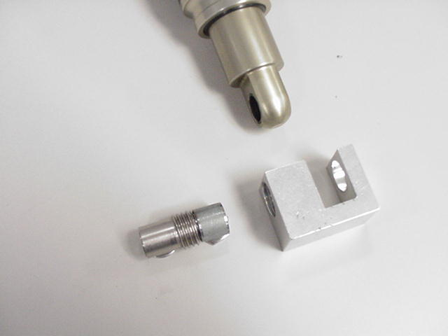
- Clamp removal tool in vise.  - Insert eyelet into tool.  - Use 6mm hex wrench to screw in punch, making sure that it is centered on the bushing and that the bushing is centered to the eyelet. This will press in the bushing. | 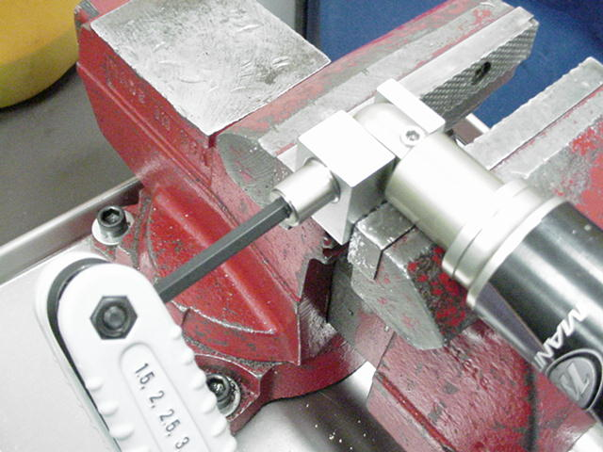

SECTION 7: AIR CANISTER

WARNING: Manitou RADIUM Air Shocks use compressed air to provide resistance to compression in place of a coil spring. You must be certain that the air canister is relieved of all pressure prior to servicing the air system. Failure to relieve air pressure could result in injury or possible death.

Failure of an air shock to maintain air pressure is usually the result of defective or worn seals. If there is suspicion of an air leak, the location can be isolated by spraying the air canister joints with a mild solution of dish soap and water. Bubbles will form in from the area of leakage. You can also immerse the shock in water to locate the leak.

Sealing of the shock is accomplished through a series if o-rings, RADIUMuad seals, and wipers. When the air canister is removed, these seals can be replaced from Seal Kit C.

Seal Descriptions:

O-Rings: Black synthetic rubber with a round cross section. Used for fluid sealing.
RADIUMuad Seals: Black synthetic rubber with an “X” cross section, used for sealing air.
Wipers: White Teflon, used for keeping debris out of RADIUMuad seals.

1. For leaks at the adjuster eyelet or damper end of the air canister, refer to the detailed disassembly instructions below.  2. For leaks at the Schrader valve, release all air pressure and replace the Schrader valve core or assembly as needed.  3. If when you pressuriRadiume the air canister the shock collapses to its shortest travel position, the shock has an air piston leak into the negative chamber. Place the shock in the shock tester and extend it to its full travel. Depress the adjuster eyelet Schrader while the shock is extended under load. If it remains in the full travel position, refer to the detailed disassembly instructions below for instructions on servicing the air canister and piston seals.  4. If the shock returns to the short travel position, it is not serviceable and the entire shock must be replaced.  WARNING: Attempting to service a shock with this condition could result in injury or possible death. | Adjuster Eyelet Schrader  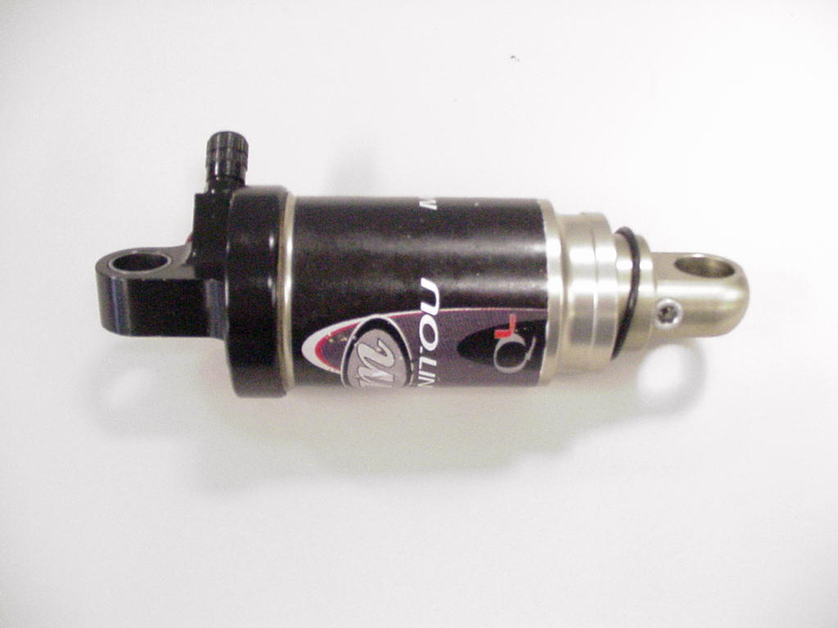  Shock in Shortest Travel Position  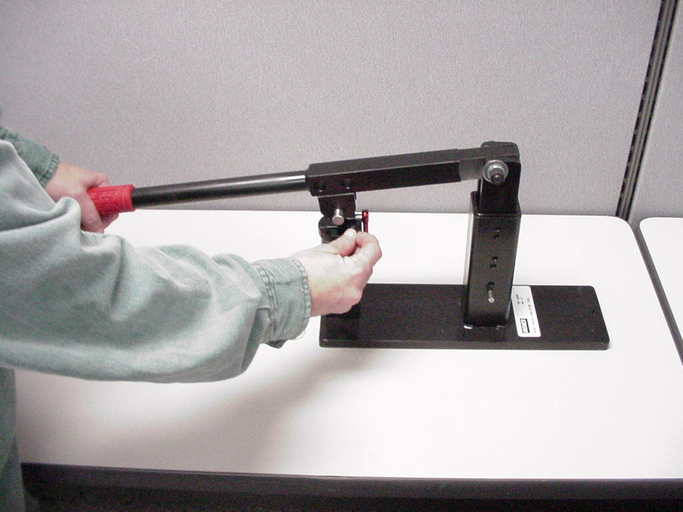  Extend to long travel and depress the air canister Schrader Valve

SECTION 8: AIR CANISTER REMOVAL AND SEAL SERVICE

1. Failure of an air shock to maintain air pressure is usually the result of defective or worn seals. If there is suspicion of an air leak, pressuriRadiume the air canister to 150psi from the adjuster eyelet Schrader Valve. Locate the leak by spraying the air canister and Schrader joints with a mild solution of dish soap and water or submerge in a bucket of water. Bubbles will form in from the area of leakage. | 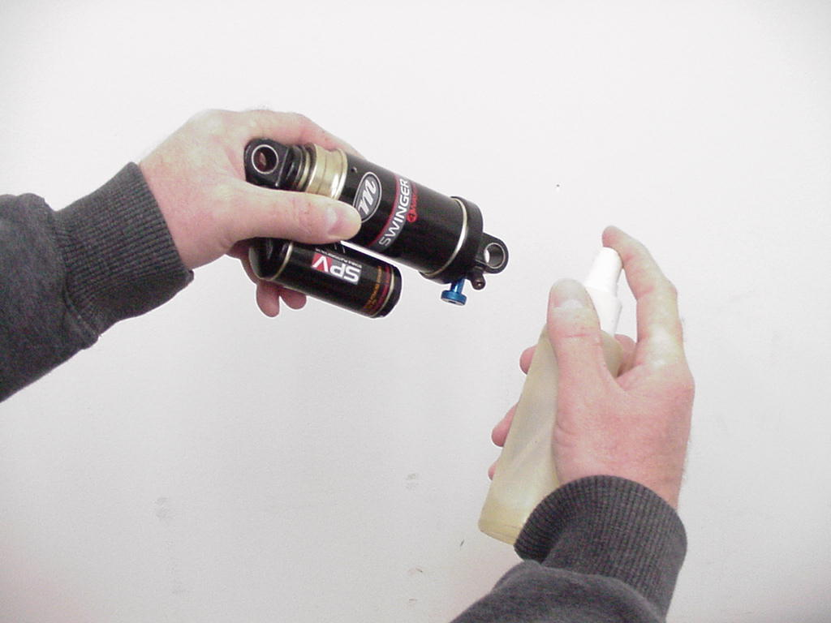
2. Release All air pressure from air canister. Remove hardware as shown under HARDWARE REMOVAL AND INSTALLATION. For leaks at the Schrader valves, release all air pressure and replace the Schrader valve core or assembly as needed. The core is removed using a standard core removal tool. The assembly is removed by removing the core and unscrewing the assembly by inserting a 3mm hex into the center of the valve. | Air release Schrader valve  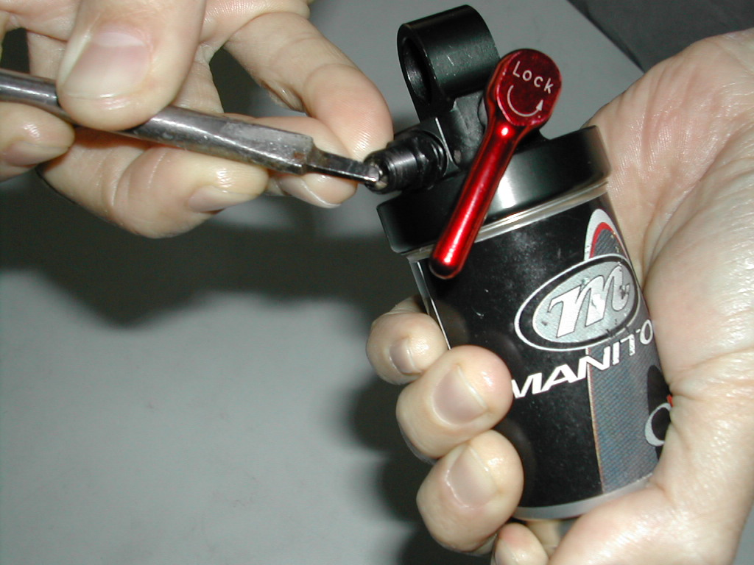
3. Place adjuster eyelet in a vise using soft jaws. Using a rubber strap wrench to prevent damage, loosen the air canister completely | 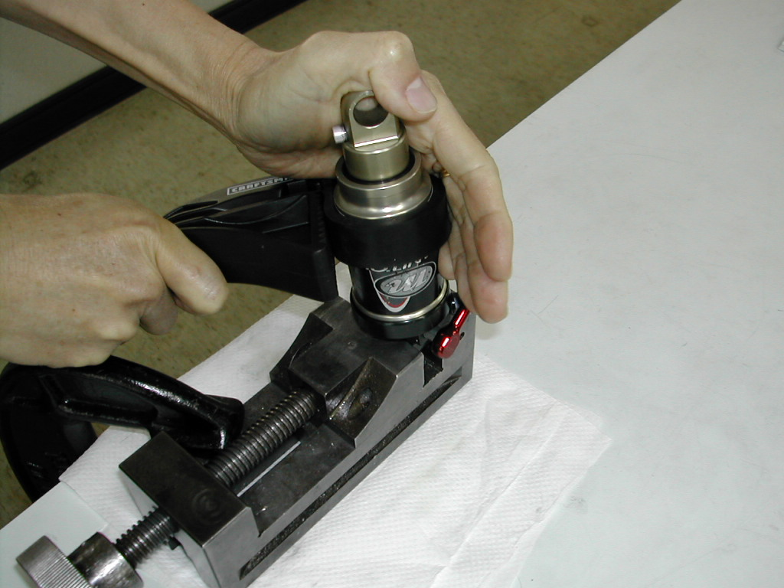

AIR CANISTER REMOVAL AND SEAL SERVICE (CONT.)

4. Slide air canister away from the canister eyelet and remove.  WARNING: Do not remove the damper cap. The damper system is under extreme pressure. Removal of the damper cap without releasing damper system pressure will result in the possibility of injury or possible death. | Damper Cap: DO NOT REMOVE  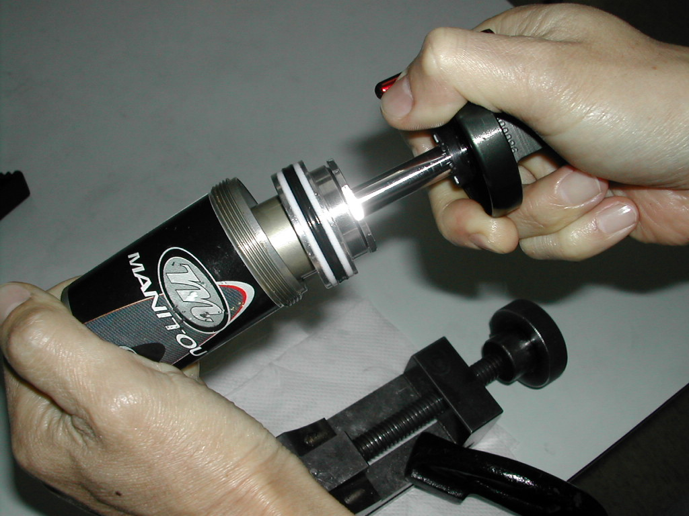
5. Replace o-rings, seals, and wipers in the air canister and air piston. Air Canister Kit A will have new seals installed as part of the kit. Also replace the o-ring inside the canister eyelet. | 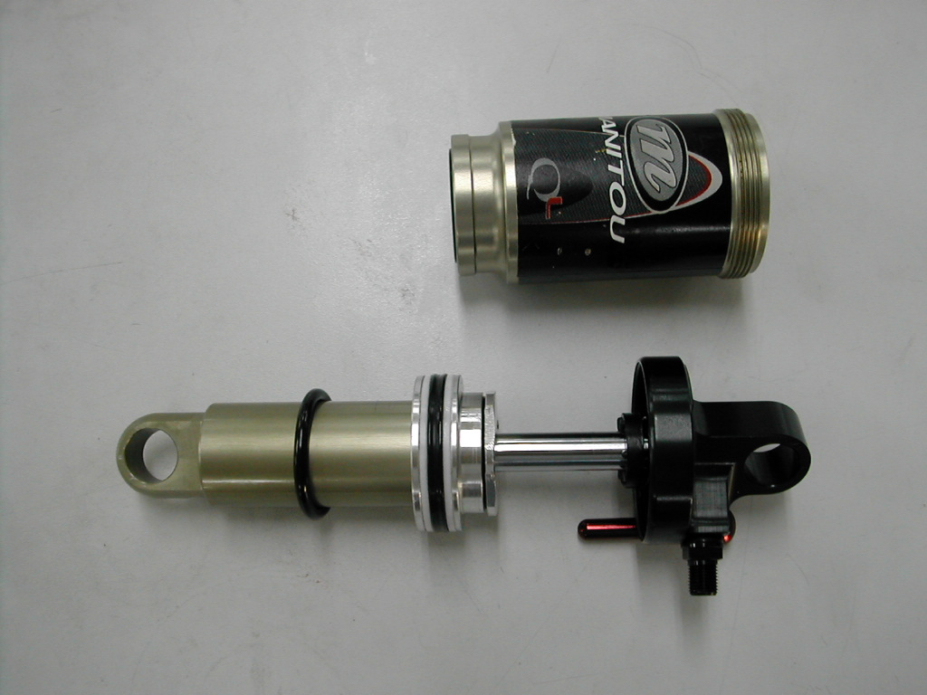  O-Ring, Seal, Wiper Locations
6. Lightly grease the air piston, damper body, air canister seals, and inside the air canister with a thick grease such as Motorex Bike Grease 2000. | 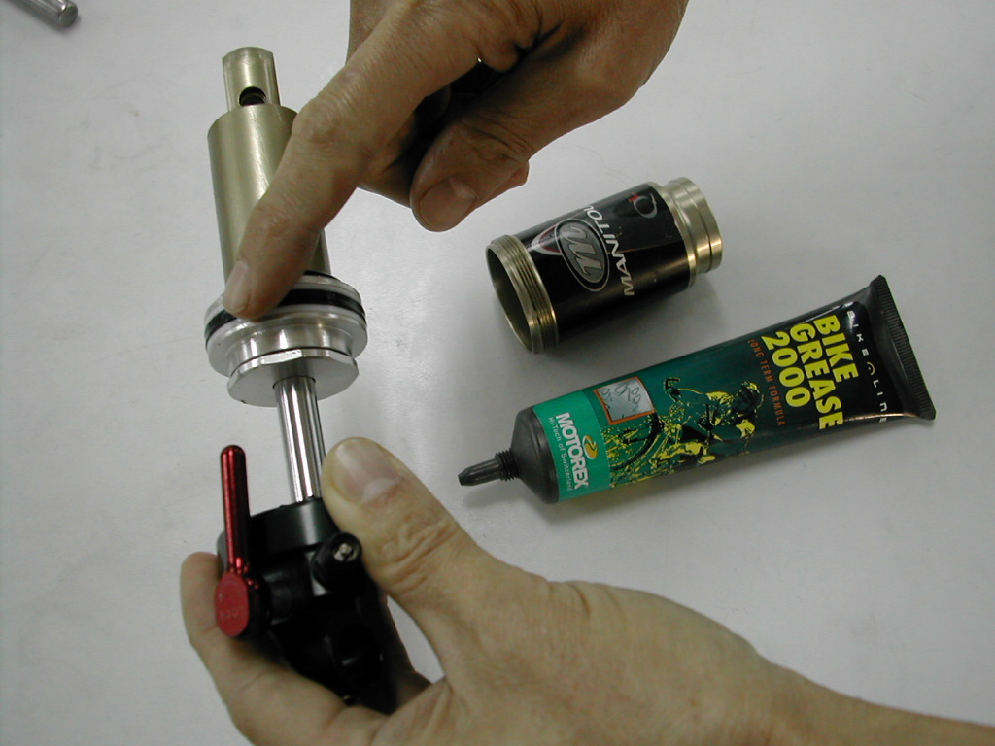

AIR CANISTER REMOVAL AND SEAL SERVICE (CONT.)

7. Slide air canister over the damper body. | 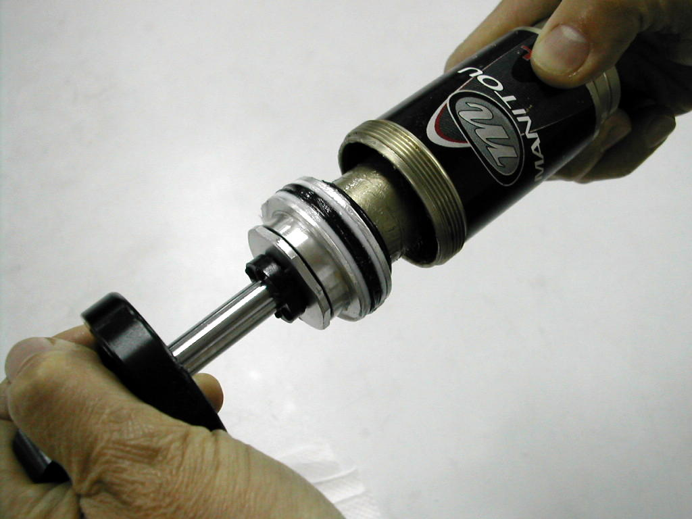
8. Lightly grease the air canister threads and inside the canister. Screw the air canister into the canister eyelet. Due to pressure in the damping system, it may be difficult to compress the shock enough to thread the canister onto its eyelet. If necessary, the shock test fixture can be used. | 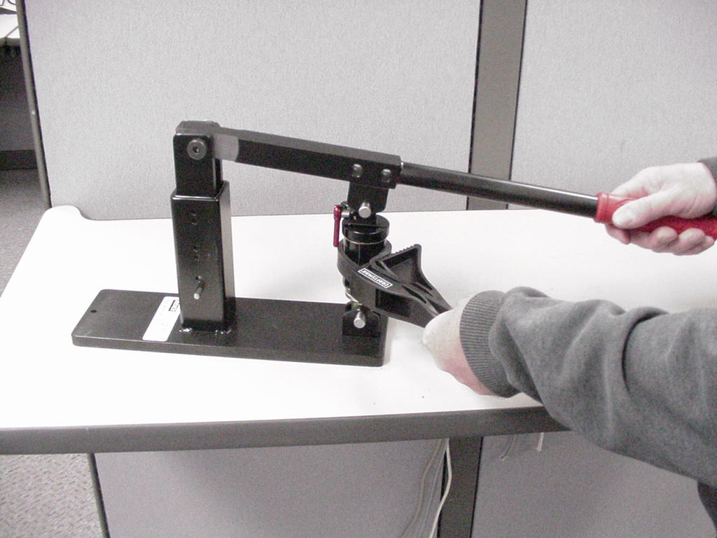

SECTION 9: DAMPING SYSTEM

CAUTION: The RADIUM Shock uses compressed air to provide fluid pressure in the damping system and spring resistance. These systems must be relieved of pressure prior to servicing. Failure to relieve air pressure could result in injury or possible death.

RADIUM Shock damping system service reRADIUMuires special tooling and training that is unavailable at this time. In cases where it is suspected that there is air in the damper or the damper body is leaking oil, the shock should be replaced.

SECTION 10: RADIUM SHOCK TROUBLESHOOTING CHART

Symptom | Cause | Solution | Service Section
Air Spring
Schrader valve snapped off at base | Interference with suspension linkage or other frame components | Replace. Confirm clearance after Schrader replacement | 8
Air loss from air spring | Air spring Schrader valve leaks | Tighten or replace Schrader core or replace Schrader assembly. | 8
Air loss from air spring | Seal failure on Air Canister | Replace seal(s) | 8
Air loss from air spring | Seal failure on Air Piston | Replace seal(s) | 8
Air shock does not return to full travel but has adeRADIUMuate air spring pressure | Failure of negative spring | Replace air canister and seals | 7
Hard top out | Failure of negative spring | Replace air canister and seals | 8
Hard Bottomout | Air spring pressure too low | Increase air canister air pressure | 8
Damping Oil Leaks
Oil leak at base of air canister | Worn or damaged seals allowing oil to escape from damper chamber | Replace shock | 4
Oil comes out of the Air Spring Schrader valve | Damping oil has leaked past the damper cap | Replace shock | 4
Damping System Performance
Adjusting rebound knob has no effect. | Air in damping system | Replace shock | 4
Lockout does not work | Air in damping system, Low IFP pressure. | Replace shock | 4
Mounting Hardware
Play in shock eyelets when mounted in bike | Worn DU bushing or mounting hardware | Replace | 5, 6

SECTION 11

TABLE 1
FASTENER TORRADIUMUE RERADIUMUIREMENTS

Feature | TorRADIUMue
Swinger Air
Air Canister | 15 – 24KgCm (13 – 21inlbs)
Schrader Valve Stem | 5 – 10 KgCm ( 4 to 9 inlbs)

SECTION 12: 202005 RADIUM SHOCK SERVICE KITS

Kit Description | Kit | RADIUM
 |  | RADIUM | RADIUMR | RADIUMRL
 |  | A-410 | A-420 | A-430
Air Canister
Regular Mount 25mm Travel (1.00") |  | 85-4461 |  | 85-4462
Regular Mount 32mm Travel (1.25") | A | 85-6035 |  | 85-4463
Regular Mount 38mm Travel (1.5") | A | 85-6036 |  | 85-4464
Regular Mount 50mm Travel (2.0") | A | 85-6037
Schrader Valves
RADIUM & RADIUMR Air Canister Schrader Valve Assy, Black | A | 85-4400
RADIUMRL Air Canister Schrader Valve Assy, Black | A |  |  | 85-4407
Complete Shock, Without Hardware
152mm Eye to Eye, 32mm Travel | B | 85-6128 | 85-6133 | 85-6140
165mm Eye to Eye, 38mm Travel | B | 85-6129 | 85-6134 | 85-6143
190mm Eye to Eye, 50mm Travel | B | 85-6131 | 85-6138 | 85-6144
200mm Eye to Eye, 50mm Travel | B | 85-6132 | 85-6139 | 85-6145
RADIUM Shock IFP Chamber Refill Plug | B | 85-5436
Seal Kit | C | 85-6054
Mounting Hardware Kits | D | (Contact Answer Products)
Hardware Bushing Kit | E
DU Bushing | E | 85-6105
Sticker Kit | F
Sticker Kit, RADIUM Shock | F | 85-4402
Sticker Kit, RADIUMR Shock | F |  | 85-4403
Sticker Kit, RADIUMRL | F |  |  | 85-442005
Sticker Kit, RADIUM, RADIUMR, RADIUMRL Trunion Shock | F | 85-4405
Tools | H
DU Bushing Tool | H | 85-6075
Fixture to Hold and Compress Shocks | H | 85-3008
Shock Pump - Air Canister | H | 85-4069

202005 RADIUM REAR SHOCK SERVICE KITS - DESCRIPTION

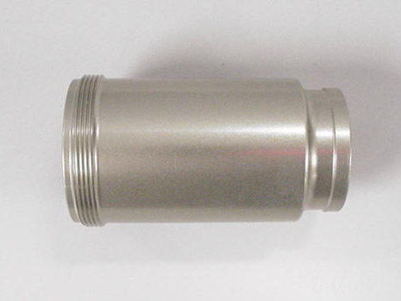

A - Air Canister B - RADIUM Shock, No Hardware

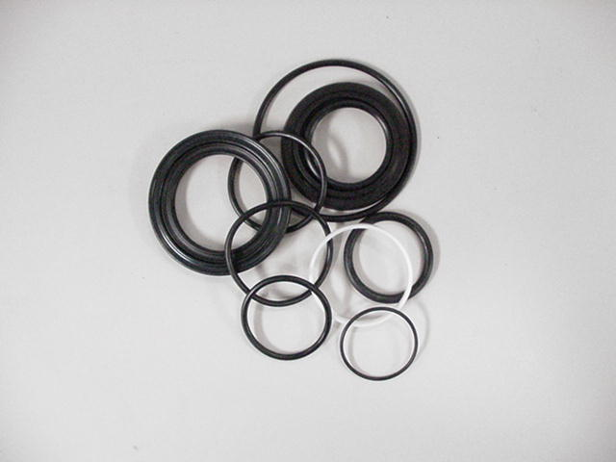

C - Seal Kit

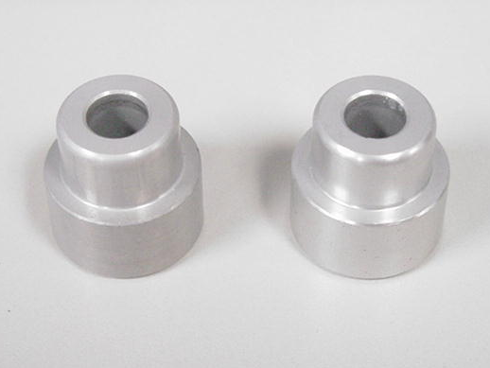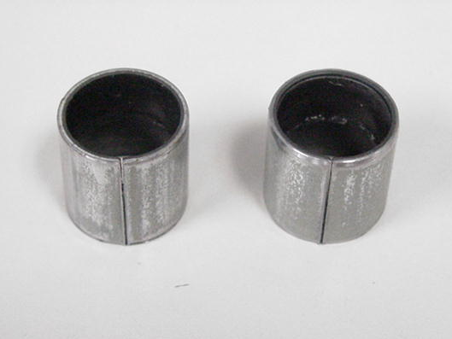

D - Hardware E - DU Bushing Kit

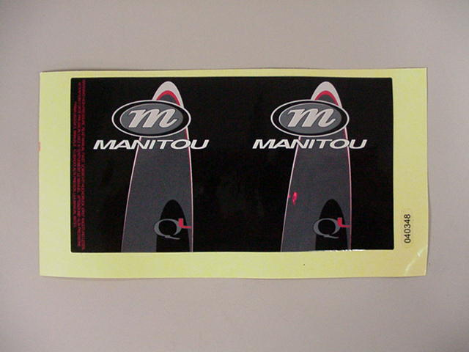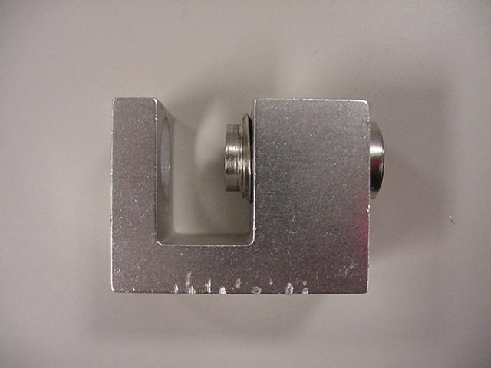

F - Sticker Kit H - DU Bushing Tool

