2004 Six Service Manual
Rev NC

Table of Contents

Description | Page
Introduction | 3
Front Suspension Terminology | 4
Disassembly Instructions | 6
Assembly Instructions | 6
Troubleshooting Chart | 7
Six Schematic and Torque Specifications | 8
Six Service Kit Chart | 9

Contact Information

Answer Products Customer Service Department
28209 Ave. Stanford
Valencia, CA 91355

Toll Free: (800) 423-0273
Direct: (661) 257-4411
FAX: (661) 775-1798
E-mail: warranty@answerproducts.com
tech@answerproducts.com
Web site: www.answerproducts.com



INTRODUCTION

This manual is intended to guide the user through basic service of Manitou Six front forks. Service is supported by the identification of common parts and assemblies that have been assembled into Service Kits. The purpose of this manual will be to describe conditions that may drive the need for service and to provide installation instructions for the kits.

Due to the time-consuming nature suspension fork service, at this time our primary focus is to offer service kits that minimize the amount of downtime and labor involved.

Important information is highlighted in this manual by the following notations:

WARNING
Failure to follow WARNING instructions could result in severe injury or death to the person inspecting or repairing the suspension fork or the user.

CAUTION
A CAUTION a caution indicates special precautions that must be taken to avoid damage to the product.

NOTE
A NOTE provides key information to make procedures easier or clearer

GENERAL WARNING: Suspension forks by design can contain preloaded springs, gases and fluids under extreme pressure and warnings contained in this manual must be observed to reduce the possibility of injury or possible death. Following these instructions can help you reduce the risk of being injured. Any questions in regards to the information in this manual should be directed to Answer Products Customer Service at (661) 257-4411.

WARNING: Suspension forks uses preloaded spring(s) to provide compression spring resistance. This system must be relieved of preload prior to servicing. Failure to relieve air pressure could result in injury or possible death.

CAUTION: Suspension forks use precision machined aluminum and other soft alloy components. Using correct tools for assembly is essential to prevent damage.

GLOSSARY OF TERMS

Arch – A support that connects the two outer lower legs of the casting so as to keep them moving in unison.

Boss – The word used to describe an outer casting that has brake posts for V-brakes or cantilever brakes.

Bottom Out Bumper – A rubber or elastomer device that absorbs the shock that occurs when a suspension is compression to its limit.

Bushings – A cylindrical sleeve between a fork stanchion tube (inner leg) and a fork outer casting (slider), which facilitates the sliding movement between these two parts.

Coil Spring – A coiled piece of metal that acts as a spring to help suspend a fork.

Compression – The phase of the suspension operation in which the wheel travels up, or travels closer to the frame. The suspension forks reaction to a bump in the trail.

Convertible Travel – A system used to alter the travel of a suspension fork. It requires moving a travel clip on the compression rod to a different position. This operation is accomplished by disassembling the fork and physically moving the travel clip on the compression rod.

Crown Steerer Assembly – the stanchion legs (inner legs), the fork crown, and the steer tube pressed together as one assembly. This assembly is then finished by adding all of the fork internals and then outer casting (slider).

Drop Out – The end of an outer casting (slider) where the wheel attaches.

Dust Boot – Usually a piece of rubber in the shape of a cylinder with baffles to allow it to compress as the fork compresses through its travel. Its function is to help keep dirt and water from getting into the inner legs of the fork.

Fork Crown – The component that joins the stanchion tubes (inner legs) to the steer tube of the fork.

MCU – (Micro-Cellular Urethane) Special urethane that is filled with tiny air cells that act like springs when the elastomer is compressed.

No Boss - The word used to describe an outer casting that has no brake posts for V-brakes or cantilever brakes. This casting is to be used for disk brakes only.

O-Ring – A soft, flexible neoprene or Buna rubber ring with a round cross-section, which is used for sealing and retention.

Outer Casting – (see Slider)

Preload – A condition of compressing a spring or elastomer before the operating loads are put on the suspension, so that it provides a stiffer spring rate.

Rebound – The phase of the suspension operation in which the wheel returns to its original position on the ground after compression.

Reverse Arch Technology – Also known as RA. It is a system that is designed to move the arch of a fork to the backside of a fork, rather than the conventional front position. It was designed to provide greater rotational torque strength to an outer casting (slider), without adding additional weight to the fork.

SAG – The amount a suspension fork compresses at rest with a normal load (rider’s weight).

Seal – A part, usually neoprene rubber or Buna, that keeps contaminants out and/or working fluids in.

Spring Rate – The rate at which the resistance of a spring increases as it is compressed.

Slider/Outer Casting – The tube (outer casting leg) of the suspension fork that remains fixed to the wheel. It slides up and down on the stanchion leg (inner leg).

Stanchion Legs – The suspension tube (inner leg) fixed to the fork crown. It remains stationary during the operation of the suspension.

Steer Tube – The long cylindrical tube that extends from the top of the fork crown. Its function is to be inserted into the bicycle head tube and attach the suspension to the bicycle frame.

Top Out Bumper – A rubber, coil spring, or elastomer device that absorbs the shock that occurs when the load is taken off a suspension so that it is allowed to rebound to its limits

Travel – The amount that a wheel moves between the most compressed and the most extended states of the suspension

Wiper Seal – A rubber material that is used as a seal to keep dirt and water out of the outer casting legs. It is not designed to keep air pressure or extreme oil pressure in. Manitou has the new Evil Genius wiper seals.

2004 Six Forks Disassembly and Rebuild Instructions

Disassembly Instructions

WARNING This fork uses a preloaded coil spring provide spring resistance. The spring must be relieved of its preload prior to servicing. Failure to do so could result in injury or possible death.

- From the left leg dropout (Left when sitting on the bike), use a 4mm hex wrench to remove the compression rod screw.
- From the right leg dropout, use an 6mm hex wrench to turn the compression rod clockwise until it can be pushed into the casting. If you cannot unscrew the compression rod see step 7.
- Remove crown/steer/inner leg assembly from the outer leg casting.
- Turn spring preload adjuster knob counter clockwise until it stops. Remove 2mm hex screw on spring preload adjuster knob and remove knob on the top left side of the fork.
- Remove preload adjuster using 18mm socket.
- Compress fork and remove the spring preload, MCU, and spring assy.
- Remove top leg cap on right hand side using 27mm socket.
- If you could not remove the right side compression rod externally, reach down inside the inner leg with a 6mm hex, the top of the compression rod has a recessed 6mm hex that a hex wrench will fit into. The comp rod can be unscrewed counterclockwise at this point. Remove crown/steer/inner leg assembly from the outer leg casting.
- Remove rubber bumper and clip on compression rods.
- Turn crown/steer upside down to allow the comp rods to fall out of the inner legs.

Setting Travel

Setting fork in short travel:  - Follow Disassembly steps above.  - Using pliers, pull thicker clip from top of rod and install it in slot just below flange.  - Reassemble assembly and fork as directed below. | 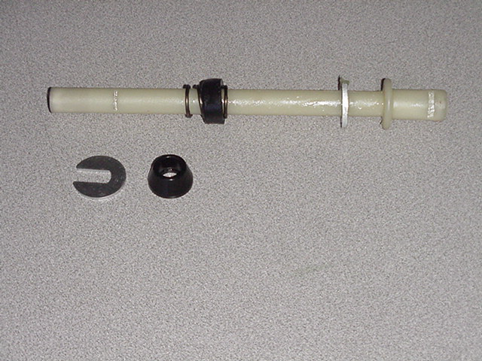  Thicker Clip in slot below flange  Bottom out clip removed for clarity

Setting fork in longer travel:  1. Follow Disassembly steps above.  - Using pliers, pull thicker clip from bottom of rod and install it in slot just above flange.  - Reassemble assembly and fork as  directed below. | 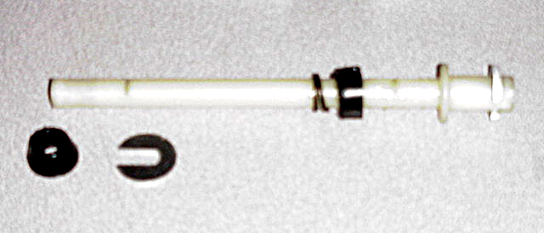  Thicker Clip in slot above flange

Bushing Removal and Installation-Six Sport

(See Below)

Assembly Instructions

WARNING All top caps for Damper and Spring systems must be properly tightened prior to use. Failure to do so could result in injury or possible death.

WARNING When installing the outer Leg Casting to the Crown Steer Assy, Compression Rod bolts and Damper Shafts must be properly tightened prior to use. Failure to do so could result in injury or possible death.

- Drop the compression rods into the crown/steer assy. Make sure that the compression rod accepts the 4mm screw is installed in the left leg.
- Slide on the rubber bottomout bumper and clip onto the compression rod(s)
- Remove rubber fork boots from the casting and slide them onto the inner legs of the crown/steer assy.
- Lightly grease the bushings on the inside of the outer leg casting and on the lower portion of the inner legs below the boots using a thick grease such as Motorex Bike Grease 2000.
- Grease spring heavily with Motorex Bike Grease 2000. Install the spring preload, MCU, and spring assy into the crown/steer assy.
- Tighten preload adjuster using 18mm socket per table 1.
- Insert 2mm hex screw into spring preload adjuster knob and install knob on the top left side of the fork.
- Press inner leg assembly into outer leg casting until comp rod contacts casting.
- From the left leg dropout, use a 4mm hex wrench to install the compression rod screw. Tighten per table 1.
- From the right leg dropout, use a 6mm hex wrench to turn the compression rod counterclockwise until it screws into the casting. You may have to apply pressure from the top of the comp rod using a long 6mm hex to start screwing it in.
- Slide fork boots down and snap over dust seal flange.
- Lubricate the inner legs through the Microlube ports using Prep-M grease.

Bushing Removal & Installation

Bushing Removal

(Note: use appropriate removal ring that corresponds to the leg diameter of the fork being repaired)

Leg Diameter | Answer Kit #
25.4mm (1”) | 85-5191
28.6mm (11/8”) | 85-5189
30mm | 85-5194
32mm | 85-5192

Bushing Removal Tool Components  - Slide Hammer  - Threaded Handle  - Slide  - Threaded Shaft  - Removal Ring | 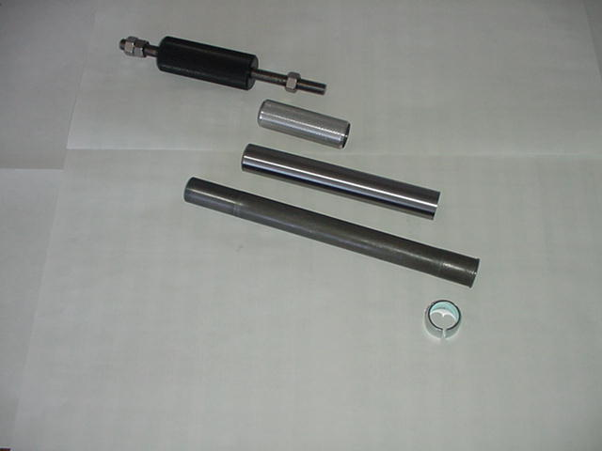
Bushing Removal Tool Assembly | 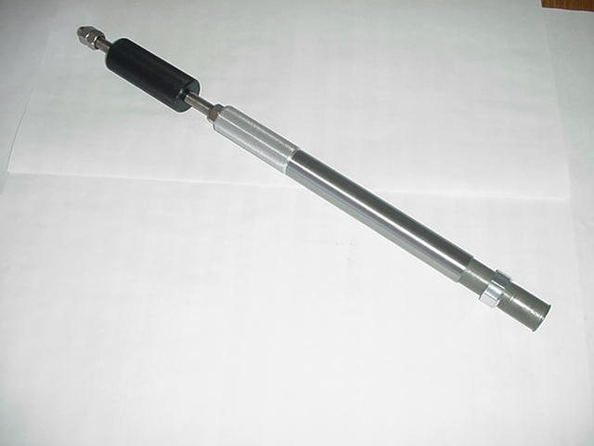

Bushing Removal (CONT.)

Bushing Removal Instructions  - Install 25.4mm Removal ring on the shiny, smaller diameter threaded shaft. Be sure to install the ring with the tapered, chamfered end first, followed by the long slide tube. This tapered end leads the tool through the bushing.  - Start the procedure by removing the Dust/Wiper seal with a screwdriver, prying it out.  - Insert Removal tool past the upper bushing and then stop. It is important to pull one bushing out at a time. Push the slide on the threaded shaft down towards the removal ring. Hold the casting with one hand and the slide hammer with your other hand. Now move the slide hammer in a motion away from the casting and repeat this action until the bushing comes out.  - For all other leg diameters: use the larger diameter (dark colored) threaded shaft and repeat steps A-C. | 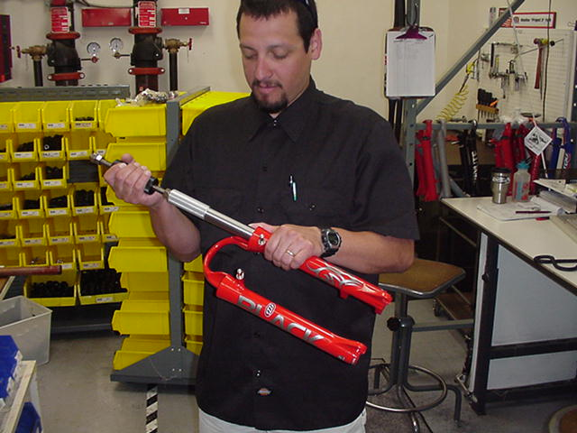

Bushing Installation

(Note: Sizer kits listed in above chart contain the sizers needed for each specific leg diameter.)

Bushing Installation Tool Components  - Installation Mandrel  - Threaded Rod w/nuts  - Sizer rings  - Spacer  - Washer  - Nut | (1) (2)  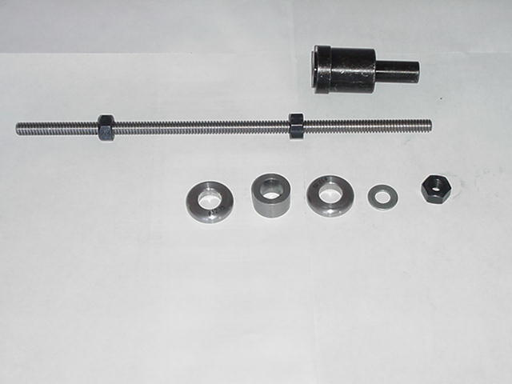  (3) (4) (3) (5) (6)

Bushing Installation (CONT.)

Bushing Installation Tool Assembly  With weighted handle | 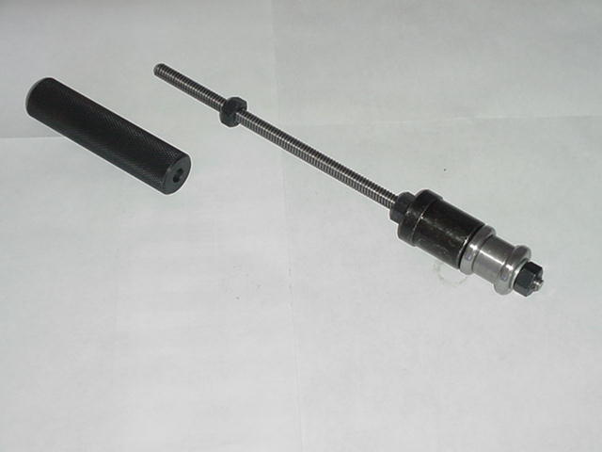
When selecting sizer rings to install bushings, choose the two rings that are in the middle of the size run to start with.  - Assemble installation tool as shown in picture above. Each leg diameter kit has all of the needed pieces to remove and install bushings for forks with serviceable bushings. Some of the kits come with gauges to tell you how far to drive in the lower bushings. Upper bushings are driven in as far as the stop in the top of the casting will allow. The general rule of thumb is that the lower bushings must not be driven any deeper than 5” into a casting leg. If they do go deeper, call Customer Service at Answer Products – 800-423-0273 for a new outer casting.  - Always assemble Mandrel with the larger diameter sizer ring being placed on the mandrel first, then the spacer, the next largest sizer ring, followed by the washer and the nut to hold it in place. Be sure to lock the nut above the Mandrel and below the Mandrel against each other. | 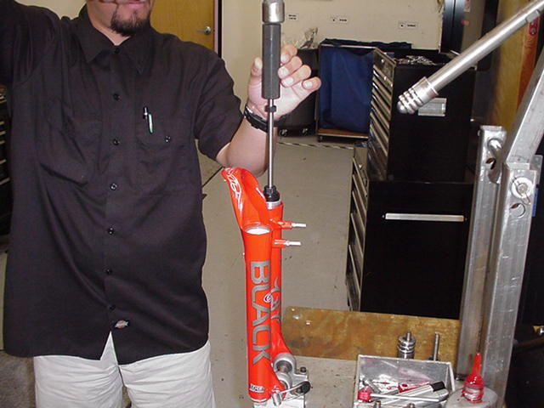
- Replace the lower bushing (bushing with a thicker wall diameter) first. Place a small amount of Prep M grease onto the sizer rings to help the rings come through the bushings when pulling them out. Slide bushing onto Mandrel until it stops. Apply a bead of Red Loctite all the way around the outside of the bushing. Hold casting on top of bench with a rag under the end of the legs and insert installation tool with bushing into casting leg. | 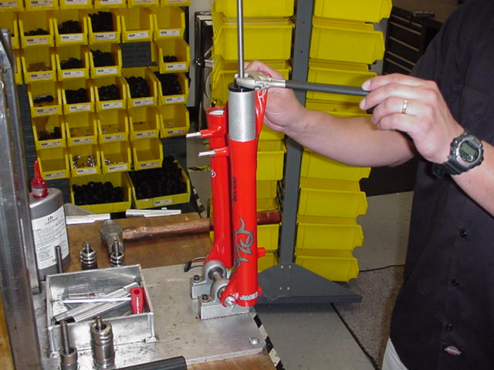
Bushing Installation (CONT.)

- Slide weighted handle onto end of threaded rod and tap rod into casting with rubber Mallet until proper depth is achieved. If using depth gage, slide gage onto rod before installing weighted handle and let it settle on of Mandrel. Tap rod until appropriate line on gage is even with top of casting leg.

- Remove weighted handle and gage (if applicable).

- For sizing of the lower bushing:

- Use slotted top cap from sizer kit and set it into the top of the casting leg, straddling the threaded rod. Spin the extra nut with washer down to the top cap and using a wrench, socket, or speeder wrench, tighten the nut in a clockwise direction. This will cause the Mandrel to be pulled through the bushing, thus sizing it. Keep turning the nut until the tool is all the way through the bushing and can be pulled out of the leg.

- To install top bushings, repeat steps B-E. Note that the top bushing gets inserted until it stops against the step inside of the casting. The extra sleeve that comes with the sizer kit is used to space the top cap off of the casting, so that there is enough room to pull the sizers out of the casting without bottoming on the cap.

- If you find that the bushings are too tight after installing them, use the sizer Mandrel that does not have a stop on it to hold the bushing while installing it into the casting. This is available in the 25.4mm leg kit (85-5191) to go back in and resize the bushings.

- To resize bushings, Choose the next larger size rings and repeat the above process.

- When satisfied with the results, reinstall Dust/wiper seals and then reassemble fork

TROUBLESHOOTING

Symptom | Cause | Solution | Service Manual Page
Oil leaks from Wiper Seals | Seal not seated properly | Remove Casting from Inner Legs, reinstall or replace seals | 6
 | Nicks or scratches on inner legs | Replace Crown/Steerer/Inner Leg Assembly | 6
 | Wear | Remove Casting from Inner Legs, reinstall or replace seals | 6
Lack of Travel | Tight Bushings | Replace outer leg casting (Six) or replace bushings (Six Sport)
 | Fork alignment | Visually inspect fork, call Answer Products Customer Service | 3
Fork Top out | Top out spring damaged | Inspect and replace Top out spring if needed. | 6
Fork Bottom out | Too much SAG | Refer to SAG Set up in Tuning section of Owners Manual
 | Bottom out Bumper damaged | Inspect and replace Bottom out Bumper if needed | 6
Play in Fork | Loose bushings | Replace outer leg | 6
 | Loose Compression Rod bolt | Tighten bolt to specified torque
 | Loose press fit tolerances | Call Answer Products Customer Service | 3

Six: Fastener Torque and Setup Levels

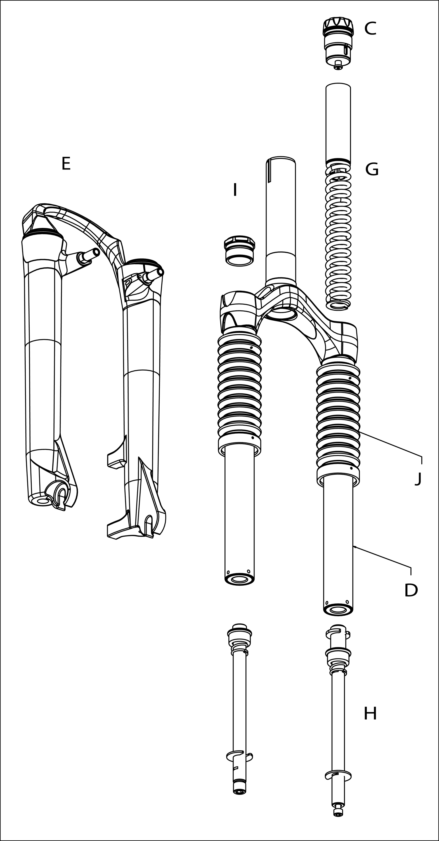

Model: Six
Description | Torque Value
Torque – Brake Post | 90–110inlbs (10.2-12.4nm)
Leg Caps | 25–35inlbs (2.8-4.0nm)
Torque - Comp Rod Screw | 10-30inlb (1.1-3.4nm)
Torque - Comp Rod | 10-30inlb (1.1-3.4nm)
Adjuster caps:
Torque | 35-50inlbs (4.0-5.7nm)
Six Service Kits

Model |  | Six | Sport
Code |  | S-410 | S-420
Travel (mm) |  | 80 or 100 | 80 or 100
Pre Load Adj/Top Cap | C | 85-4810
Crn/Str/Leg | D
 | ***Steel S/T (26") | 85-5366
 | ***Blk AL S/T(26") STD/SM | 85-5667
Outer Leg Assy | E
STD | Black (26") | 85-5250 | 85-5228
STD | Silver (26") | 85-5368 | 85-5229
STD | Red (26") | 85-5251 | 85-5230
STD | White | 85-5369 | 85-5274
STD | Cobalt | 85-5370 | 85-5530
STD | Orange | 85-5371 | 85-5531
STD | Yellow | 85-5372 | 85-5532
STD | Candy Chrome | 85-5373 | 85-5533
STD | Candy Red | 85-5374 | 85-5534
STD | Candy Blue | 85-5375 | 85-5273
No Boss | Black (26") | 85-5376 | 85-5236
No Boss | Silver (26") | 85-5377 | 85-5233
No Boss | Red (26") | 85-5378 | 85-5237
No Boss | White | 85-5379 | 85-5537
No Boss | Cobalt | 85-5380 | 85-5538
No Boss | Orange | 85-5381 | 85-5539
No Boss | Yellow | 85-5382 | 85-5540
No Boss | Candy Chrome | 85-5383 | 85-5541
No Boss | Candy Red | 85-5384 | 85-5542
No Boss | Candy Blue | 85-5385 | 85-5543
Sticker Kit | F - Silver | 85-5386 | 85-5388
 | F - Black | 85-5387 | 85-5389
Ride Kits | G
 | ***Soft | 85-5167
 | ***Medium | 85-5168
 | ***Firm | 85-5169
Comp Rod/ | H
 | 80 or 100 | 85-4921
Knob Kit | I | 85-5395
Boot Kit | J | 85-5390
Seal Kit | K | 85-5391
Bumper Kit | K | 85-5363
Bushing Kit | E |  | 85-5324

Six Service Kits (Cont.)

